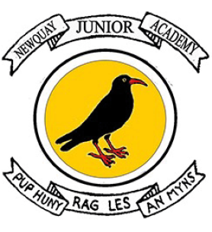


Newquay Junior Academy
Religion and World Views Curriculum Statement

INTENT
We believe that Religion and World Views should provoke challenging questions about the meaning and purpose of life, beliefs about God, issues of right and wrong and what it means to be human. Our Religion and World Views curriculum focuses on developing a deep interest in world views and a sound knowledge built through a coherent and tightly sequenced curriculum. It embraces a global and cultural breadth, and we are mindful to ensure that the uniqueness and background of every child is recognised and valued.

Our diverse, culturally-rich and wide-scoping curriculum is underpinned by the teaching of basic skills, knowledge, concepts and values in a rigorous and coherent way. Explicit links to story-telling and creativity are made to enthuse learners. Many enhancement and enrichment activities are used throughout the curriculum to engage children and create purposeful, high-leverage outcomes that give children the opportunity to use and apply their developing knowledge and skills.

Our aim is to create an environment that prompts curiosity and critical thinking and allows learners to connect strands of learning across all aspects of the curriculum.

We aim to ensure that all pupils:
- Make sense of a range of religious and non-religious beliefs through well told stories
- Understand the impact and significance of religious and non-religious beliefs on believers, exploring practice and history
- Make connections between religious and non-religious beliefs, concepts, practices and ideas studied as well as making links with and developing their own personal view.
- Explore the different lenses through which Religion and World Views can be interpreted, encouraging pupils to be curious and debate ideas.
IMPLEMENTATION

KS2 - Opening Worlds

We have a consistent approach, using clear themes from Opening Worlds and the National Curriculum, creating a curriculum that is progressive. It is characterised by strong vertical sequencing within subjects (so that pupils gain security in a rich, broad vocabulary through systematic introduction, sustained practice and deliberate revisiting) and by intricate horizontal and diagonal connections, thus creating a curriculum whose effects are far greater than the sum of their parts.

Each theme has an enquiry statement or question which will inform the components of knowledge that allow them to make connections and reach informed conclusions. Children will use a range of carefully curated resources from the Opening Worlds curriculum alongside religious artefacts, and core subject specific vocabulary to secure and gain understanding. Children will consider how each lesson and unit is built upon from previous knowledge and they will create connections in their learning not only in RE, but through all aspects of the curriculum, particularly geography and history.

In studying religions through multiple disciplines, pupils will learn about and learn from the different kinds of question human beings can ask about religious origins, beliefs and practices, namely questions that derive from philosophy, theology, social sciences and history. For example, when studying a particular religion in a particular place, asking the following different kinds of question: how does this story from the Quran help Muslims to understand this precept from the hadith? What does this New Testament story mean to Christians? What are the big ideas that this Hindu story reflects (eg dharma)? How are these ideas expressed in other stories and in diverse religious practices across time and space?

What is Opening Worlds?

Opening Worlds is a knowledge-rich humanities programme for teaching Religion and World Views, History and Geography in Years 3 to 6. As a school, we are provided with curriculum resources together with training, support and ongoing programme-related professional development for our staff.

This diverse, culturally rich and wide-scoping curriculum is underpinned by the teaching of basic skills, knowledge, concepts and values in a rigorous and coherent way. Explicit links to story-telling and creativity are made to enthuse learners. Our aim is to create an environment that prompts curiosity, critical thinking and allows learners to connect strands of learning across all aspects of the curriculum.

What does this look like at Newquay Junior Academy?

The programme meets and substantially exceeds the demand of the National Curriculum for History and Geography and is compatible with our locally agreed syllabi in Religion and World Views. The programme is characterised by strong vertical sequencing within subjects (so that pupils gain security in a rich, broad vocabulary through systematic introduction, sustained practice and deliberate revisiting) and intricate horizontal and diagonal connections, thus creating a curriculum whose effects are far greater than the sum of its parts. As the programme builds on prior learning, Years 4, 5 and 6 will start with the Y4 Curriculum in the 2025-26 academic year.

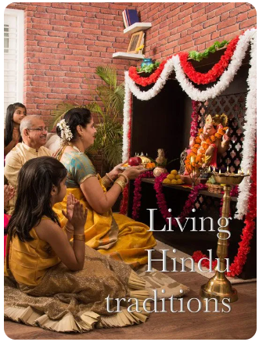
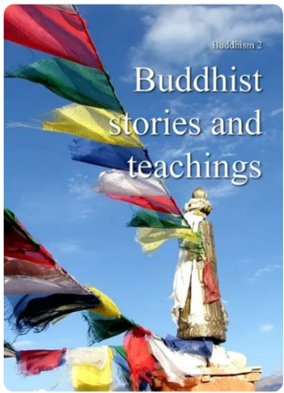
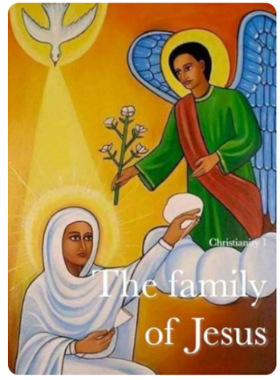
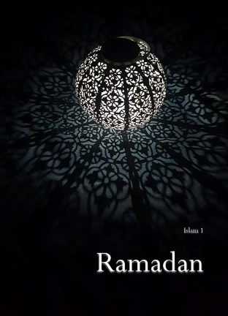
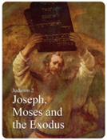

IMPACT
Children will show achievement through independently applying the knowledge learned; this will be evidenced through:

- Building and revisiting a knowledge schema throughout the unit and before and after each lesson, with a focus on key vocabulary.
- Lesson observations and subject leader discussions with pupils.
• Displays and knowledge schema creation.
- Answering retrieval questions to support recall and committing information to their long-term memories.
- Pupil voice opportunities for the children to reflect on their own learning and progression.
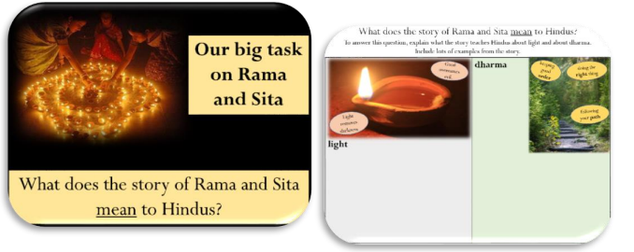
- Understanding and using prior knowledge, from current or previous year groups’, alongside the unit, making connections and thinking about similarities, differences, and connections.
- End of unit synoptic tasks.
- Confidently debating and discussing choices made.

