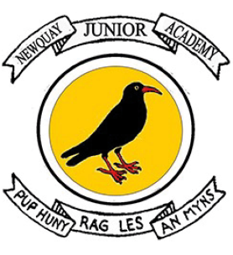

Newquay Junior Academy
History Curriculum Statement

INTENT
At Newquay Junior Academy we provide the children with opportunities to gain a coherent knowledge and understanding of Britain’s past, including the local area and the wider world. Knowledge will be built on as the children progress through school, through a carefully crafted enquiry curriculum, alongside the knowledge-rich Opening Worlds curriculum, enabling a deeper learning and understanding of history. The children will become curious about events in the past considering significant events and people in living memory and beyond, asking questions and developing perspective and judgements. History will help the children to understand the complexity of people’s lives, process change, the diversity of societies and relationships between different groups, as well as their own identity and the challenges of their time.

IMPLEMENTATION
We ensure a coherent curriculum and consistent approach using clear themes from Opening Worlds and the National Curriculum, that are built on throughout the years creating a curriculum that is progressive. It is categorised within by strong vertical sequencing within subjects (so that pupils gain security in a rich, broad vocabulary through systematic introduction, sustained practice and deliberate revisiting) and by intricate horizontal and diagonal connections, thus creating a curriculum whose effects are far greater than the sum of their parts. Each theme has an enquiry statement or question which will inform the components of knowledge that allow them to make connections and reach informed conclusions. Children will use a range of carefully curated resources from the Opening Worlds curriculum alongside primary and secondary resources, and core subject specific vocabulary to secure and gain understanding.

The children will:

• use the concepts of continuity and change, cause and consequence, similarity and difference, and significance, in order to make connections, draw contrasts, analyse trends, frame historically valid questions and create their own structured accounts, including written narratives and analyses.

• practise the methods of historical enquiry, understand how evidence is used rigorously to make historical claims, gain familiarity with diverse primary sources that the past leaves behind and discern how and why subsequent arguments and interpretations of the past have been constructed.

Children will consider how each lesson and unit is built upon from previous knowledge and they will create connections in their learning not only in History, but through all aspects of the curriculum, particularly Geography and Religion and World Views.


What is Opening Worlds?

Opening Worlds is a knowledge-rich humanities programme for teaching History, Geography and Religion and World Views in Years 3 to 6. As a school, we are provided with curriculum resources together with training, support and ongoing programme-related professional development for our staff.

This diverse, culturally rich and wide-scoping curriculum is underpinned by the teaching of basic skills, knowledge, concepts and values in a rigorous and coherent way. Explicit links to story-telling and creativity are made to enthuse learners. Our aim is to create an environment that prompts curiosity, critical thinking and allows learners to connect strands of learning across all aspects of the curriculum.

What does this look like at Newquay Junior Primary School?

The programme meets and substantially exceeds the demand of the National Curriculum for History and Geography and is compatible with our locally agreed syllabi in Religion and World Views. The programme is characterised by strong vertical sequencing within subjects (so that pupils gain security in a rich, broad vocabulary through systematic introduction, sustained practice and deliberate revisiting) and intricate horizontal and diagonal connections, thus creating a curriculum whose effects are far greater than the sum of its parts. As the programme builds on prior learning, Years 4, 5 and 6 will start with the Y4 Curriculum in the 2025-26 academic year.

IMPACT
Children will show achievement through independently applying the knowledge learned; this will be evidenced through:

- Building and revisiting a knowledge schema throughout the unit and before and after each lesson, with a focus on key vocabulary.
- Lesson observations and subject leader discussions with pupils.
• Displays and knowledge schema creation.
- Answering retrieval questions to support recall and committing information to their long-term memories.
- Pupil voice opportunities for the children to reflect on their own learning and progression.
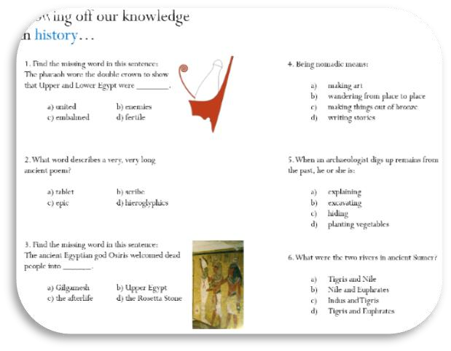
- Understanding and using prior knowledge, from current or previous year groups’, alongside the unit, making connections and thinking about similarities, differences, and connections.
- End of unit synoptic tasks.
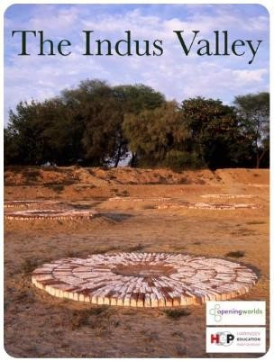
- Confidently debating and discussing choices made.
