


Edgcumbe Avenue, Newquay, Cornwall TR7 2NL
Tel: 01637 874543
njasecretary@nja.celtrust.org
www.newquayjunior.net
Head of Academy: Mrs. Tania Findlay MBE

Wednesday 29th January 2025
Dear Parents & Carers,
Year 6 SAT’s Revision Guides
As you may be aware, Year 6 will participate in end of Key Stage 2 Statutory Assessments (SATs) in the week commencing Monday 12th May 2025.
In preparation for these tests and to help support your child’s learning at home, we recommend purchasing CGP SATs Buster Revision Guides.
We are pleased to be able to offer you 3 guides (KS2 Grammar, Punctuation & Spelling, KS2 Maths and KS2 Reading) for a heavily subsidised bundle cost of £5.00 (RRP £15.00). These may be ordered by Wednesday 5th February 2025 via ParentPay (payment item: Y6 SAT's CGP Revision Guide Bundle) and will be distributed before the February half-term break.
Further information regarding Year 6 SATs will be communicated shortly.
Yours sincerely,
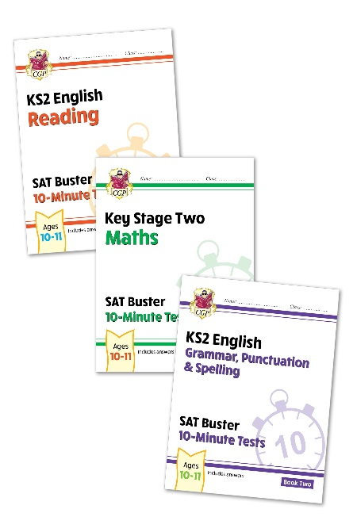
Mr Doble & Year 6 Team

