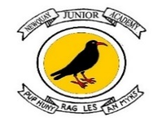
Christianity Knowledge Organiser – Spring Term 1
Year 4 – Pupil version

Unit L2.3 What is the Trinity and why is it important to Christians? (God/Incarnation)
Key Vocabulary  God The all-powerful and all-loving being that Christians believe created the world and everything in it  Trinity The Christian belief that God is Father, Son and Holy Spirit; three in one.  Jesus The second person of the Trinity or the Son; God in the flesh.  Incarnation ‘In the flesh’; Christians believe Jesus is God ‘in the flesh’, or God incarnate.  Symbol A thing that represents or stands for something else; e.g. the triquetra is a symbol of the Christian belief that God is Trinity.  Triquetra A Celtic symbol for the Trinity.  Overview – Sequence of lessons (Learning Objectives)  1. To discuss what water symbolises in Christianity.  2. To explore the meaning of the Holy Trinity.  3. To consider the symbolism used to depict the Holy Trinity.  4. To create a Christian baptism prayer.  5. To express the meaning of the Holy Trinity using symbols and art. | Knowledge Building blocks YOU NEED TO KNOW THAT:  •Christians believe God is Trinity: Father, Son and Holy Spirit.  • Christians believe The Father creates; he sends the Son who saves his people; the Son sends the Holy Spirit to his followers.  • Christians find that understanding God is challenging; people spend their whole lives learning more and more about God.  • Christians really want to try to understand God better and so try to describe God using symbols, similes and metaphors, in song, story, poems and art.  • Christians worship God as Trinity. It is a huge idea to grasp and Christians have created art to help to express this belief.  • Christians believe the Holy Spirit is God’s power at work in  the world and in their lives today, enabling them to follow Jesus.  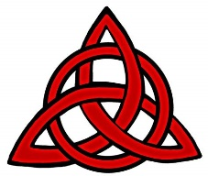  The Holy Trinity  Christians believe that God can be seen in three ways, known as the Holy Trinity:  -The Father – Creator of the world;  -The Son – Who came to Earth as Jesus;  -The Holy Spirit – God’s power within Christians.  Triquetra
The Big Frieze - The ‘big story’ of the bible is divided into 8 key concepts. The first concept in the ‘big story’ of salvation is God. Christians believe that God is the Father, Son and holy spirit (holy trinity).
Creation | Fall | People of God | Incarnation | Gospel | Salvation | Kingdom of God

