Edgcumbe Avenue, Newquay, Cornwall TR7 2NL
Tel: 01637 874543
njasecretary@nja.celtrust.org
www.newquayjunior.net
Executive Headteacher: Mr Craig Hayes B.ED (Hons)
12th January 2024

Dear Parents and Carers,

Newquay Junior Academy – Annual Attendance Information for all parents and carers

As we begin the new term, I would like to take the opportunity to thank you for all your support so far, this academic year. Every year, we update all parents and carers regarding our attendance policy.

I am delighted to say that our strategy of 'Learning Together to Help Every Child Achieve More' is working. At Newquay Junior, we believe there is no limit to what every child can achieve, and that every child deserves the chance to fulfil their potential.

The current national average attendance in England is 93.7%. Our whole school attendance is 95.8% so we have much to celebrate!

Please remember that our gates open at 8.25am, and, your child needs to be in class by 8:40am for morning registration: any pupils arriving after this time will incur a late mark and these have an impact on a pupil’s overall attendance.

You can find further information about the official CELT guidance regarding unauthorised leave of absence (holidays and absence in term time) on the following page.

If you have any questions, please contact the attendance team.

Yours sincerely,

Mr. Craig Hayes,
Executive Headteacher.

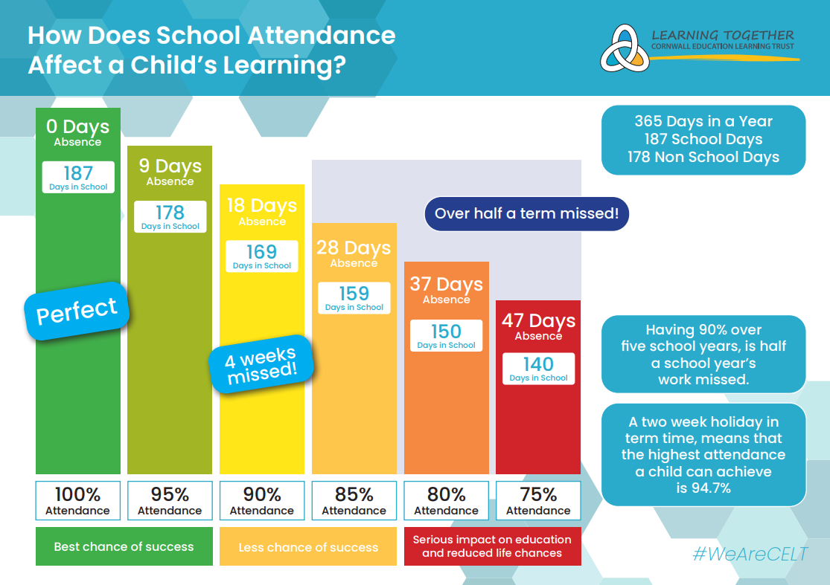

Official Guidance regarding unauthorised leave of absence
(Holidays and absence in term time)

Here at Newquay Junior, we recognise that there are occasions when it is appropriate to authorise an absence, such as when a pupil is genuinely too ill to attend school, has a medical appointment that cannot be taken outside of school hours or a request for leave has been agreed in exceptional circumstances.

However, the Government does not support parents taking children out of school unless the school agrees this is appropriate under ‘exceptional circumstances’. Any request for leave should be made in writing to the Headteacher using the school’s request form.

Department For Education and Cornwall Education and Learning Trust Attendance Information:

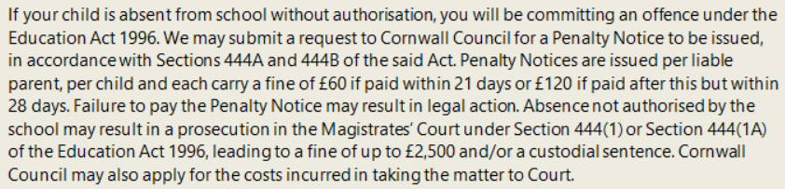

‘Parent’ as set out in Section 576 of the Education Act 1996, defines parent to include: natural parents, whether they are married or not; any person or body who has parental responsibility for a child (as defined by the Children Act 1989) and; any person who, although not a natural parent, has care of a child. Having care of a child means a person with whom a child lives and who looks after a child, irrespective of what their relationship is with said child.

You are welcome to contact the academy to discuss any concerns you may have regarding this or if you feel you would like advice or support in helping your child attend more regularly. Newquay Junior is committed to maximising the education of all its pupils and aims to work with parents to ensure this can be achieved. Please see the chart over the page which indicates the impact of lost learning when a child is absent from school.

The decision to submit a request for the issue of a Penalty Notice will be considered when a child’s attendance is deemed to be ‘not regular’. The definition of ‘not regular’ in this instance is when it is below the threshold set by Cornwall Education Learning Trust (CELT). For all CELT schools, this attendance threshold is set at 96%, in line with national attendance data. In the Autumn Term, a child’s attendance for the previous academic year will be considered before deciding on a course of action. From January onwards, the decision will be based on attendance data from the current academic year.

