27th February 2025
Dear Parents and Carers of Lego League Club,
Lego League Competition on Wednesday 12th March 2025
The Lego League Regional Final will take place on Wednesday 12th March 2025 at RNAS Culdrose. If your child has been taking part in the Lego League club on a Monday, they are invited to attend. They will be part of the team of 11 pupils representing Newquay Junior Academy at this event.
Pupils will need to arrive at Newquay Junior Academy at 7.30am on Wednesday 12th March. We will leave NJA at 7.40am to travel to RNAS Culdrose by the minibus. After the competition, we expect to return to the academy between 4.15pm- 4.30pm ready for collection.

What Pupils Need on Wednesday 12th March
On the day, pupils need:
✔ Wear warm clothing and have been provided with a blue NJA Team Hoody to wear at the event. ✔ Bring a coat and small bag.
✔ Packed lunch, snacks and drinks to last them the whole day.

How to Confirm Your Child’s Place
Please complete the electronic form below to give permission for your child to attend the event and provide their home time arrangement at 4.15pm- 4.30pm on the day.
https://forms.office.com/e/Je5k2nSgJZ
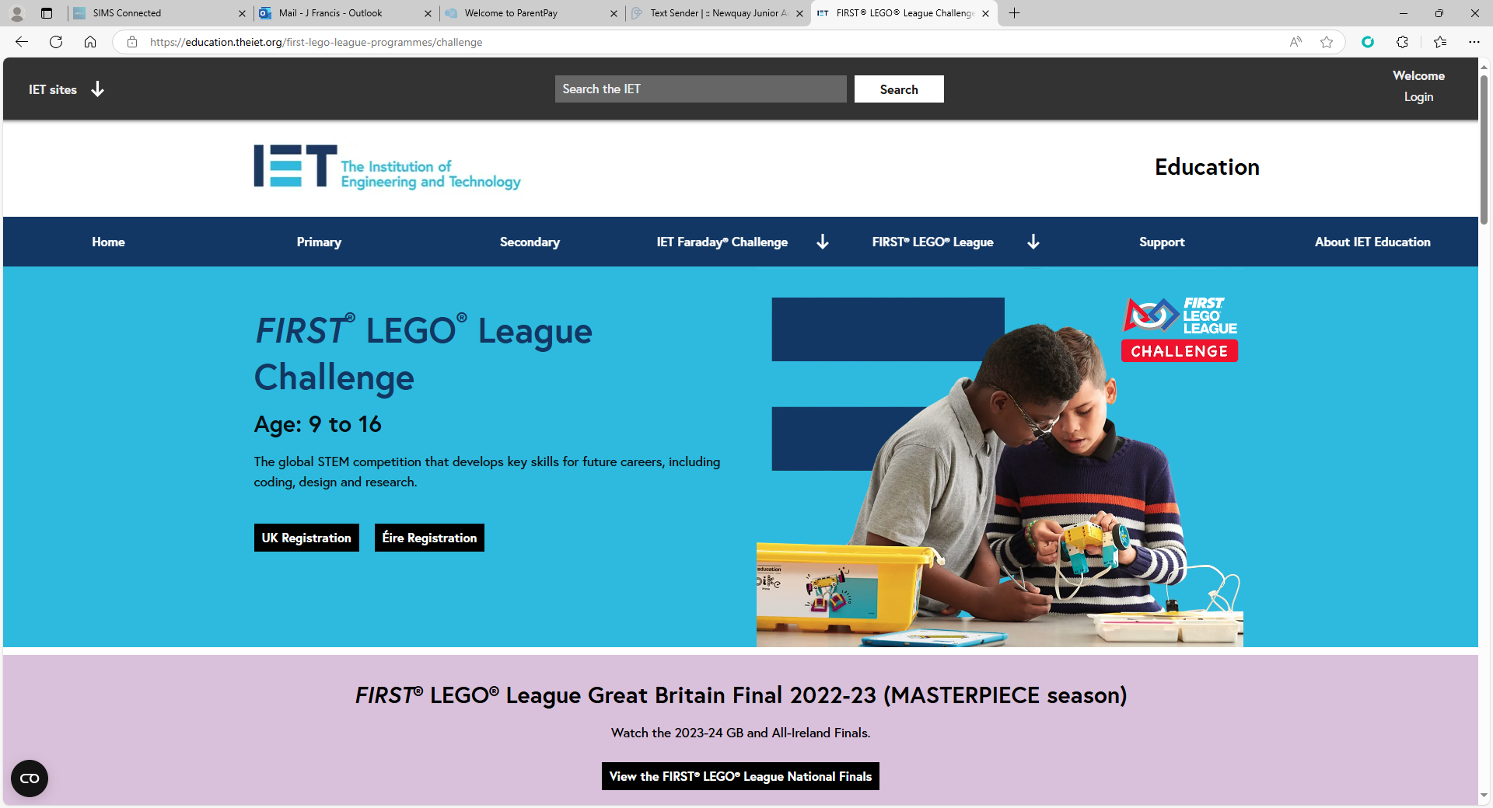
Thank you for your prompt response and we look forward to taking part in this exciting Lego competition!
Yours sincerely,
Mrs Springett and Mr Riches
Lego League Club
Newquay Junior Academy

