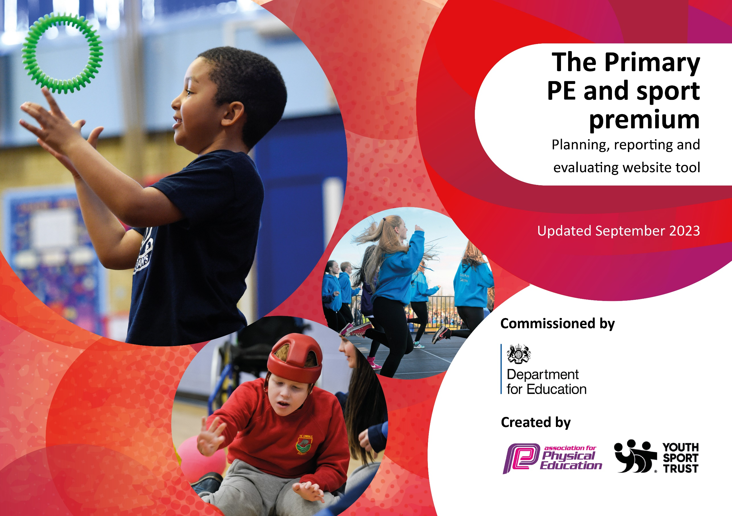

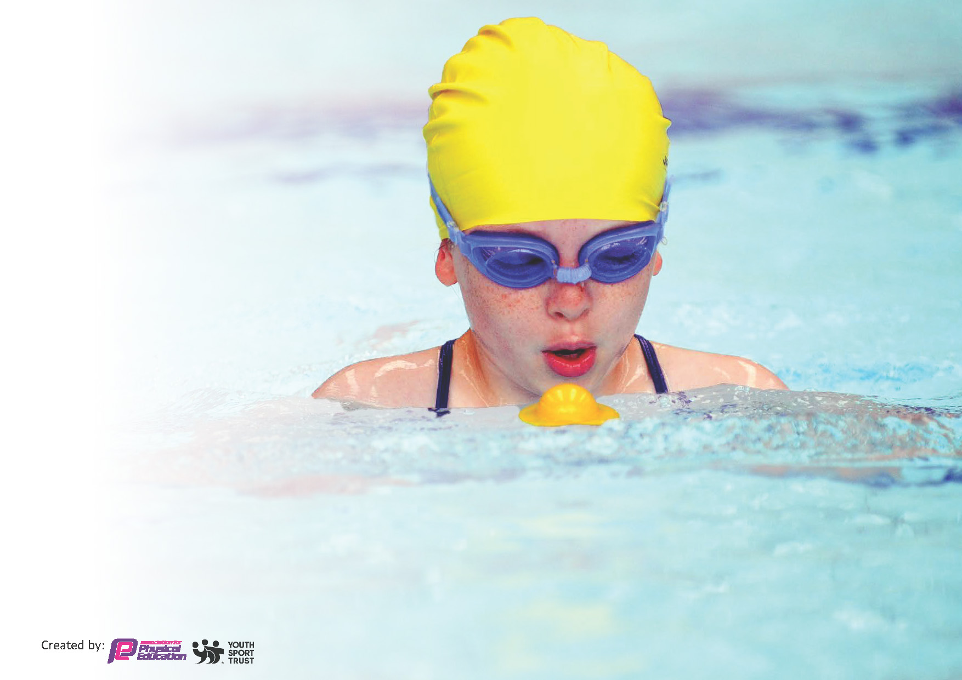
This template can be used for multiple purposes:
by:
- It enables schools to effectively plan their use of the Primary PE and sport premium
- It helps schools to meet the requirements (as set out in guidance) to publish information on their Primary PE and sport premium
- It will be an effective document to support Ofsted inspections enabling schools to evidence progress in Physical Education (PE) and evidence swimming attainment, which forms part of the PE National Curriculum. We would recommend schools consider
the Intent, Implementation and Impact of any spend, as examined within the Education Inspection Framework.

It is important that your grant is used effectively and based on school need.

Schools must use the funding to make additional and sustainable
improvements to the quality of the PE, School Sport and Physical Activity (PESSPA)
they offer. This means that you should use the Primary PE and sport premium to:

- Build capacity and capability within the school to ensure that improvements made now will benefit pupils joining the school in future years
- Develop or add to the PESSPA activities that your school already offers.

The Primary PE and sport premium should not be used to fund capital spend projects; the school’s core budget should fund these. Further detail on capital expenditure can be found in the updated Primary PE and sport premium guidance.

The Primary PE and sport premium guidance, outlines 5 key priorities that funding should be used towards. It is not

necessary that spending has to meet all the key priorities, you should select the priorities that you aim to use any funding towards.

Although completing this template is not a requirement for schools, schools are required to publish details of how they spend this funding. Schools must also outline what the impact this funding has had on pupils’ PE and sport participation and attainment and how any spending will be sustainable in the future. All funding must be spent by 31st July 2024.

The Department for Education has worked closely with the Association for Physical Education (afPE) and the Youth Sport Trust (YST) to develop this template and encourages schools to use it. This template is an effective way of meeting the reporting requirements of the Primary PE and sport premium.

Review of last year’s spend and key achievements (2023-2024): Newquay Junior Academy
/2023)

We recommend you start by reflecting on the impact of current provision and reviewing your previous spend.

Activity/Action | Impact | Comments
Key indicator 1: Increased confidence, knowledge and skill of all staff in teaching PE and Sport.  Key indicator 2: Engagement of all pupils in regular physical activity.  Key indicator 3: The profile of PE and sport is raised across the school as a tool for whole school improvement.  Key indicator 4: Broader experience of a range of sports and activities offered to all pupils.  Key indicator 5: Increased participation in competitive sport | 96% of pupils are working at or above age expectation by July 2024.  100% of pupils were engaged in at least 30 minutes of physical activity a day.  NJA has a strong reputation for PESSPA. Pupils working at or above expected in Reading: 88%, Writing: 84%, Maths: 83%  36 sporting competitions and activities attended this year. 24 topics covered withing the PE curriculum. 46 sports clubs and activities were offered as extracurricular provision. 400 pupils attended an extra-curricular activity. External coaches worked within the academy.  - 400 pupils (76%) attended an extracurricular club.  - 65 pupils (72%) with SEND attended a club.  - 62 pupils (91%) with Pupil Premium attended a club  100% of pupils participated in the two intra-class events throughout the year. 331 pupils represented NJA at events hosted off-site. | Continue to develop the PE curriculum so it reflects the needs of our pupils. Continue to provide CPD to all staff.  Continue to raise the profile of DrEAM breaks, physical activity and the link to mental health. Increase engagement with disadvantaged pupils.  Continue to raise the profile of PESSPA and ensure ALL staff know the benefits.  Continue to develop and improve links with community coaches and clubs. Use ‘pupil voice’ to see what else pupils would like to try / participate in. Big push on Disadvantaged pupils and pupils with SEND.  Develop inter-house events, which focus on teamwork, respect and resilience.

Key priorities and Planning: Newquay Junior Academy: £ 20,910
This planning template will allow schools to accurately plan their spending.

Action – what are you planning to do | Who does this action impact? | Key indicator to meet | Impacts and how sustainability will be achieved? | Cost linked to the action
The PE leader will continue to construct and develop a curriculum that is ambitious and ensures that all pupils, particularly disadvantaged pupils and pupils with SEND, are engaged in regular physical activity. Our aim is for all pupils to undertake at least 30 minutes of physical activity a day. | - The lower KS2 curriculum will be updated with a focus on refining fundamental movement skills and preparing pupils for sports specific focus in Upper KS2.  - All teaching staff will receive CPD so they are able to consistently deliver ‘good’ and ‘outstanding’ lessons throughout a broad and balanced P.E. curriculum.  - All learning support staff will receive targeted CPD so they are able to support ALL pupils within their P.E. lessons.  - All staff will facilitate and deliver daily DrEAM (DRop Everything And Move) breaks.  - The PE lead will ensure there is ‘active’ play, lunchtime and wrap-around provision.  - All pupils will participate in a broad and balanced PE curriculum.  - All pupils will be physically active for at least 30 minutes a day.  - Purchase quality equipment, to increase daily physical activity levels.  - Identified pupils will receive daily morning ‘fun fit’ sessions | Key indicator 1: Increased confidence, knowledge and skill of all staff in teaching PE and Sport.  Key indicator 2: Engagement of all pupils in regular physical activity.  Key indicator 4: Broader experience of a range of sports and activities offered to all pupils. | Target  100% of staff can deliver ‘good’ and ‘outstanding’ PE lessons. All staff will feel more confident in delivering PE and school sport.  Target  100% of pupils in each year group are working at or above age expectation by the end of the year, with 30% of pupils in each year group working above age expectation.  Target  100% of pupils are engaged in at least 30 minutes of physical activity a day.  Target  To continue to improve the provision for our disadvantaged pupils and pupils with SEND. | PE Specialist: £15,000

The PE leader will continue to develop the curriculum to ensure it is coherently planned and sequenced towards cumulatively sufficient knowledge and skills for future learning and employment. | - The PE specialist will design, develop, implement and monitor a PE curriculum that includes:  - The development of life skills that are transferable to all areas of the curriculum.  - Explicit links to 'The Blue Six’ model and the trust’s continuing work on Metacognition and Self-Regulated Learning. This will include Improving pupils’ oracy and metacognitive knowledge.  - Ensuring that all PE lessons start with and refine the pupil’s fundamental movement skills.  - Embedding the use of Flashback Fours within PE lessons.  - A focus on developing ‘good’ mental and physical health.  - All staff will deliver and / or support PE to ensure that skills taught within PE are transferred to other curriculum areas whilst continuing to focus on the trusts work regarding peer coaching and mentoring.  - All pupils will receive guidance on how to use and apply transferable skills in other areas of the PE curriculum, as well as other subject areas. | Key indicator 3: The profile of PE and sport is raised across the school as a tool for whole school improvement.  Key indicator 1: Increased confidence, knowledge and skill of all staff in teaching PE and Sport. | Target  PE planning will show how the language for learning is being developed and can be transferred to other curriculum subjects.  Target  All pupils will use sentence stems and be able to articulate their learning.  Target  Improved outcomes in reading, writing and math’s. | PE Specialist: £15,000 (as above)
The PE specialist will ensure all teachers have a thorough knowledge of the curriculum being taught within the academy. | The PE specialist will:  - collaboratively plan, deliver and assess high quality lessons to provide CPD to non - specialist PE teachers.  - Provide training for teachers so that they can check pupils’ understanding systematically, identify misconceptions accurately and provide clear, direct feedback.  - Provide training so that teachers use assessment well to help pupils embed and use knowledge fluently, and to check understanding and inform teaching.  Teachers will:  - check pupils’ understanding systematically, identify misconceptions accurately and provide clear, direct feedback.  - help pupils embed and use knowledge fluently, and to check understanding and inform teaching. | Key indicator 1: Increased confidence, knowledge and skill of all staff in teaching PE and Sport. | Target  Maintain 90% of observed PE lessons to be judged as at least good and ensure 30% are outstanding.  Target  Target pupils who are not working at ‘age expected’ in PE and provide interventions to further support these pupils.  Target  100% of pupils in each year group are working at or above age expectation by the end of the year, with 30% of pupils in each year group working above age expectation.  Target  Ensure all staff use adaptive teaching to ensure ALL pupils make progress. | PE Specialist: £15,000 (as above)
Maintain and increase the profile of physical activity and competitive sport within the academy. Ensure pupils participate in external festivals and competitions. | - Newquay Junior Academy will be part of the Newquay Sports Network Group.  - The PE Lead will attend termly NSN meetings.  - NJA will attend all NSN events and where possible take additional teams.  - NJA will participate in all CELT sports events.  - NJA will offer a wide provision of both lunchtime and after-academy clubs giving ALL pupils the opportunity to attend and participate in a club.  - The PE lead will facilitate inter-class competitions throughout the year, giving ALL pupils opportunities to participate in competitive sport.  - Lunchtime playworkers will promote physical activity at break time and lunch times.  - Ensure local clubs deliver activities in both curriculum and extra-curricular time i.e. kickboxing, dance.  - The PE specialist will continue to develop links with local community clubs and share information regarding these clubs with NJA families.  - The PE specialist will promote, advertise and lead national incentives that promote being physically and mentally healthy i.e. walk to school week, mental health day etc.  - The PE lead will acknowledge and celebrate inspirational sporting role models by having visual displays within the academy as well as arranging to have inspirational speakers come into the academy to speak / work with pupils. | Key indicator 2: Engagement of all pupils in regular physical activity.  Key indicator 3: The profile of PE and sport is raised across the school as a tool for whole school improvement.  Key indicator 4: Broader experience of a range of sports and activities offered to all pupils.  Key indicator 5: Increased participation in competitive sport | Target  NJA to attend all NSN and CELT events.  Target  To offer a varied and enriched extracurricular programme.  Target  100% of pupils to participate in inter-house events and Sports Days.  Target  80% of disadvantaged pupils participate in after-academy clubs or competitions.  Target  80% of SEND pupils to participate in extra-curricular clubs or competitions.  Target  To recognise and participate national initiatives that will support our pupils with their mental and physical health.  Target  To share and promote local sports and activity clubs with our NJA families.  Target  To share the journeys of aspirational sporting role models from a variety of localities (local, national, international). | NSN Membership: £2500  Equipment for extra-curricular provision: £1500  External coaching specialists: £1110
Raise attainment in swimming to enable all pupils to meet the requirement of the National Curriculum Programme by the end of KS2. | - Pupils who are unable to swim 25m after participating in our lower KS2 swim programme will be identified and targeted with additional intensive swimming lessons.  - 1 week of intense daily one-hour sessions.  - Developing learning support’s confidence to support pupils in the water, particularly, pupils with SEND and / or complex needs.  - All pupils in year 5 will participate in the nationally recognised ‘Float to Live’ initiative, this will be led by our outdoor lead. | Key indicator 4: Broader experience of a range of sports and activities offered to all pupils. | Target  100% of our Year 6 cohort can swim competently, confidently and proficiently over a distance of at least 25 metres.  Target  All pupils in Year 5 and Year 6 understand the concept of ‘float to live’ and are able to demonstrate this whilst being in the ocean. | Top-Up Swimming: £800  Total: £20,910

Key achievements 2024-2025: Newquay Junior Academy
This template will be completed at the end of the academic year and will showcase the key achievements schools have made with their Primary PE and sport premium spending.

Activity/Action | Impact | Comments

Swimming Data: Newquay Junior Academy
Meeting National Curriculum requirements for swimming and water safety.
Priority should always be given to ensuring that pupils can perform safe self-rescue even if they do not fully meet the first two requirements of the National Curriculum programme of study

Question | Stats: | Further context  Relative to local challenges
What percentage of your current Year 6 cohort can swim competently, confidently and proficiently over a distance of at least 25 metres? | TBC
What percentage of your current Year 6 cohort can use a range of strokes effectively [for example, front crawl, backstroke, and breaststroke]? | TBC | Use this text box to give further context behind the percentage.

What percentage of your current Year 6 cohort are able to perform safe self-rescue in different water-based situations? | TBC
If your schools swimming data is below national expectation, you can choose to use the Primary PE and sport premium to provide additional top-up sessions for those pupils that did not meet National Curriculum  requirements after the completion of core lessons. Have you done this? | TBC
Have you provided CPD to improve the knowledge and confidence of staff to be able to teach swimming and water safety? | TBC

Head Teacher: | Craig Hayes
Subject Leader or the individual responsible for the Primary PE and sport premium: | Holly Rai – PE Lead
Governor: | Sean Dixon
Date: | 4th October 2024

