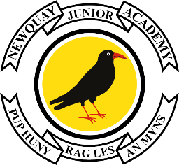



23rd September 2024

Dear Parents and Carers,

**Year 3 – Gannel Walks**

Year 3 will be visiting the Gannel next week, as part of their geography sessions on exploring rivers.

On their trip day, pupils need to wear their PE kit, bring a waterproof coat, drink and snack.

They will also need a pair of old trainers/wellies and spare socks to change into.

The classes are scheduled to go on the following days during the morning, and they will return for lunch and home times as usual:

|  |  |
| --- | --- |
| **The Ganel Visit** |  |
| Tuesday 1st October | 3JJ |
| Wednesday 2nd October | 3JKR |
| Thursday 3rd October | 3JR |
| Friday 4th October | 3CS |

On their trip day:

* Pupils should wear their PE kit including PE Hoody or academy jumper.
* Bring a water bottle and a waterproof coat.
* Bring a pair of old trainers or wellies to wear and socks to change into afterwards.

If there are any updated medical concerns or changes of contact numbers for the visit day, please inform the academy office.

Thank you for your continued support.

Yours sincerely,

Year 3 Team

