
Christianity Knowledge Organiser – Autumn Term 1
Year 6 – Pupil Version

Unit U2.1 What does it mean if Christians believe God is holy and loving? (God)
Key Vocabulary  God The all-powerful and all-loving being that Christians believe created the world and everything in it.  Holy God is morally pure and hates sin – God is separate from human beings who are sinful.  Loving God wants the very best for human beings and does a lot to care for them.  Omnipotent God is all-powerful (unlimited power).  Omniscient God knows all things (knowing everything).  Prayer A spiritual communication with God.  Eternal God created time and is not limited by it – God does not get old like human beings.  Overview – Sequence of lessons (Learning Objectives)  1. To explain connections between biblical texts and Christian ideas of God.  2. To explain connections between biblical texts and Christian ideas of God.  3. To explore what cathedrals show about God.  4. To reflect on Christian, Humanist and my own guidelines for living life.  5. To understand what it means if Christians believe God is holy and loving. |  |  | Knowledge Building blocks PUPILS WILL KNOW THAT:  • Christians believe God is omnipotent, omniscient and eternal, and that this means God is worth worshipping.  • Christians believe God is both holy and loving, and Christians have to balance ideas of God being angered by sin and injustice (see Fall) but also loving, forgiving, and full of grace.  • Christians do not all agree about what God is like, but try to follow his path, as they see it in the Bible or through Church teaching.  • Christians believe getting to know God is like getting to know a person rather than learning information.  The Holly Bible is the world’s best-selling book – It’s made up of 66 short books (poems, songs, stories, letters and predictions) written by 40 different authors. The Bible tells us about God and the world that he created, and how God loves people and wants to be our friend.  The Old Testament – 39 books that teach us about how the world was made by God, and how the people he chose to live a holy life (Israelites).  The Holy Trinity  -Christians believe that God can be seen in three ways, known as the Holy Trinity:  -The Father – Creator of the world;  -The Son – Who came to Earth as Jesus;  -The Holy Spirit – God’s power within Christians.  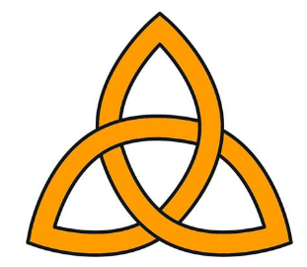  The New Testament – 27 books with stories about Jesus (God’s son) and what he did and said. It also talks about how the church was started by his followers (Christians). It also spreads the message of God’s love.
The Big Frieze - The ‘big story’ of the bible is divided into 8 key concepts. The first concept in the ‘big story’ of salvation is God. Christians believe that God is the Father, Son and holy spirit (holy trinity).
Creation | Fall | People of God |  | Incarnation | Gospel | Salvation | Kingdom of God
