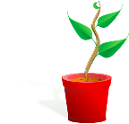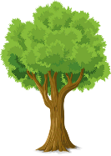

**PARTS OF A PLANT**

**FLOWERS**

**The flowers are often brightly coloured and smell to attract insects. Insects help with the plants reproduction through pollination.**

**LEAVES**

The **leaves** use light from the sun, along with carbon dioxide from the air and water to make food for the plant. This process is called photosynthesis.

**STEM / TRUNK**

The **stem** carries water and nutrients to different parts of the plant. They keep the plant upright.

**ROOTS**

The **roots** of a plant take up water and nutrients from the soil. The roots also keep the plant steady and upright in the soil; they "anchor" the plant.

**What does a plant need to grow?**

Plants

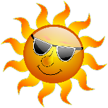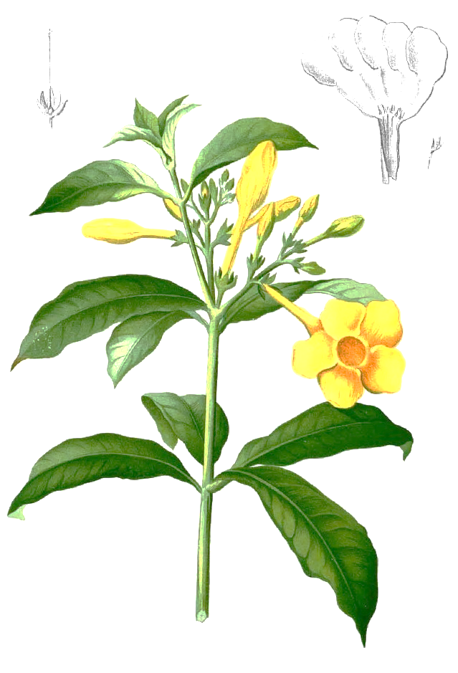

Smaller plants find it hard to survive when larger plants take up space. They block out sunlight and take nutrients and water from the soil.

light

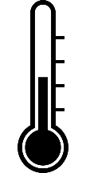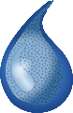

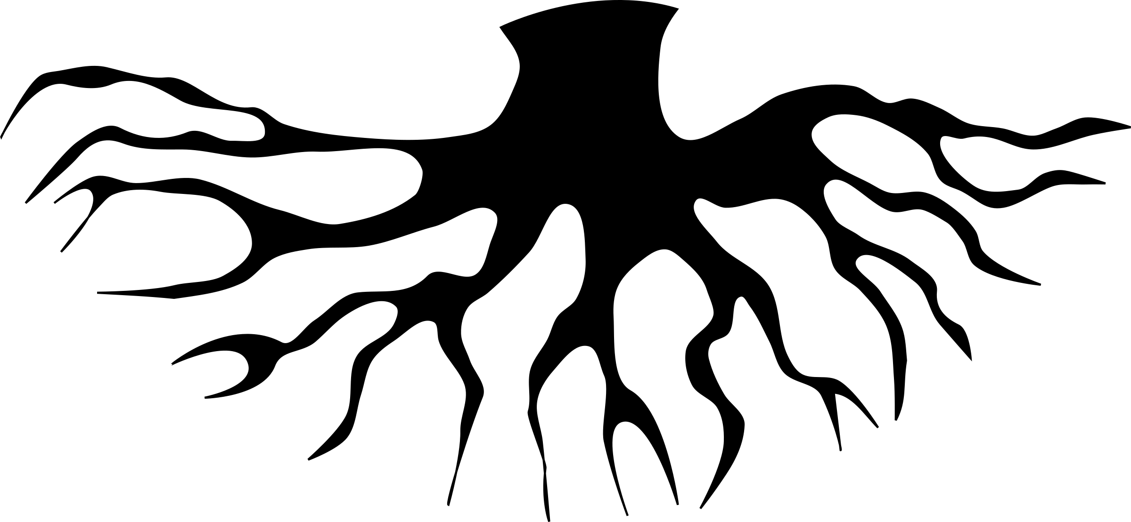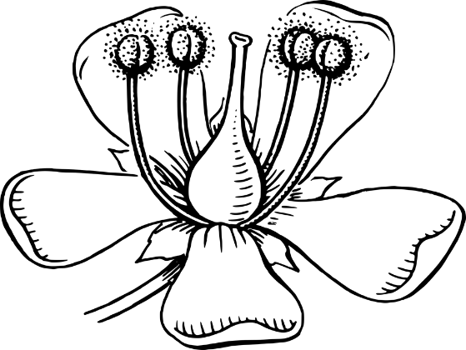

filament

stigma

anther

**PARTS OF A FLOWER**

nutrients

water

warmth

stem

leaves

flowers

Not all plants produce flowers. These non-flowering plants, such as Ferns and mosses. They grow from spores instead of seeds. Non-flowering plants as well as flowering plants make their own food through photosynthesis.

**PLANT REPRODUCTION**

**Pollination -** Pollen is carried by insects or blown by the wind from one flower to another. This process is called **pollination**.

**Fertilisation -** Pollen reaches the carpel of the new flower. Pollen then travels to the ovary where it fertilises egg cells (ovules) to make seeds. This process is called **fertilisation**.

**Seed Dispersal -** The seeds are scattered by animals or the wind. This process is called **dispersal**. Some of the seeds will grow into new plants.

air

roots

style

ovary

sepal

stem

petal

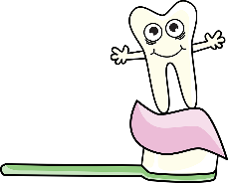

**TOOTH DECAY**

Muscles

Skeletons move because bones are attached to muscles.

When a muscle **contracts** (bunches up), it gets shorter and so pulls up the bone it is attached to.

When a muscle **relaxes**, it goes back to its normal size.

The Skeleton and Muscle System

1.) Tooth decay is the destruction of your tooth enamel

2.) Milk is a good source of calcium and good for your teeth.

3.) Plaque, a sticky film of bacteria, constantly forms on your teeth.

4.) When you eat or drink foods containing sugars, the bacteria in plaque produce acids that attack tooth enamel.

5.) Tooth ache and bad breath are symptoms of tooth decay.

**skull**

(protects the brain)

**collar bone**

(connects the arms to the body)

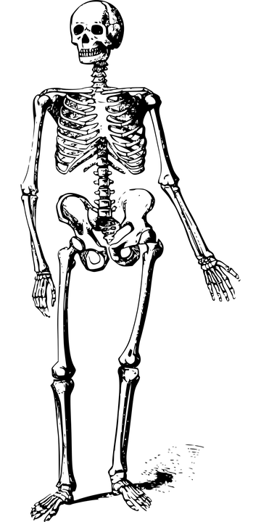

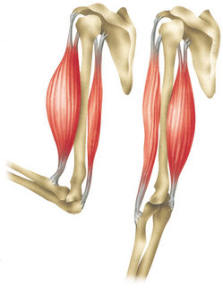

**shoulder** (joint)

**contracted**

**ribcage**

(protects the lungs and heart)

**elbow** (joint)

**spine**

(keeps the body upright)

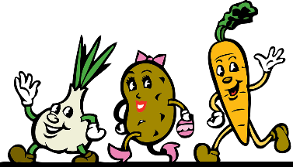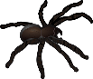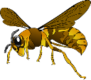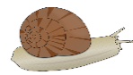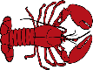Image result for microorganism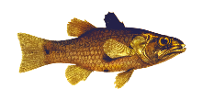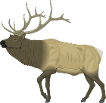

**ankle** (joint)

**knee** (joint)

**wrist** (joint)

**pelvis**

(balance and support the legs)

**Invertebrates** (no internal skeleton)

**HEALTHY EATING**

To keep your body fit and healthy you need a balanced diet using all of the food groups.

**Carbohydrates** – Main source of energy for our bodies (rice, potatoes, pasta and bread).

**Protein** – Repairs and builds muscles, organs and immunity (fish, meat, eggs and cheese).

**Sugar and Fats** – Stored for energy and creates a layer of fat to keep us warm. Should not have too much of these (chocolate, sweets, butter, oil, cream).

**Vitamins and Minerals** – Keeps us growing and fighting infections (fruit and vegetables).

**relaxed**

The skeleton protects our internal organs, keeps us supported and helps us move.

**Vertebrates** (internal skeleton)

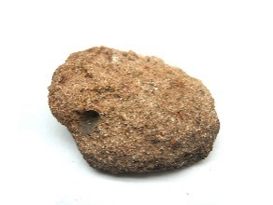

**What is soil made from?**

Rocks and Soils

SEDIMENTARY

These rocks form under the sea. Rocks are broken into small pieces by wind/water (**erosion**). They settle as mud, sand, minerals and even remains of living things. Over time, layers pile up and the pressure turns this **sedimen**t into rock.

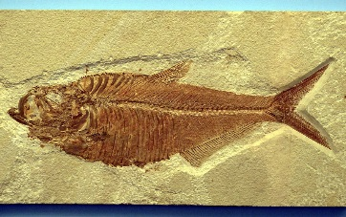

FOSSILS

**AIR** – Oxygen, carbon dioxide, nitrogen etc.

limestone

chalk

sandstone



**ORGANIC MATTER** – Living and dead plants and animals.

**lava**

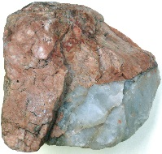

A fossil is the remains or the impression left by a prehistoric plant or animal embedded in rock.

It takes place in sedimentary rock because the heat from lava and magma in igneous and metamorphic rock would be too high for fossils to survive.

**WATER** – Air and water fill the gaps between particles of soil.

Igneous

Far underground, the temperature is so hot, rock melts into a liquid (molten rock).

When the liquid is underground it is called ‘**magma**’ and it can cool to form an intrusive rock. When it spills out (volcano), the liquid is called ‘**lava**’ and it cools to form extrusive rock.

. Heat proud

Drop, Water, Liquid, Purity, Clean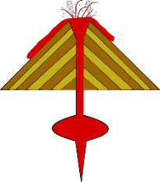

**MINERALS** – Minerals come from broken down rock.

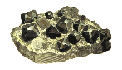

obsidian

granite

basalt

**magma**

**1.)** An animal, creature or plant dies and ends up at the bottom of the sea. It gets covered in a layer of rock.

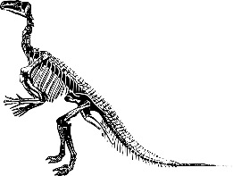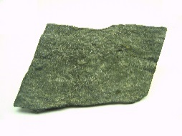

MAN-MADE ROCKS (ANTHROPIC)

These rocks are made by humans.

***CONCRETE*** – a mixture of water, sand/rock/gravel and cement (chalk & clay)

***BRICKS*** – Clay soil, sand or lime which have been air-dried or fire-hardened.

***MOCK ROCK*** – Victorians made rock gardens and surfaces that looked like rock.

METAMORPHIC

When sedimentary or igneous rock is near magma, it **heats** up and chemicals change in the rock. However, it does not heat up enough to melt it. As it cools it becomes metamorphic rock.

marble

quartzite

slate

**PROPERTIES OF ROCKS**

**1.)** HARD / SOFT – Some rocks need to be cut or split with tools because they are so hard (e.g. granite) but others are soft and can be moulded (e.g. clay).

**2.)** PERMEABLE / IMPERMEABLE – Permeable rocks allow water to pass through (e.g. pumice) but impermeable rocks do not let water pass through (e.g. marble)

**3.)** DURABLE – Rocks which are resistant to erosion last longer and are more durable. Buildings are often made with these (e.g. limestone)

**4.)** DENSITY – If the particles in the rock are tightly packed then it has a high density. These rocks would sink in water (e.g. basalt).

**2.)** Over time, more layers of rock form on top and the only thing which would remain are the bones or the space where the bones used to be (mould fossils).

**3.)** Sometimes sediment enters the space where the bones used to be and takes the shape of the creature (cast fossil).

**4.)** Over a long period, the sea may recede / go back leaving the rock.

**5.)** Erosion and weathering of the rock means the fossil can now be seen!

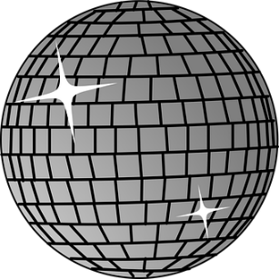[](https://www.google.co.uk/url?sa=i&rct=j&q=&esrc=s&frm=1&source=images&cd=&cad=rja&uact=8&ved=0ahUKEwiyxf3r-bXRAhVEthQKHV0nAaUQjRwIBw&url=https://pixabay.com/en/rainbow-default-colors-948520/&bvm=bv.143423383,d.ZGg&psig=AFQjCNFuc_wXTIyyR8EMNftlxpFh79D--w&ust=1484081811112047)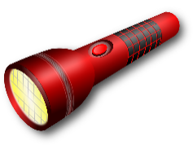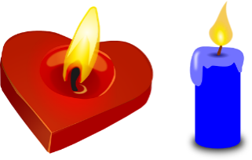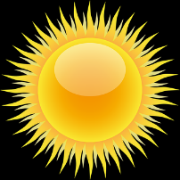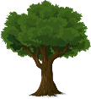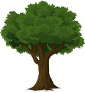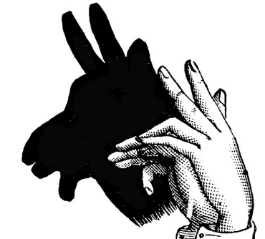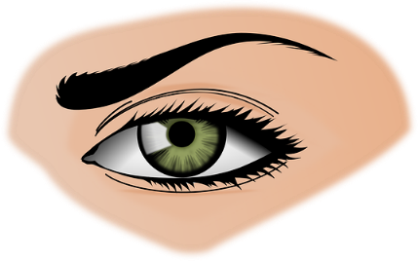

A mirror is not a light source.

It reflects light so doesn’t create it.

As the earth spins and the sun sets in the west in the evening, the shadow is long.

Light

Because light travels in straight lines, when it hits an object, it is blocked. It can’t bend around the object so it casts a shadow.

**LIGHT SOURCES**

**ROY G. BIV**

Rainbows are formed when the sun shines through water particles (transparent) and when white light passes through,

it 'bends' and splits into the range of colours which

make white light

***Opaque:*  This is the name given to objects which light *cannot* travel through. They block light and create shadows**

***Translucent:* This is the name given to objects which *some light can* travel through.**

***Transparent:* This is the name given to objects which light *can* travel through.**

When light hits a smooth object, it bounces off (reflects) making it appear shiny.

As the earth continues to spin the sun is overhead by midday. Because the sun hits the object from above, the shadow is short.

As the earth spins, it makes the sun appear to rise in the east in the morning. Because the sun hits an object at an angle, the shadow is long.

**1.)** We can see objects because light reflects off them and into our eyes.

**2.)** Light reflects off most objects, especially colours like white and yellow.

**3.)** If there is no light at all (pitch-black), then there is no light to reflect and we can’t see anything at all.

**4.)** At night you can still see a bit in the dark because the moon is reflecting light.

Light travels in straight lines. It travels from the light source either directly into our eyes, or reflecting off objects at 670 million mph.

**What is a Magnet?**

A magnet is a special object which produces an area of magnetic force around itself called a ***magnetic field*.**

If a ***metal*** object enters this magnetic field, they will be attracted towards the magnet and end up sticking to it. (Non-metallic objects such as wood, plastic or fabric would not be attracted to it.)

**Here is a range of different magnets:**

Forces and Magnets

**PUSHING AND PULLING**

A force is a push or pull acting on an object as a result of the object’s interaction with another object. Forces can make objects stop or start moving.

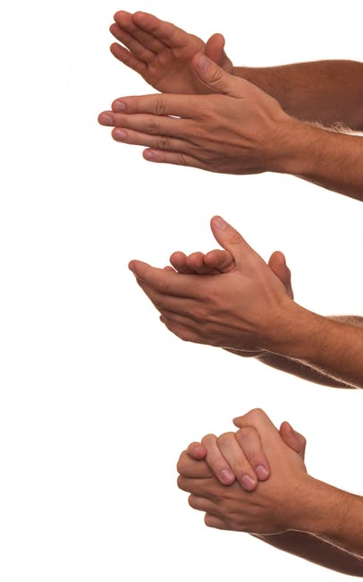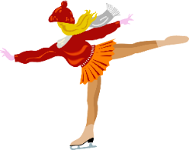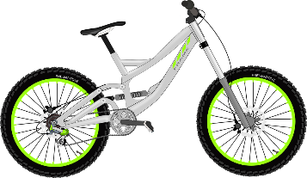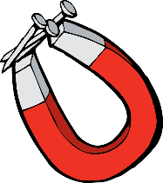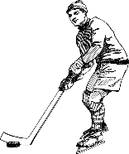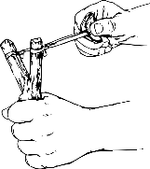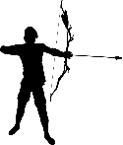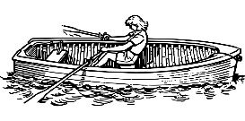

**FUN FACTS ABOUT MAGNETS**

* The most powerful magnet in the universe is a star called ‘Magnestar’.
* Animals can be affected by magnetic pulls. Birds and turtles navigate by them and sharks are repelled by them!
* Earth’s core is said to be filled with iron and nickel (metals which give it a magnetic field).

## The Same poles repel / The opposite poles attract

If you try to put two magnets together with the **same** poles pointing towards one another, the magnets will push away from each other. We say they ***repel*** each other. Opposite poles ***attract*** and are brought together.

Inside a compass is a small magnetic pin which constantly points north.

Earth has a natural magnetic field which means the pin turns to always face north and helping people find their way.

S

E

W

N

**Magnetic Poles**

When two magnets are close, they create pushing or pulling **forces** on one another. These forces are strongest at the ends of the magnets. The two ends of a magnet are known as the **north pole** (N) and the **south pole (S).**

**Friction**

When objects are pushed or pulled, an opposing force can be felt. This opposite force is called ‘friction’. Friction causes things to slow down or stop. The grip on our shoes stops us slipping. Therefore, friction is great.

Ice-skates on an ice-rink will move for a long time because there is very little friction. The rougher the surfaces, the greater the friction.

This rubbing of two surfaces can release energy, causing heat. (Try rubbing your hands together!)

Cylindrical Ring Arc / Crescent

Bar Button Horseshoe

Pull

PUSH