
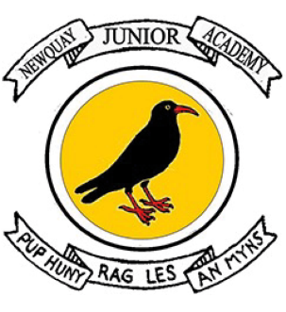

History Introduction Statement
We believe high-quality history education stimulates curiosity and helps children to understand the complexity of people’s lives, process change, the diversity of societies and relationships between different groups, as well as their own identity and the challenges of their time.
Through our History curriculum, which covers the full national curriculum for KS2, we develop the skills, knowledge, understanding and vocabulary that pupils need to think and talk as an historian. We strive for a curriculum which enables pupils to develop a sense of identity and cultural understanding based on their own historical heritage and that of others. From September 2024 we have adopted the ‘Opening Worlds’ Curriculum as we believe that this is this provides our children with the breadth and depth of world history to enable them to become successful, respectful members of society, with positive behaviours who live informed, enriched lives.
Through our history teaching, pupils learn to value their own and other people’s cultures in modern multicultural Britain and, by considering how people lived in the past, they are better able to make their own life choices today and as they grow and to play a part in designing the future as a citizen of the world. In our school, history makes a significant contribution to citizenship education by teaching about the development of democratic societies. We teach children to understand how events in the past have influenced our lives today; we also teach them to investigate these past events and, by so doing, to develop the skills of enquiry, analysis, interpretation and problem-solving.

