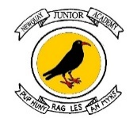

9th November 2023

Dear Parents and Carers,

Year 5 – Christmas Concert – Thursday 14th December 2023

We are delighted to invite you to our Year 5 Christmas Concert. Year 5 are learning the songs in class and are keen to share their seasonal cheer, after a busy term learning all about Space.

Parents and Carers can attend the Year 5 Christmas Concert on Thursday 14th December at 10am. The performance will be held in the Edge Hall. Please arrive at 9.50am at the side of the Edge Hall and we can welcome you.

We appreciate that not every family will be able to attend due to work and previous commitments, however we hope to welcome as many families as possible.
If you have any queries about the event, please contact your child’s class teacher directly.
We thank you for your continued support and we look forward to sharing our Year 5 Christmas Concert with you all.

Yours sincerely,

Year 5 Team.

