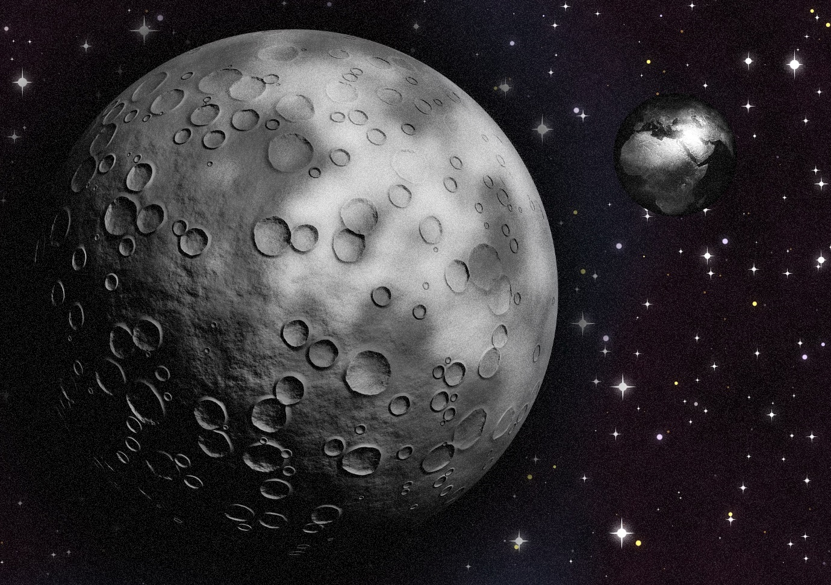

Knowledge Organisers
Year 4 Science

Newquay Junior Academy

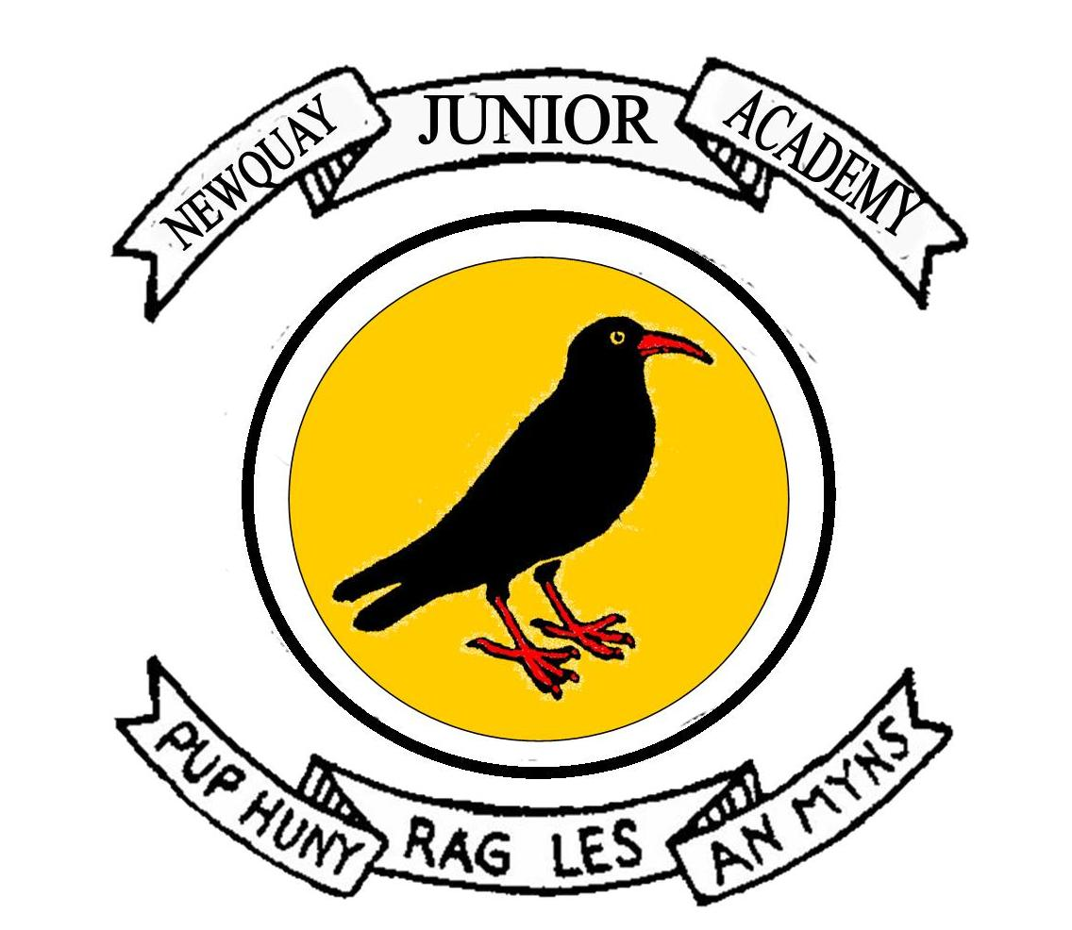

Contents

Living Things and Their Habitats | p3
The Digestive System and Teeth | p4
States of Matter | p5
Sound | p6
Electricity | p7

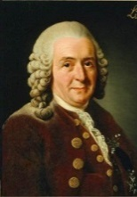
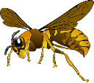
MRS GREN

M.R.S. G.R.E.N. is a useful way to remember the necessary features of
living organisms.

MOVEMENT
It can change its position.
RESPIRATION
It releases energy from a food
source.
SENSITIVITY
It responds to things (e.g. light).
GROWTH
It can develop and get larger.
REPRODUCTION
It can make copies of itself or produce offspring.
EXCRETION
It can get rid of waste products.
NUTRITION
It consumes chemical material / food.

Living Things and Their habitats
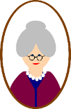
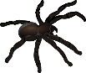

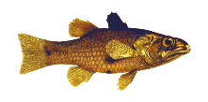

Carl Linnaeus simplified the naming of living things in 1735. Names of living things were often very long so he gave them a two-part (binomial) name. It was a mixture of genus and species (and in Latin) e.g. Human was Homo Sapien, Wolf was Canus Lupus and Lion was Felis Leo.
Invertebrates (no backbone)
In about 350 B.C. Aristotle (a Greek philosopher) classified all things into 4 main groups.
Vertebrates (backbone)

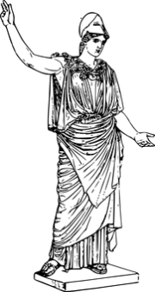
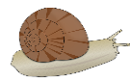


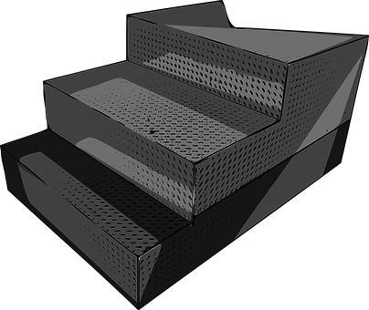


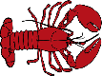
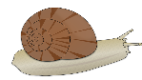

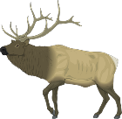
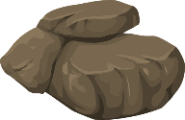

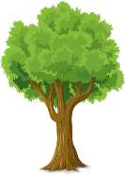
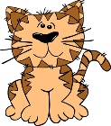
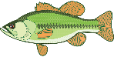
Human Beings
Animals (cats and fish)
Plants (trees and grass)
Non-Living (rocks)
Man-Made Threats to the Environment
1.) Air pollution – Petrol and diesel used to power motor vehicles release carbon monoxide – a poisonous and harmful chemical. The burning of fossil fuels contribute to environmental damage too.
2.) Water pollution – Industrial waste and run-off from farming, which often uses fertilisers, can pollute rivers and streams.
3.) Rubbish –Plastic and household waste ends up on the streets, in the sea or in rubbish dumps, destroying habitats and wildlife.

Groups of Living Organisms

Mammals - warm-blooded, have hair on their bodies, parents care for the young, females produce milk for their babies, breathe through lungs, most are terrestrial (live on land) though some are aquatic (live in sea).
Birds - warm-blooded, most can fly, have feathers and wings, most build nests, hatch from eggs, most baby birds must be fed by parents and cared for until they can survive on their own (though some, like baby chickens and quail, can search for food a few hours after hatching)
Fish - aquatic animals, breath through gills, cold-blooded, most have scales, most develop from eggs that the female lays outside her body
Amphibians - live part of their life cycle in water and part on land, have gills when young, later develop lungs, cold-blooded, usually have moist skin.
Reptiles - hatch from eggs, cold-blooded, have dry, thick, scaly skin

Predators hunt and eat other animals. Prey are hunted by predators.
Decomposer
Feeds by decomposing the remains of living things.
FOOD
CHAINS
Consumer
Eats the producer. (Secondary consumers eat the primary consumer.)
Producer
Produced from an energy source (e.g. the sun) such as plants.

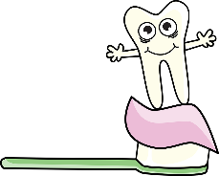
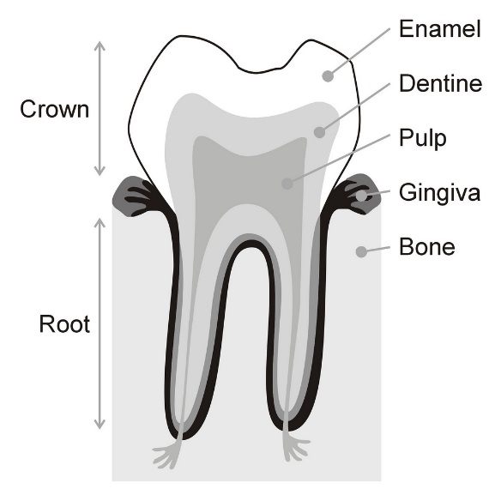
Parts of the Tooth
TOOTH DECAY
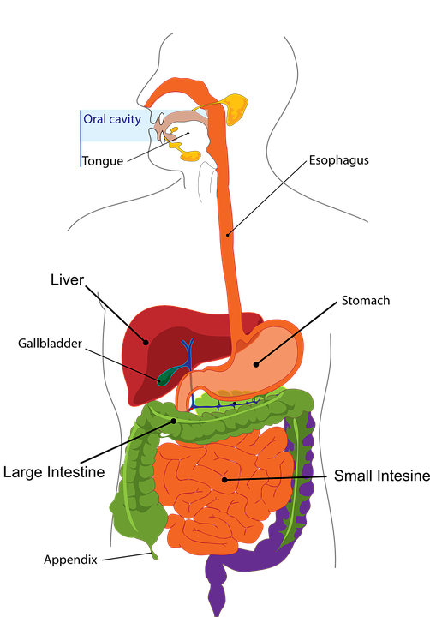
1
Oesophagus
Colon
The Digestive System and Teeth
1.) Tooth decay is the destruction of your tooth enamel

2.) It can be a problem for children, teens and adults.

3.) Plaque, a sticky film of bacteria, constantly forms on your teeth.

4.) When you eat or drink foods containing sugars, the bacteria in plaque produce acids that attack tooth enamel.

5.) Tooth ache and bad breath are symptoms of tooth decay.
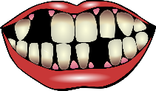
Mouth – Where food first enters the body. It is chewed and mixed with saliva, then swallowed.

Teeth – Used to break food into smaller pieces making it easier to swallow.

Oesophagus – Tube of muscle which connects the mouth to the stomach.

Stomach – Food is mixed with stomach acid
and broken down to form a liquid.

Enamel: The visible part of the tooth. It is harder than bone and protects the tooth.
Dentin: Found underneath the enamel and is similar to bone.
Pulp: Found in the centre of the tooth and is full of blood vessels and nerves. It supplies the tooth with nutrients.

Rectum – Any waste we do not need is stored here until it is ready to leave the body.

INCISORS – At the front of the mouth and used for biting
CANINES – Sharpest teeth. Next to incisors and used for tearing. Sharp and pointed in predators for killing prey.
PREMOLARS – Flat, wide and used for chewing towards the back of the mouth.
MOLARS – At the back of the mouth. Used for chewing and grinding food. Wide and flat in shape, including wisdom teeth at the back which appear in adulthood.
Intestines – Liquid from the stomach passes into the small and large intestines. This is where nutrients and water we need is passed into the blood stream and transported around our body

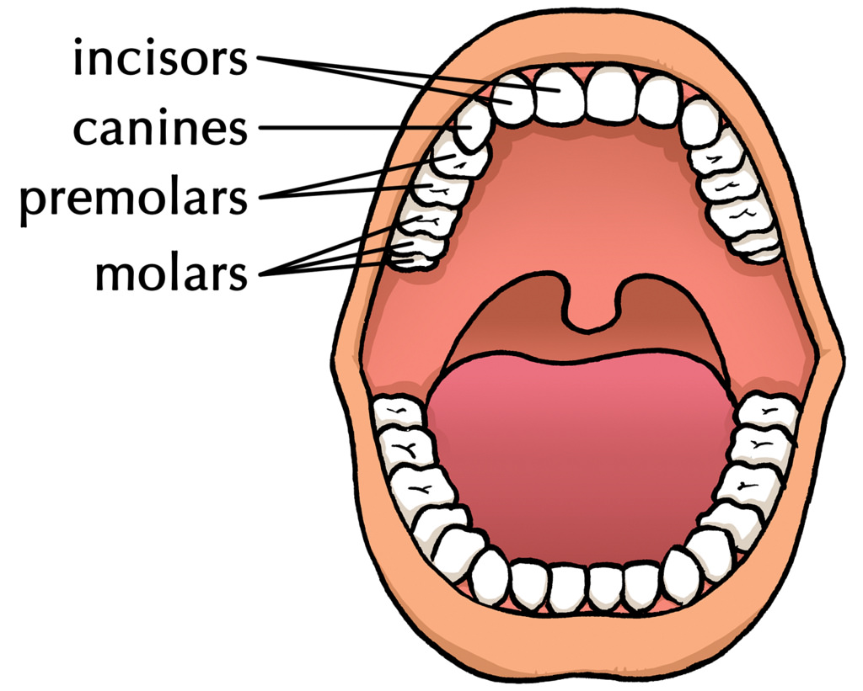

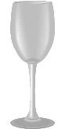
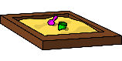
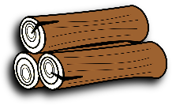
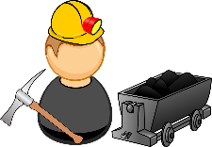
KEEPING COOL
Materials
Solids, liquids and gases are called the three states of matter. Materials can be changed from one state to another by heating or cooling.

Heating
- If ice (solid) is heated, it changes to water (liquid). This change is called melting.
- Water (liquid) can change to water vapour (gas). This is called evaporation.
- If water (liquid) is heated until it boils, it changes to water vapour (gas) very quickly. Water boils at 100°C.

Cooling
- If water vapour (gas) is cooled, it changes to water (liquid). This change is called condensing.
- If water (liquid) is cooled, it changes to ice (solid). This change is called freezing. Water freezes at 0°C.
CHANGING STATE
MAN-MADE
NATURAL
. Heat proud



Three states of matter
GAS: particles far apart and randomly arranged / move around
LIQUID: particles close but randomly arranged / move around
SOLID: particles very close together / vibrate around a fixed position


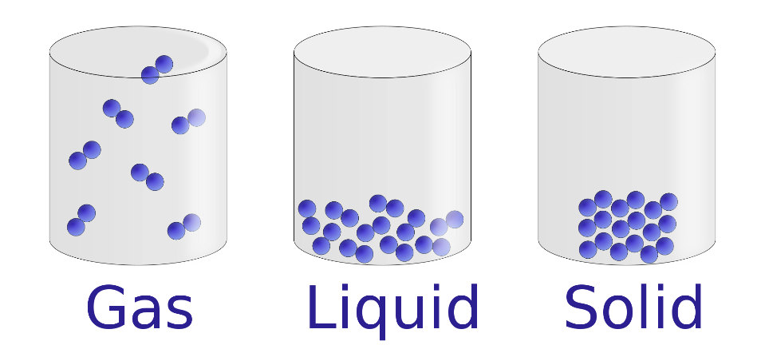
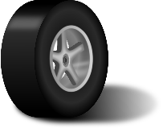

FREEZING
CONDENSATION
Examples
Ice
Wood
Glass
Diamond

MELTING
EVAPORATION

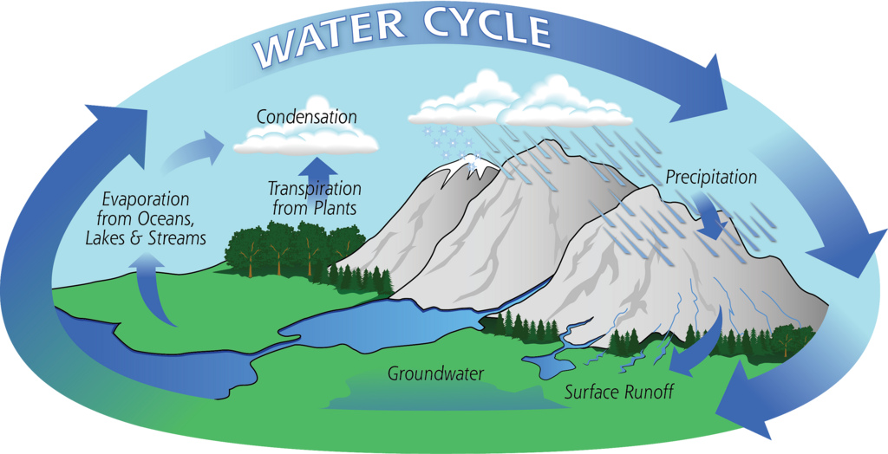
FEATURES

- Solids hold their shape. (Salt, sand and sugar are tiny solids so they pour like a liquid but they pile up and are nit wet.)

- Liquids form a pool not a pile!

- Gases escape from an unsealed container and fill the entire volume of space.
Examples
Water
Milk
Washing up liquid

Examples
Steam (water vapour)
Hydrogen
Carbon Dioxide
Oxygen

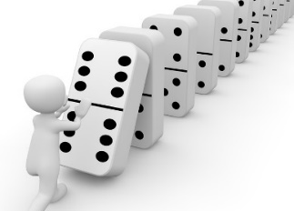

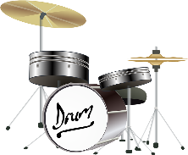
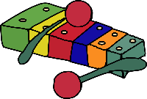
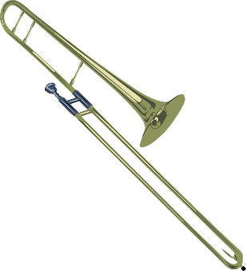
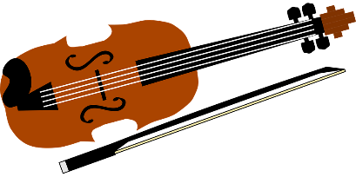
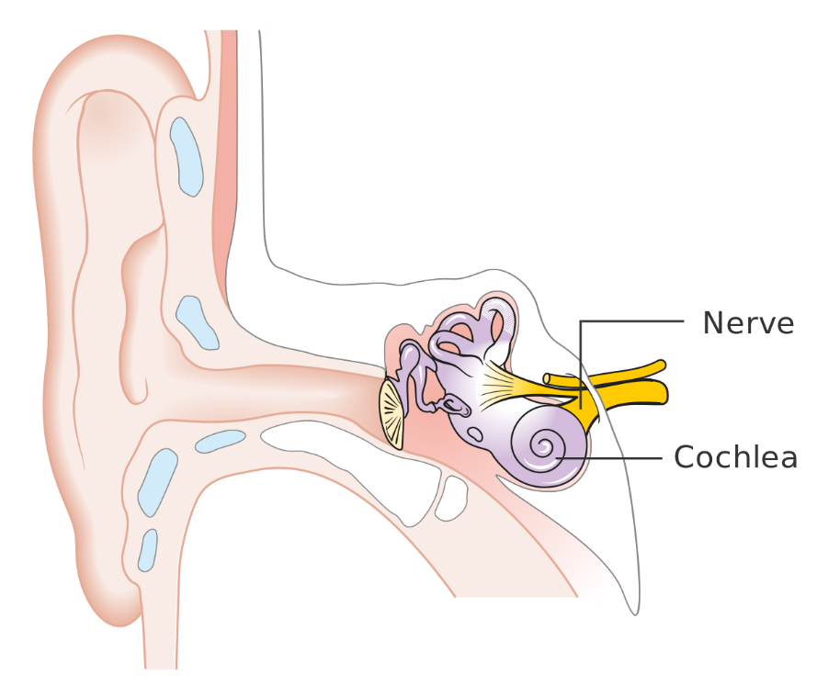
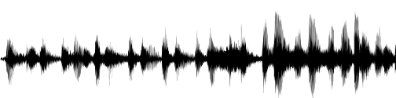
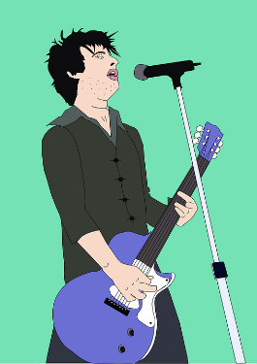
Sound travels better through some materials than others. It travels very well through metal pipes for example.

The louder the volume, the bigger the vibrations. The size of the vibration is called the amplitude. Quieter volumes have smaller amplitudes and louder sounds have larger amplitudes.

Sounds travel in a wave. The vibrations make air particles closes to the object vibrate, which then passes the vibrations to the particle next to it and so on – like dominoes
falling!
Sound vibrations can travel through different materials:

SOLIDS: metals, stone, wood
LIQUIDS: water
GASES: air

Outer Ear
Middle ear bones which include the hammer, anvil and stirrup. (The smallest bones in the human body!)

sends electrical signals to the brain.
DID YOU KNOW? Sounds get fainter (quieter) as the distance from the sound source increases.

DID YOU KNOW? Soundproofing is when a material is used to absorb loud sounds. Recording studios or night clubs might use them to stop sound escaping the room! Soft, spongey or pliable material is often best for this.
PITCH
The pitch of a sound is how high or how low it sounds. A high pitch has a high sound and a low pitch has a low sound.

Stringed Instruments
Tighter, thinner or shorter strings make higher pitches. Faster vibrations make pitches high and slower vibrations make pitches low.

Wind Instruments
The column of air inside the instrument causes it to vibrate. Shortening this makes a higher sound, lengthening it makes a lower sound.

Percussion Instruments
The surface is struck and it therefore vibrates. Smaller instruments have higher sounds (smaller keys of a xylophone, hand bells etc.). The tighter or thinner the skin on a drum, the higher the pitch.

contains thousands of tiny hair cells which change the vibrations to electrical signals.
Ear drum which passes vibrations to the middle ear bones.
VIBRATIONS
Sound is made when an object vibrates and therefore causes the air around it to vibrate too. These vibrations are carried to your ear for you to hear them.

Sound

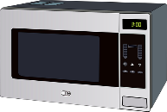
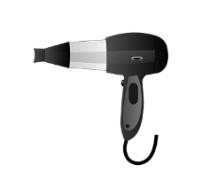
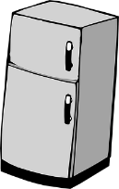
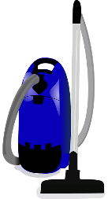
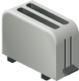
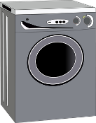
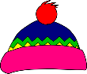
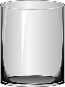

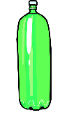
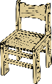


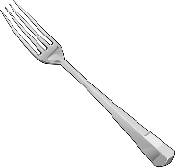
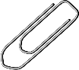
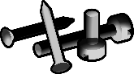
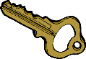
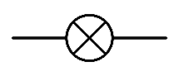
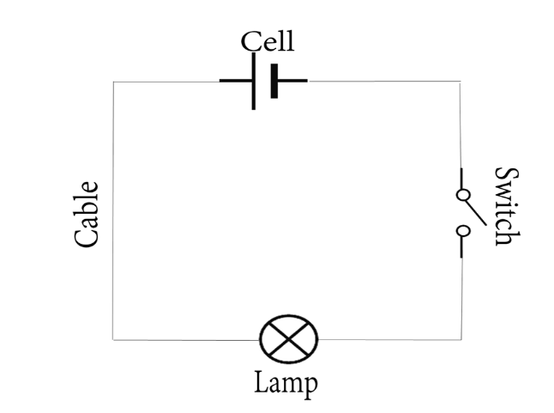
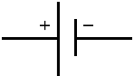
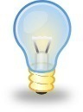

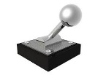
Electricity
1.) If you make the wires longer, the bulb will get dimmer. This is because there is more resistance.
2.) If you add more bulbs, the bulbs get dimmer. This is because there is also more resistance.
3.) If you add more batteries, the bulbs will get brighter. This is because there is less resistance and a greater current.

COMMON APPLIANCES
Wire
BULB
An electrical conductor lets electricity pass through. They are often metals but it also includes water.

An electrical insulator does not let electricity pass through.

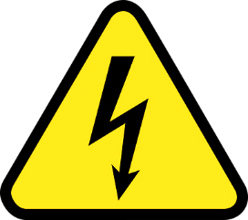
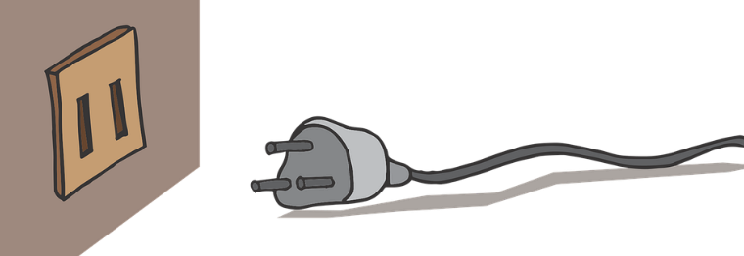
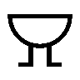
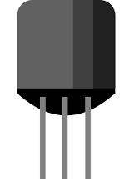
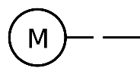
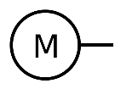
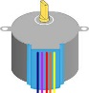

SWITCH
BATTERY/CELL
BUZZER
This circuit will not work because the switch is open.
A circuit must be complete to work. It must also always have a battery/cell.
DANGER! HIGH VOLTAGE!
Electricity is everywhere so always be safe. Be careful of mains switches, open sockets and any signs to do with electricity. The human body is 80% water so it conducts electricity. If someone has had a shock always turn the electricity off first, then call for help!

MOTOR
WIRES

