22nd January 2024

Dear Parents and Carers,
On Friday 2nd February 2024, Newquay Junior Academy will be taking part in Number Day. Pupils in Years 3, 5 and 6 are encouraged to take part in 'Dress up for Digits.' This will involve pupils and staff wearing non-academy uniform with an item of clothing or an object with a number on it. This can be a sports shirt, a cap, a playing card etc.

Year 4 have the option to dress up as rock stars, if they prefer, as they will also be taking part in a Number Day Times Table Rock Stars Competition.

As well as taking part in Maths activities and games it is also about raising money to support the NSPCC. If you are able to donate, it would be greatly appreciated. Donations can be made via your child’s ParentPay or a small cash donation that your child can hand into the class teacher.

We appreciate your support.

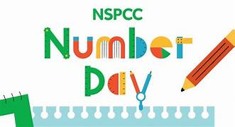
Yours sincerely,
Mr C Hayes
Executive Headteacher.

