
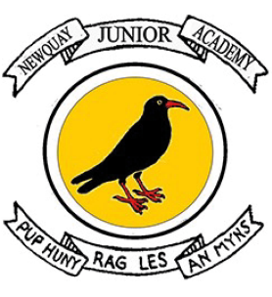 Newquay Junior Academy
Geography Curriculum Statement

INTENT
At Newquay Junior Academy we want all children to understand their sense of place in the world. Pupils are provided with opportunities to explore and discuss answers to questions about the natural and human aspects of the world. As geographers, they will locate where they are in the world and beyond. Using our local environment and researching and exploring the wider world, the children will use enquiry and fieldwork to discover human and physical processes and make sense of the world around them. There will be opportunities to think about diversity, cultures, and sustainability and how our choices can affect the world around us.

IMPLEMENTATION
We have a consistent approach using clear themes from Opening Worlds and the National Curriculum, that are built on throughout the years, creating a curriculum that is progressive. It is characterised by strong vertical sequencing within subjects (so that pupils gain security in a rich broad vocabulary through systematic introduction, sustained practice, and deliberate revisiting) and by intricate horizontal and diagonal connections, thus creating a curriculum whose effects are far greater than the sum of their parts.

Each theme has an enquiry statement or question which will inform the components of knowledge that allow them to make connections and reach informed conclusions. Children will use a range of carefully curated resources from the Opening Worlds curriculum alongside maps/aerial photos and core subject-specific vocabulary to secure and gain understanding.

In studying geography as a discipline, pupils will:

• engage in geographical reasoning about change (including past, present, and future change), diversity across space, and interaction between places, phenomena, and processes in the world.

• collect, analyse, record, and interpret geographical data, gaining skills of geographical enquiry, including fieldwork.

• interpret a range of sources of geographical information, including maps, diagrams, globes, aerial photographs, and digital technologies.

• communicate geographical information in a variety of ways, including through maps, numerical and quantitative skills and writing at length.

Children will consider how each lesson and unit is built upon from previous knowledge and they will create connections in their learning not only in Geography but through all aspects of the curriculum particularly Religion and World Views and History. Children will have fieldwork opportunities, both in our local environment and further afield as well as visitors to bring the subject to life.

What is Opening Worlds?

Opening Worlds is a knowledge-rich humanities programme for teaching Geography, History and Religion and World Views in Years 3 to 6. As a school, we are provided with curriculum resources together with training, support and ongoing programme-related professional development for our staff.

This diverse, culturally rich and wide-scoping curriculum is underpinned by the teaching of basic skills, knowledge, concepts and values in a rigorous and coherent way. Explicit links to story-telling and creativity are made to enthuse learners. Our aim is to create an environment that prompts curiosity, critical thinking and allows learners to connect strands of learning across all aspects of the curriculum.

What does this look like at Newquay Junior Academy?

The programme meets and substantially exceeds the demand of the National Curriculum for Geography and History and is compatible with our locally agreed syllabi in Religion and World Views. The programme is characterised by strong vertical sequencing within subjects (so that pupils gain security in a rich, broad vocabulary through systematic introduction, sustained practice and deliberate revisiting) and intricate horizontal and diagonal connections, thus creating a curriculum whose effects are far greater than the sum of its parts. As the programme builds on prior learning, Years 4, 5 and 6 will start with the Y4 Curriculum in the 2025-26 academic year.

IMPACT
Children will show achievement through independently applying the knowledge learned; this will be evidenced through:

- Building and revisiting a knowledge schema throughout the unit and before and after each lesson, with a focus on key vocabulary.
- Lesson observations and subject leader discussions with pupils.
• Displays and knowledge schema creation.
- Answering retrieval questions to support recall and committing information to their long-term memories.
- Pupil voice opportunities for the children to reflect on their own learning and progression.
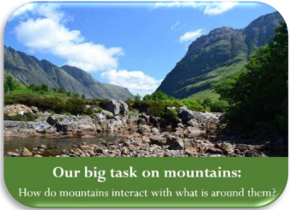
- Understanding and using prior knowledge, from current or previous year groups’, alongside the unit, making connections and thinking about similarities, differences, and connections.
- End of unit synoptic tasks.
- Confidently debating and discussing choices made.
- Applying and furthering their knowledge through use of fieldwork locally.
