
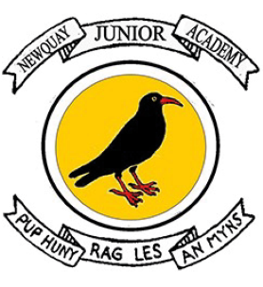

GEOGRAPHY INTRODUCTION STATEMENT

We believe that geography inspires a curiosity about the world and its people that will remain with them for the rest of their lives. We start through explicit teaching of the National Curriculum. The geography curriculum will provide pupils with knowledge about diverse places, people, resources and natural and human environments. There will be opportunities to think about sustainability and how our choices affect the world around us. Using our local environment and researching and exploring the wider world, the children will use enquiry and fieldwork to discover human and physical processes and make sense of them.
Our pupils follow the Opening Worlds curriculum which is characterised by strong vertical sequencing within subjects (so that pupils gain security in a rich broad vocabulary through systematic introduction, sustained practice, and deliberate revisiting) and by intricate horizontal and diagonal connections, thus creating a curriculum whose effects are far greater than the sum of their parts. Each theme has an enquiry statement or question which will inform the components of knowledge that allow them to make connections and reach informed conclusions. Children will use a range of carefully curated resources from the Opening Worlds curriculum alongside maps/aerial photos and core subject-specific vocabulary to secure and gain understanding.

