Pupil premium strategy statement

This statement details our school’s use of pupil premium (and recovery premium for the 2024 to 2025 academic year) funding to help improve the attainment of our disadvantaged pupils.

It outlines our pupil premium strategy, how we intend to spend the funding in this academic year and the effect that last year’s spending of pupil premium had within our school.

School overview
Detail | Data
School name | Newquay Junior Academy
Number of pupils in school | 457
Proportion (%) of pupil premium eligible pupils | 21.6%
Academic year/years that our current pupil premium strategy plan covers (3 year plans are recommended) | 2022-2023  2023-2024  2024-2025 current year
Date this statement was published | 16th September 2024
Date on which it will be reviewed | September 2025
Statement authorised by | Craig Hayes
Pupil premium lead | Lisa Mann
Governor / Trustee lead | Matt Williams
Funding overview
Detail | Amount
Pupil premium funding allocation this academic year | £159,550
Recovery premium funding allocation this academic year | £0
Pupil premium funding carried forward from previous years (enter £0 if not applicable) | £0
Total budget for this academic year  If your school is an academy in a trust that pools this funding, state the amount available to your school this academic year | £159,550

Part A: Pupil premium strategy plan

Statement of intent
We use the Pupil Premium Grant to fund three main activity types:
1. Support
2. Intervention
3. Enrichment

Support
- Upon entry, we use qualitative and quantitative data to set aspirational targets for our pupils.
- In order to support the social and emotional needs of our pupils, we contribute to the Educational Psychologist, Child Protection Lead, Speech and Language Therapist, counsellor and Educational Welfare Officer who work across Cornwall Education Learning Trust.
- Investment in a Parent Support Advisor to provide additional support for parents and break down any barriers to engagement.

Intervention
- Staff are aware of disadvantaged pupils and their progress is tracked termly and appropriate interventions are put in place to mitigate underachievement.
- A rigorous staff appraisal system involves analysis and discussion of the achievement and attainment of our pupils.
- We invest in both additional Senior Learning Support assistants and Learning Support assistants to ensure individuals are able to make at least expected progress and the most-able are challenged to achieve their potential.
- We invest in a wide range of Continuing Professional Development for teachers including high quality training, rigorous monitoring and judicious deployment of Learning Support Assistants, to ensure high quality teaching for all. There is an emphasis on engagement and effective oral and written feedback to promote progress.

Enrichment
- We offer before and after school clubs which provide enrichment activities.
- We subsidise after school provision for disadvantaged groups.
- Trips are offered and subsidised throughout the year.
In addition to the above, we provide financial assistance for uniform and food parcels for families that need it.

Challenges

This details the key challenges to achievement that we have identified among our disadvantaged pupils.
Challenge number | Detail of challenge
1 | We will ensure that the attendance of our disadvantaged pupils is the same or higher than non-disadvantaged pupils. We are aiming for 97% attendance.
2 | We will ensure that our disadvantaged pupils are making progress in reading, writing and mathematics that is the same as or higher than non-disadvantaged pupils.
3 | We will ensure that our disadvantaged pupils have the same rich and varied experiences as non-disadvantaged pupils so that their knowledge of the world and vocabulary acquisition is improved.
4 | We will ensure that we support the families of our disadvantaged pupils so that consistent approaches to learning and behaviour management are used in the academy and in the home.

Intended outcomes
This explains the outcomes we are aiming for by the end of our current strategy plan, and how we will measure whether they have been achieved.
Intended outcome | Success criteria
We will ensure that the attendance of our disadvantaged pupils is the same or higher than non-disadvantaged pupils. We are aiming for 97% attendance. | We will measure this intended outcome by:  - Ensuring all staff analyse weekly, termly and yearly attendance information, both at an academy level, trust level and national level so that interventions can be put in place quickly.
We will ensure that our disadvantaged pupils are making progress in reading, writing and mathematics that is the same as or higher than non-disadvantaged pupils. | We will measure this intended outcome by:  - Ensuring that staff use INSIGHT to analyse termly assessment information, both at an academy level, trust level and national level so that interventions can be put in place for those pupils who fall behind so that they keep up.
We will ensure that our disadvantaged pupils have the same rich and varied experiences as non-disadvantaged pupils so that their knowledge of the world and vocabulary acquisition is improved. | We will measure this intended outcome by:  - Ensuring that staff use INSIGHT to analyse termly assessment information, both at an academy level, trust level and national level so that the percentage of disadvantaged pupils achieving the expected standard in reading and writing is greater than or equal to the percentage of non-disadvantaged pupils.
We will ensure that we support the families of our disadvantaged pupils so that consistent approaches to learning and behaviour management are used in the academy and in the home. | We will measure this intended outcome by:  - Using assessment information in INSIGHT to ensure that the percentage of disadvantaged pupils achieving the expected standard in reading, writing and mathematics is greater than or equal to the percentage of non-disadvantaged pupils.  - Using CPOMS to monitor the number of behaviour incidents relating to disadvantaged pupils. We will be successful if the number of behaviour incidents for disadvantaged pupils decreases.

Activity in this academic year
This details how we intend to spend our pupil premium (and recovery premium funding) this academic year to address the challenges listed above.

Teaching (for example, CPD, recruitment and retention)
Budgeted cost: £ 95,000
Activity | Evidence that supports this approach | Challenge number(s) addressed
The class teacher and learning support will provide one to one and group support during lessons and during the academy day to ensure disadvantaged pupils make accelerated progress. | - Sutton Trust learning reviews.  - This approach has been successful in other academies in the trust.  - Teacher’s planning.  - INSIGHT assessment information | 2 and 3
Employ two Senior Learning Supports to:  - Provide opportunities for pupils to reflect on teachers’ feedback and whether this is leading to sustained improvement.  - Support pupils with their social and emotional development | - Sutton Trust learning reviews  - Teacher’s planning  - INSIGHT assessment information | 2 and 3
Employ four Senior Learning Supports, one for each year group to:  - Provide one to one and group support during mathematics and English lessons and at the beginning and end of the academy day to ensure disadvantaged pupils make accelerated progress | - Sutton Trust learning reviews  - Teacher’s planning  - INSIGHT assessment information | 2 and 3
Improve the use of regular summative and formative assessment by all staff to identify gaps in learning and inform future planning, teaching and deployment of staff | - INSIGHT assessment information  - Provision map small steps planning tool that identifies the barriers to learning and strategies to improve learning outcomes for disadvantaged pupils. | 1 and 2
Employ a learning outside the classroom specialist to implement and deliver additional enrichment projects to support core English and mathematics skills and improve confidence and self-esteem:  - Beach school  - Increased learning outside the classroom opportunities  - Forest school | - INSIGHT assessment information  - Provision map small steps planning tool that identifies the barriers to learning and strategies to improve learning outcomes for disadvantaged pupils. This will include targeted outdoor learning to promote practical applications of English and mathematics skills  - Our website, social media and learning journals will show evidence of raising aspirations days and events | 1, 2, 3 and 4
All staff to receive performance management targets that link to:  - Improving the attainment and achievement of disadvantaged pupils (75% expected and 30% greater depth across each year group in the first year) | - INSIGHT assessment information  - Provision map small steps planning tool that identifies the barriers to learning and strategies to improve learning outcomes for disadvantaged pupils.  - Performance management documents which details meetings with the leadership team on a weekly/termly basis to analyse attendance and attainment/achievement information.  - Attendance analysis information and case studies | 1, 2 and 3
Work alongside other academies in CELT to support and train our pupil premium workforce, sharing good practice across the academy trusts, to participate in Closing the Gap CELT strategy. | - CELT strategic aims  - Staff meeting agendas  - Attendance at CELT CPD events  - Improved staff knowledge | 1, 2, 3 and 4

Targeted academic support (for example, tutoring, one-to-one support structured interventions)
Budgeted cost: £ 35,000
Activity | Evidence that supports this approach | Challenge number(s) addressed
The class teacher and learning supports will use:  - Read, Write, Inc  - Writing interventions  - Mathematics interventions  - Spelling interventions  - ICT resources to support the above:  - IDL  - Spelling Shed  - My Maths  - Accelerated Reader  - Winning With Number  - Opening Worlds  - Clicker  - Tapestry  - SeeSaw  - TTRS | - Evidence in literacy, maths books, Learning Journals and on See-Saw.  - INSIGHT assessment information.  - Provision mapping data | 2 and 3
Senior learning support staff and class learning support staff to facilitate interventions and provide group or 1:1 support. | - INSIGHT assessment information.  - Provision mapping data | 2 and 3
Employ a learning outside the classroom specialist to implement and deliver additional enrichment projects to support core English and mathematics skills and improve confidence and self-esteem | - INSIGHT assessment information.  - Provision mapping data | 2 and 3

Wider strategies (for example, related to attendance, behaviour, wellbeing)
Budgeted cost: £29,950
Activity | Evidence that supports this approach | Challenge number(s) addressed
Parent Support Advisor, CELT to employ Education Welfare Officer and Assistant SENDCO to support the families of disadvantaged pupils, to improve their attendance and parent engagement | - Weekly attendance information  - CPOMS reports | 1 and 4
Purchase software licence CPOMs to provide an intuitive system for monitoring child protection, safeguarding, pastoral and welfare issues. | - CPOMS reports | 1 and 4
Purchase software licence for INSIGHT for use of regular summative and formative assessment and Provision Map so that staff can record all of the ‘additional from and different to’ interventions that are being delivered to pupils and monitor the effectiveness of the interventions. | - Teacher’s planning  - INSIGHT assessment information.  - Provision mapping data | 2 and 3
Additional enrichment projects to support the development of core literacy and numeracy knowledge and skills and improve self-esteem:  - Creative club  - Class trips  - Residentials  - Sporting events  - Breakfast club  - After school club  - Rock Steady music club  - ROAR project | - Attendance at the enrichment projects  - INSIGHT assessment information  - Website/social media/learning journals | 2 and 3
All staff to receive a performance management target linked to:  - Improving the attainment and achievement of disadvantaged pupils (75% expected and 30% greater depth across each year group in the first year). | - Performance management records  - INSIGHT assessment information.  - Provision mapping data | 2 and 3
Work alongside other academies in CELT to support and train our pupil premium work force, sharing good practice across the trust and participate in the Closing the Gap CELT strategy. | - Attendance at CELT CPD events  - Improved staff knowledge | 1

Total budgeted cost: £159,550

Part B: Review of outcomes in the previous academic year

Pupil premium strategy outcomes
This details the impact that our pupil premium activity had on pupils in the 2023 to 2024 academic year.
Data Highlights (comparison year on year) – how is the funding making a difference?

The information for 2022, 2019, 2018 and 2017 is taken from our published end of Key Stage 2 SATs tests.
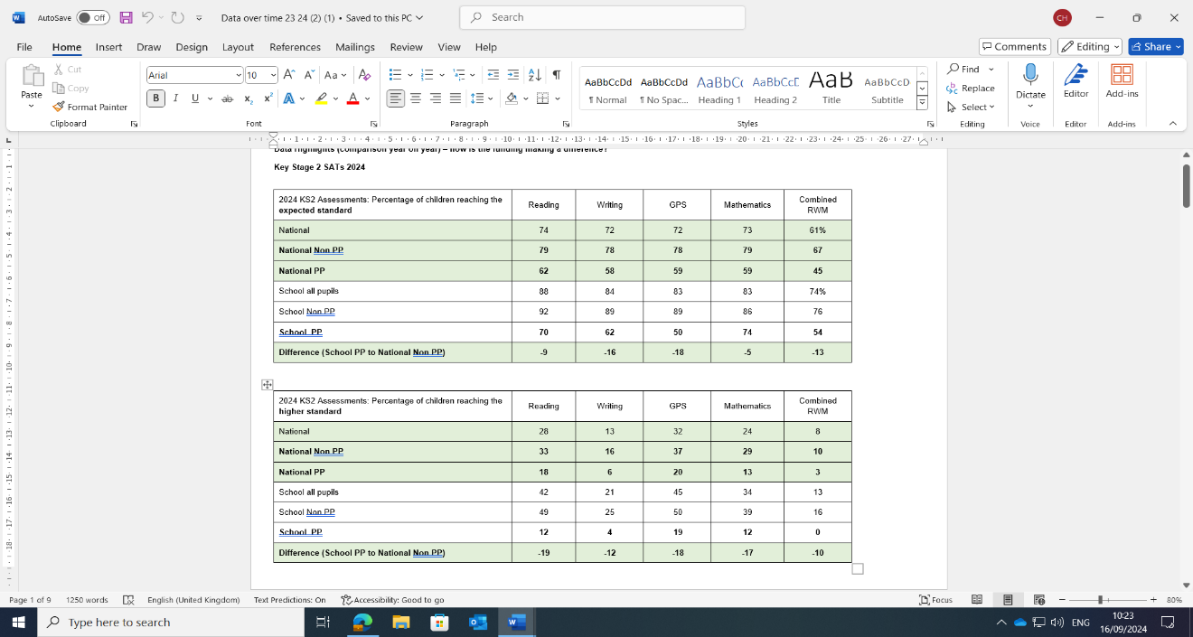
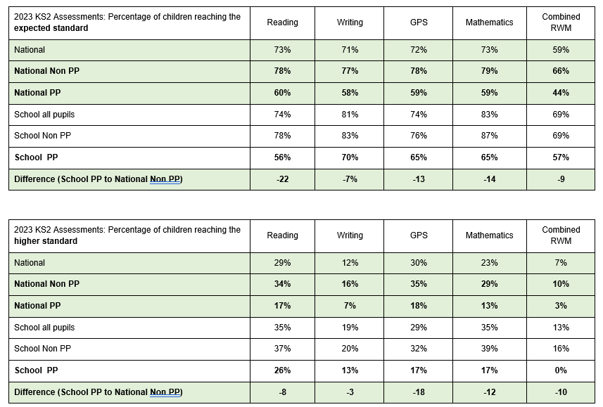
The information for 2020 and 2021 is taken from our internal teacher assessment information due to the Government’s decision to not implement end of Key Stage 2 SATs due to COVID 19.

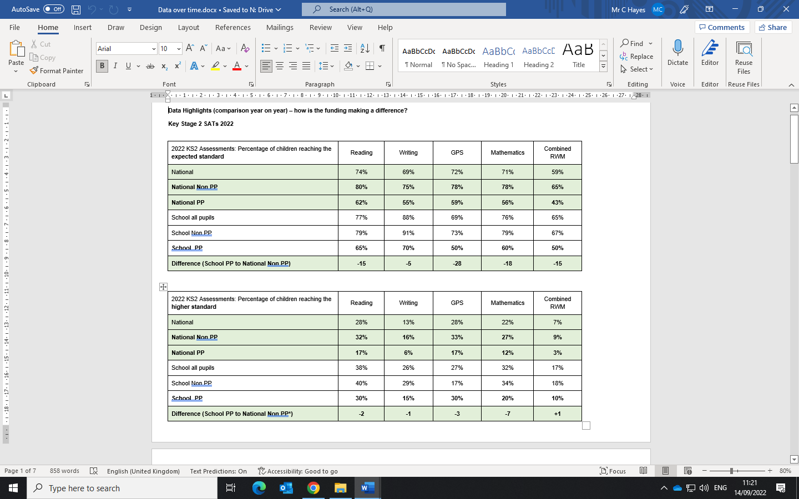
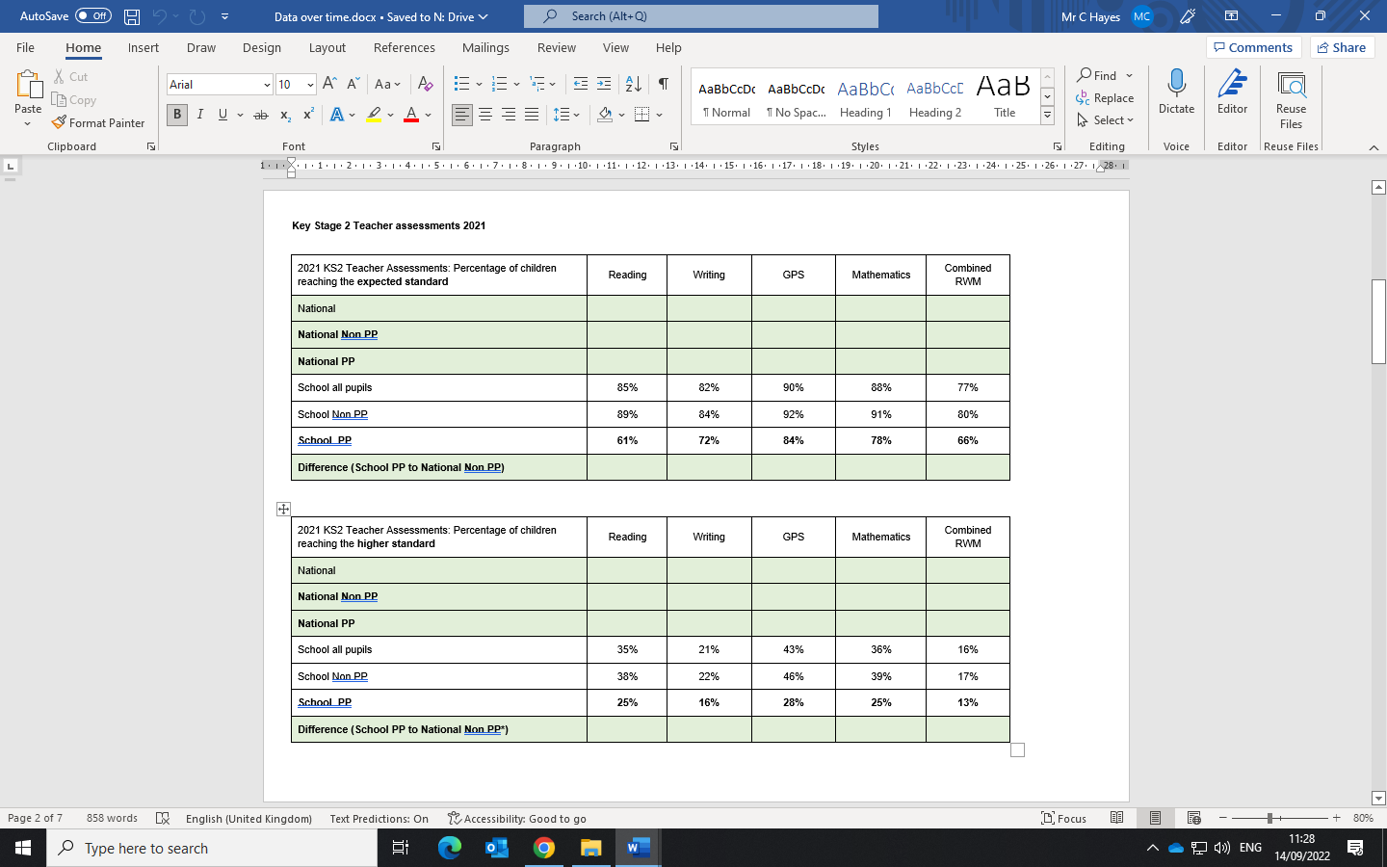

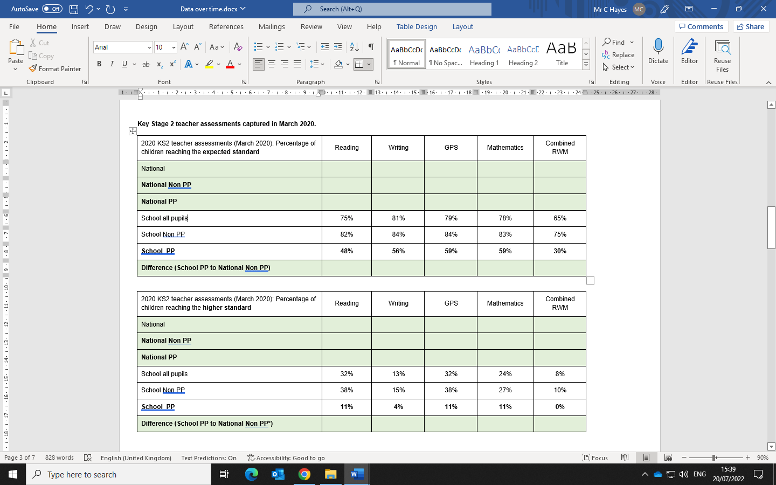
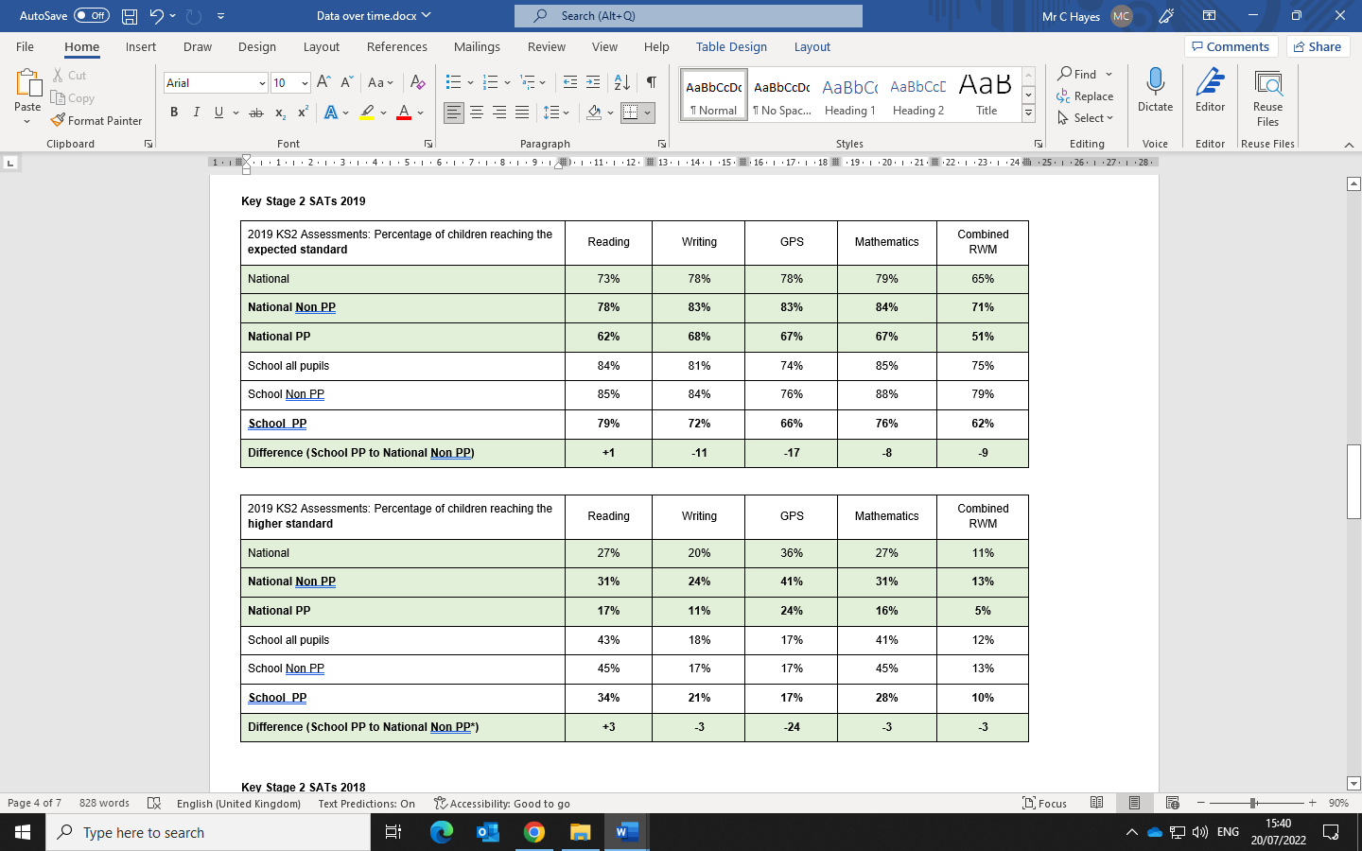

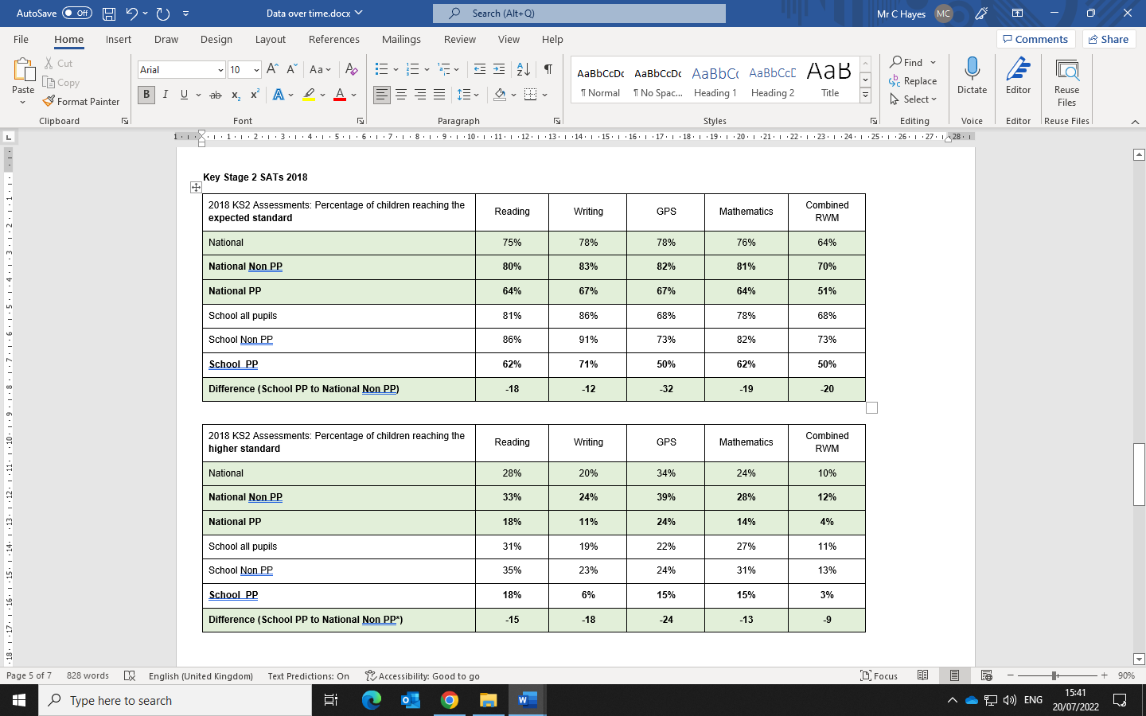
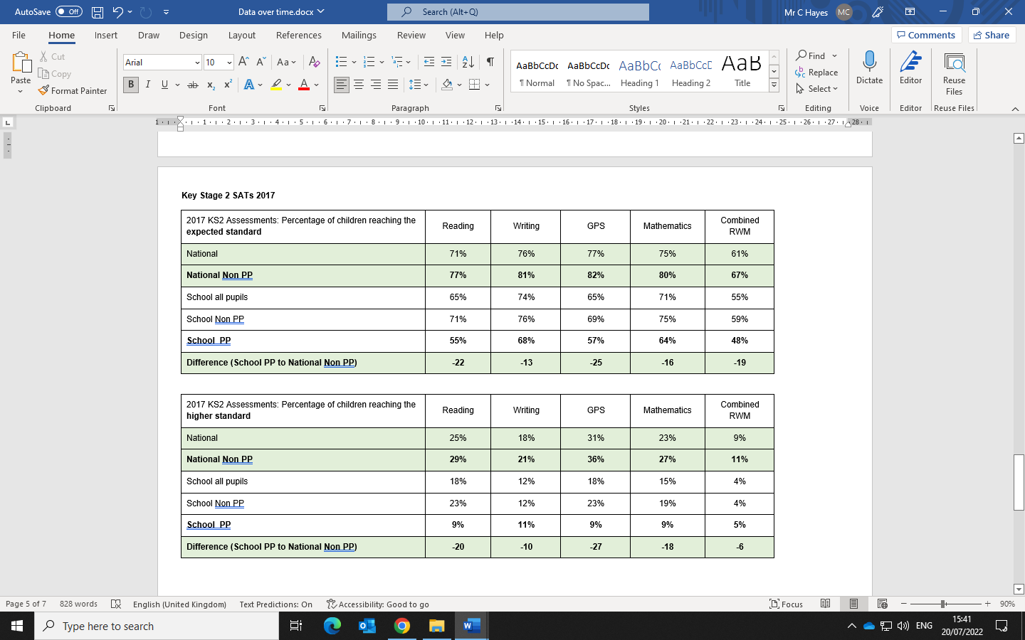

Evaluative statement:
- In 2024, the percentage of pupils in receipt of pupil premium funding reaching the expected standard at Newquay Junior Academy for reading, writing, maths and combined, continued to remain above the percentage of national pupils in receipt of the pupil premium funding reaching the expected standard.
- However, in 2024, the percentage of pupils in receipt of pupil premium funding reaching the higher standard at Newquay Junior Academy for reading, writing, GPS and maths was below the percentage of national pupils in receipt of the pupil premium funding reaching the higher standard.
- Comparing 2023 to 2024 assessment information, the gap between the percentage of pupils in receipt of pupil premium at Newquay Junior Academy achieving the expected standard in reading and maths and the national pupils not in receipt of the pupil premium funding significantly closed:
  - Reading -22% to -9%
  - Maths -14% to -5%
- However, the gap between the percentage of pupils in receipt of pupil premium funding reaching the expected standard at Newquay Junior Academy for writing and GPS compared to the percentage of pupils not in receipt of pupil premium funding reaching the expected standard for writing and GPS nationally did not close.
- Also, the gap between the percentage of pupils in receipt of pupil premium funding reaching the higher standard at Newquay Junior Academy for reading, writing and maths compared to the percentage of pupils not in receipt of pupil premium funding reaching the higher standard for reading, writing and maths nationally widened.

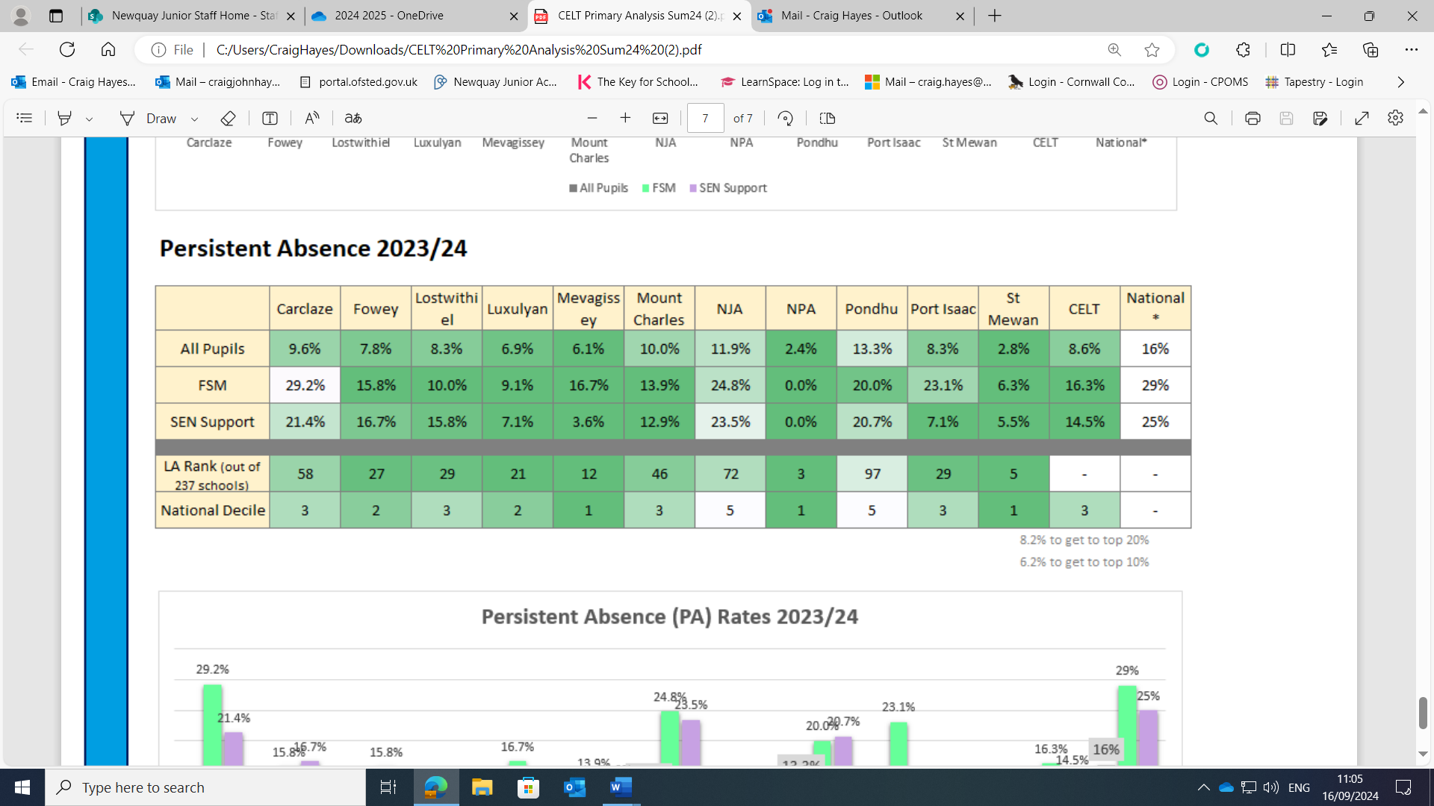
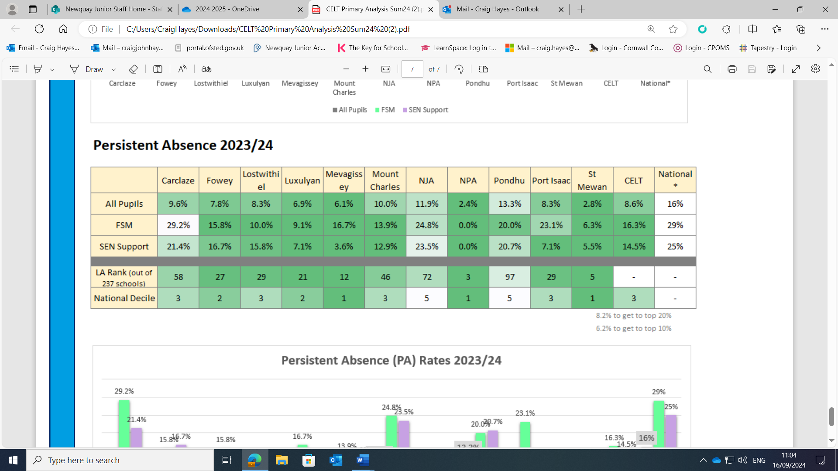
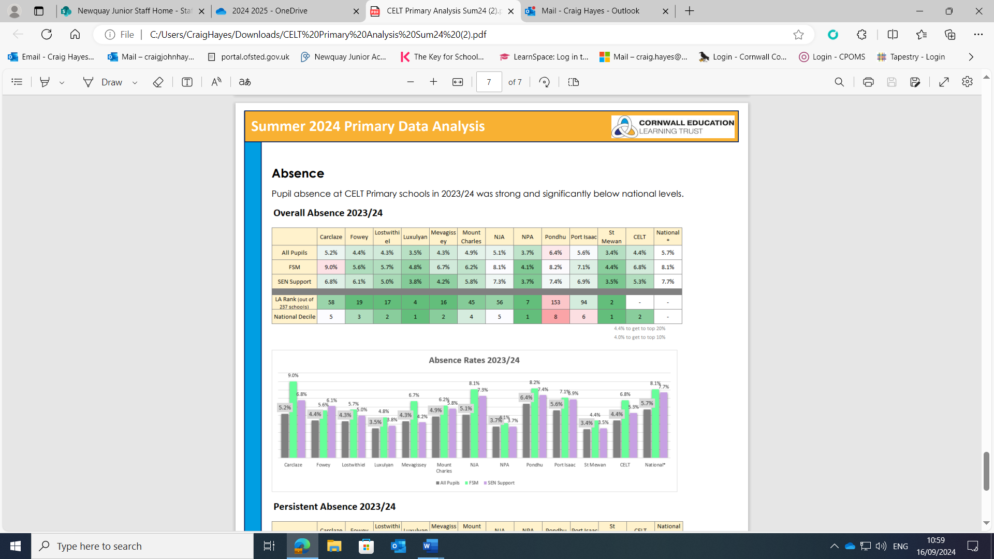
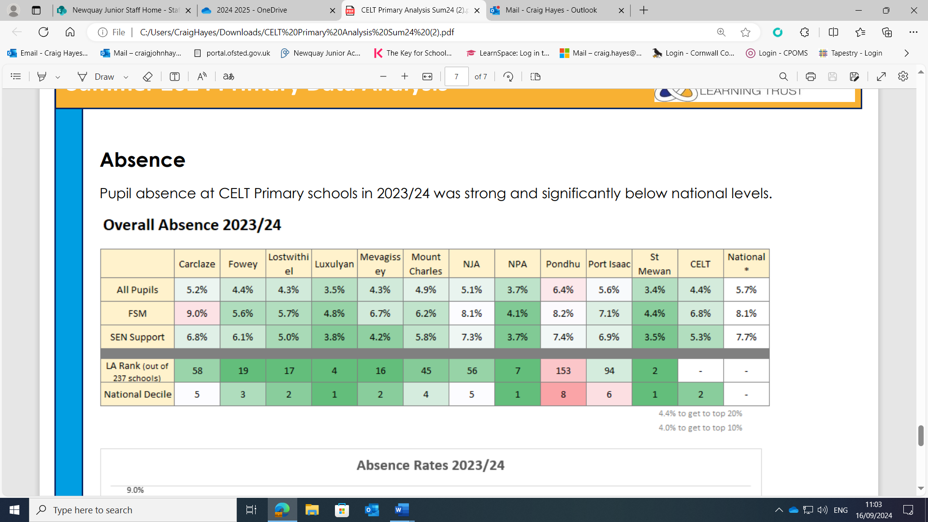
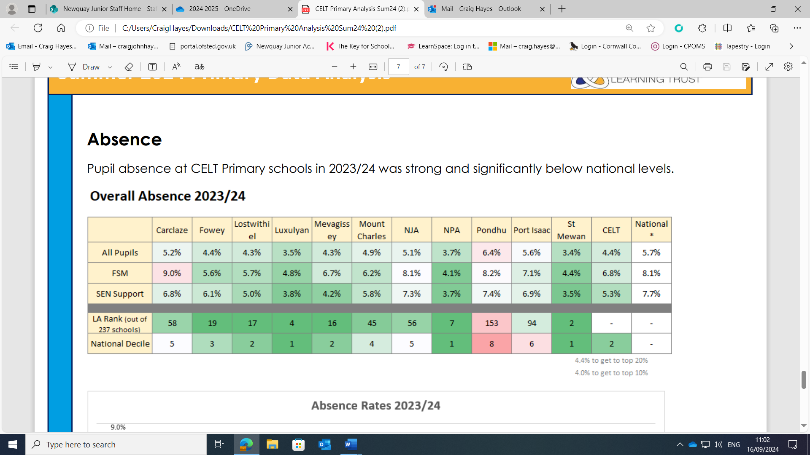
Absence and persistent absence 2023-2024

Evaluative statement (2017 – 2018, 2018 – 2019, 2019 – 2020, 2020 – 2021, 2021 – 2022 and 2022-2023). The table below shows the increase or decrease from the previous year. 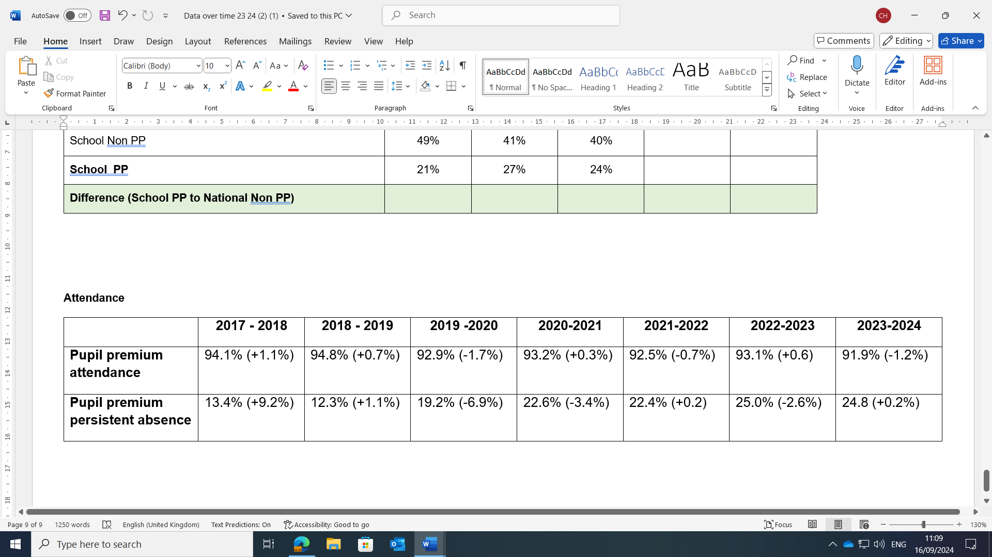Newquay Junior Academy recognises that 2023-2024 absence rates for those in receipt of the pupil premium funding have declined from 2022-2023 by 1.2%. However, we also recognise that 2023-2024 persistent absence rates for those in receipt of the pupil premium funding have improved from the 2022 – 2023 academic year by 0.2%.

Externally provided programmes
Programme | Provider
- IDL  - Spelling Shed  - My Maths  - Winning With Number  - Clicker  - Tapestry  - Seesaw | IDL/Ascentis  Education Shed  Oxford University Press  Ben Harding  Crick Software Ltd  The Foundation Stage Forum

Service pupil premium funding (optional)
Measure | Details
How did you spend your service pupil premium allocation last academic year?
What was the impact of that spending on service pupil premium eligible pupils?

