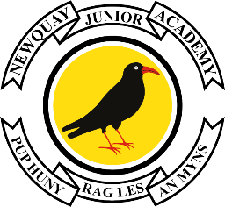

Edgcumbe Avenue, Newquay, Cornwall TR7 2NL
Tel: 01637 874543
secretary@newquayjunior.net
www.newquayjunior.net
Executive Headteacher:
Mr Craig Hayes B.ED (Hons)
20th April 2023

Dear Parent/Carer

Year 6 – Summer Term Key Dates

As Year 6 begin their final term of Newquay Junior Academy, we would like to advise you of some key dates for the diary:

2 May 2023 - London – Parents meeting in Old Hall

9-12 May 2023 - SATs

22-26 May 2023 - London/Activities Week

5 June 2023 - Head of Year 7 visit (Tretherras only – Treviglas date TBC)

8 June 2023 - Art workshops

9 June 2023 - Deadline for Leaver’s Hoodies/Yearbook orders

28 June 2023 - Transfer day to secondary school

10 July 2023 - Year 6 singing at Newquay Harbour (Wellness Week)

18/19 July 2023 - Year 6 Show

20 July 2023 - Year 6 Leavers Party

Further details for all of the Year 6 events over the coming months will be sent out nearer the time.

Yours sincerely,
Mr Doble
Head of Year 6

