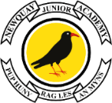

26th September 2024

Dear Parents and Carers,

**Booking information for Parent/Carer and Teacher Consultations.**

**The Face-to-Face consultations will take place at Newquay Junior Academy on**

**Tuesday 15th October or Thursday 17th October 2024**

This is your opportunity to meet with your child’s class teacher to find out more about their progress and how we can all work together to support them over this term. You will also be able to see some of their work, and we would be delighted for your child to attend and share in this meeting. **There will be one face to face meeting per pupil, which can be booked via the online booking system** on **Eschools**.Each appointment will last for ten minutes at Newquay Junior Academy.

**To book your appointment, you will need to log into the new online system called**

1. **Download the eSchools app on your phone and log in or**

**Go to the NJA website** [**www.newquayjunior.net**](http://www.newquayjunior.net)

**Login by pressing the yellow tab in the top right-hand corner**

1. **Log in to the app or website using the log in details sent to you on paper for eSchools**:

Your username: first.lastname Your password: a four-digit code

**Video Guide**  **How to book using the app** [**https://academy.eschools.co.uk/how-do-i-book-a-parents-evening-appointment-on-the-app/**](https://academy.eschools.co.uk/how-do-i-book-a-parents-evening-appointment-on-the-app/)

**Video Guide**  **How to book using the website** <https://academy.eschools.co.uk/users/parents/parents-evening-parents/>

**The booking system** opens on Wednesday 2nd 0ctober at 6.30pm on **eSchools** and

closes at 11pm on Wednesday 9th October 2024.

The face-to-face consultations will take place at Newquay Junior Academy, on either **Tuesday 15th October or Thursday 17th October**. Please arrive five to ten minutes before your appointment and go to your child’s classroom to meet the teacher.

Please note, Year 4 classes shared with two teachers will only have 1 staff member showing on the booking system. The Year 4 teachers sharing classes will be attending parents evening on the following days:

|  |  |  |
| --- | --- | --- |
|  | Tuesday 15 October Evening | Thursday 17 October Evening |
| 4MB | Mrs Morgan | Mrs Band |
| 4MH | Mrs Martindale | Mr Hoswell |
| 4SH | Ms Hawke | Ms Hawke |

We look forward to seeing you at the consultations in October. If you need any further support, please contact the office team.

Yours sincerely,

Mrs Findlay, MBE

Academy Head

**Guide to booking your parent consultation appointment using the eSchools App:**

1. **Download the eSchools app on your phone**
2. **Log into the app using the log in details sent to you on paper for eSchools**:

Your username: first.lastname

Your password: a four-digit code

1. **Select the Parents Evening function on the app in the top right-hand side**

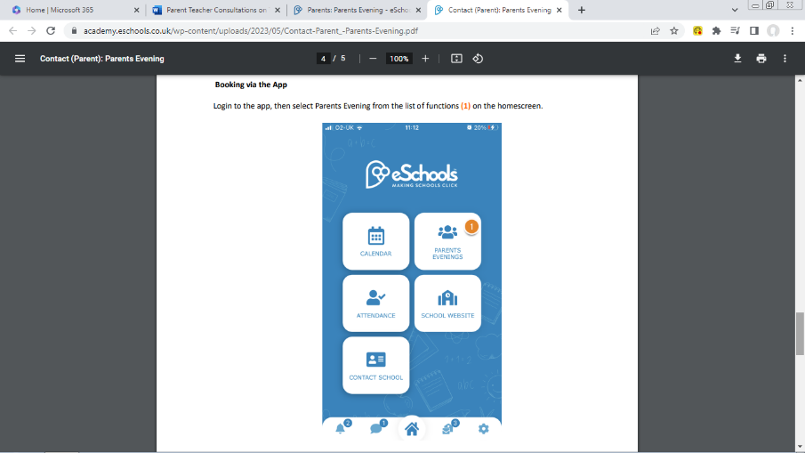

1. **Select the event Parents Evening Tues 15th Oct and Thurs 17th Oct**
2. **Select your child and click on the green arrow to book their appointment**

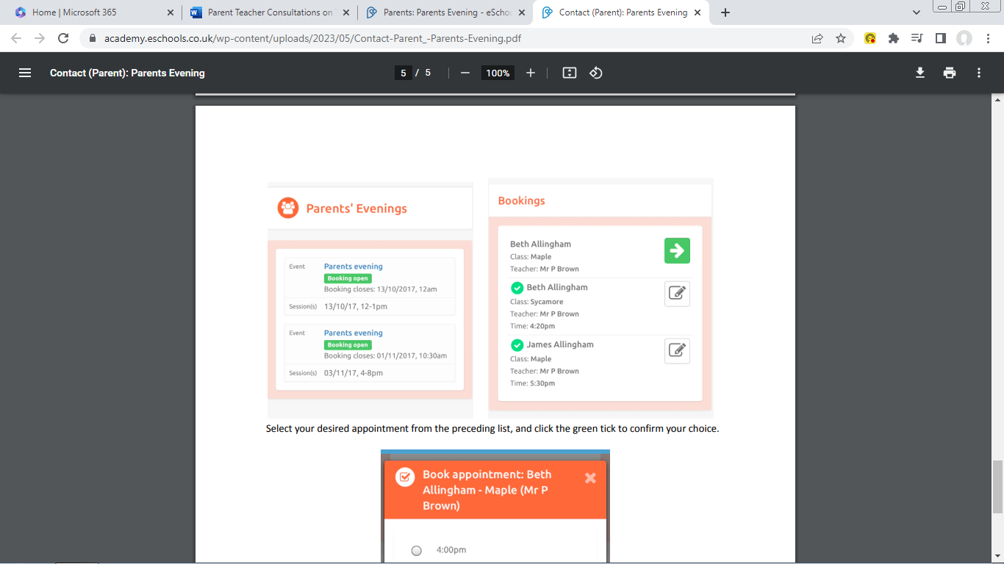

1. **Select the desired appointment from the list and tick green to book it.**

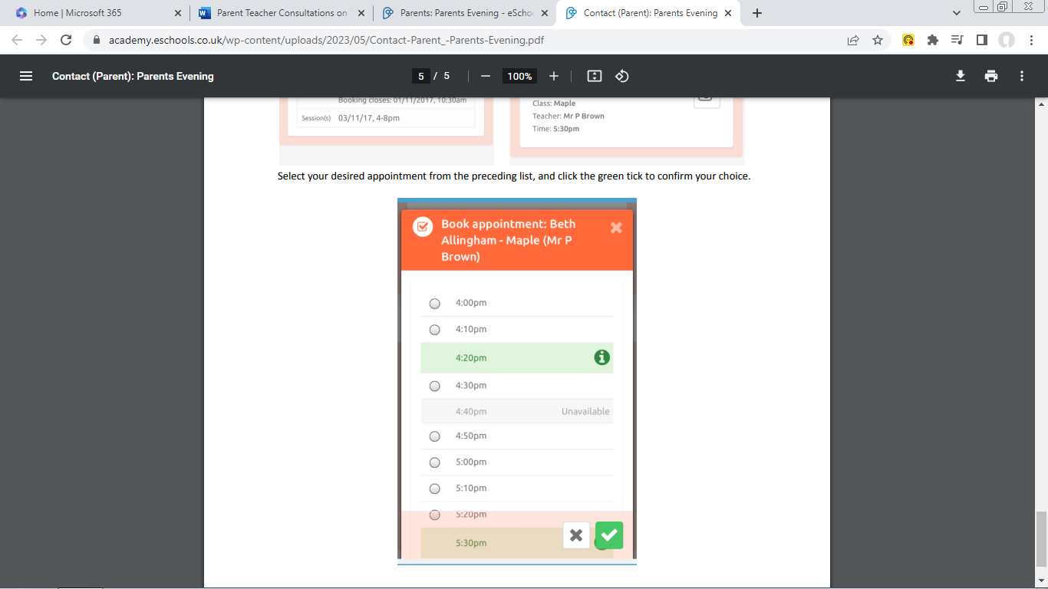

**Please write down when your appointment is, as the system does not give an email confirmation.** You can then log back into the app at any time to check your appointment.

All appointments are face to face at Newquay Junior Academy. It is only the booking that is on **eSchools**.

**Guide to booking your parent consultation appointment using eSchools on the website:**

1. Go to the NJA website [www.newquayjunior.net](http://www.newquayjunior.net)

Login by pressing the yellow tab in the top right-hand corner

1. **Log into the website using the log in details sent to you on paper for eSchools**:

Your username: first.lastname

Your password: a four digit code

1. **Select the Parents Evening that is highlighted in pink, Tues 15th Oct and Thurs 17th Oct**

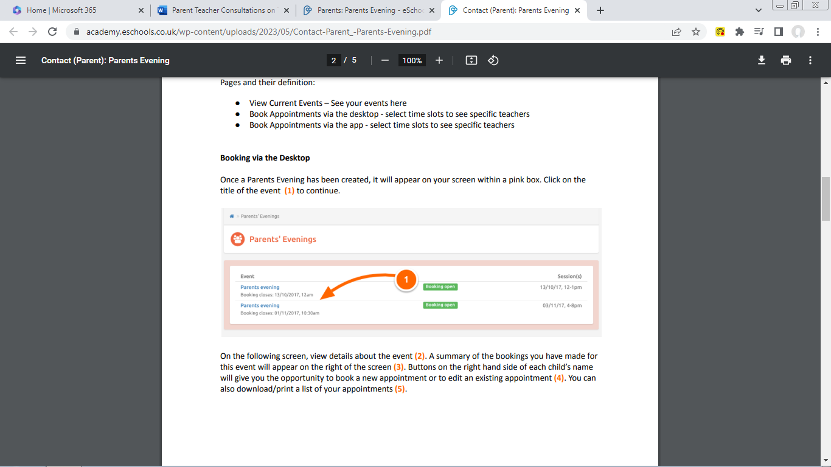

1. **Select your child and click on the green Book to make their appointment**

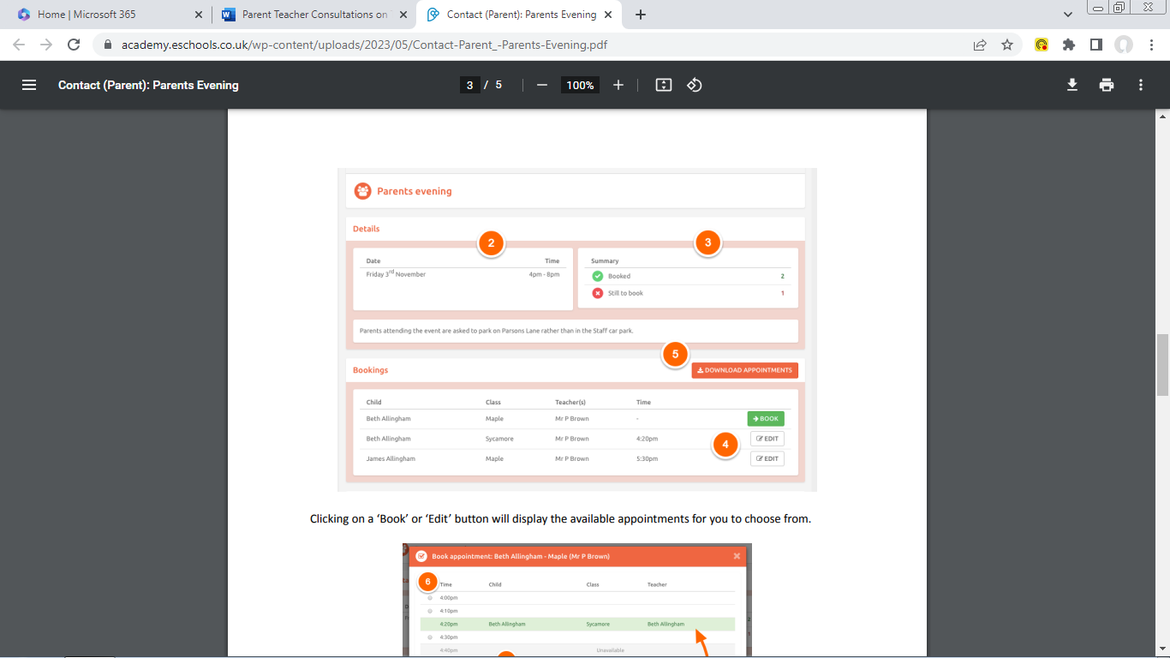

1. **Click Book or Edit to select the desired appointment from the list and press the green SAVE button.**

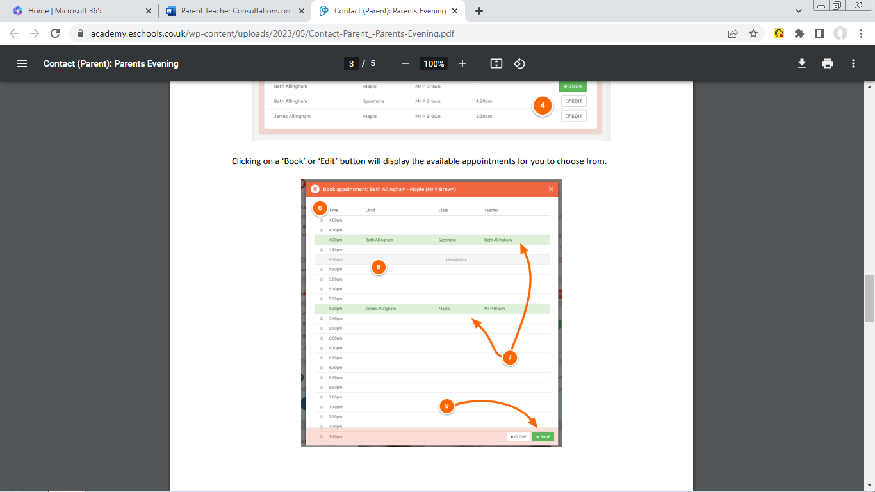

**Please write down when your appointment is, as the system does not give an email confirmation.**

You can then log back into the website at any time to check when your appointment is.

All appointments are face to face at Newquay Junior Academy. It is only the booking that is on **eSchools**.