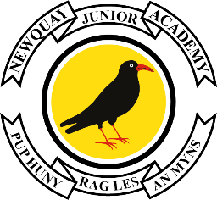

**Edgcumbe Avenue, Newquay, Cornwall TR7 2NL**Tel: 01637 874543  
[njasecretary@nja.celtrust.org](mailto:njasecretary@nja.celtrust.org)  
[www.newquayjunior.net](http://www.newquayjunior.net)

Executive Headteacher: Mr. Craig Hayes B.ED (Hons)

Head of Academy: Mrs Tania Findlay, MBE

**World Mental Health Day**

**#HelloYellow – Thursday 10th October 2024**

Dear Parents and Carers,

Newquay Junior Academy will be joining thousands of schools across the UK and taking part in ‘Hello Yellow’ in support of **Young Minds** on **Thursday 10 October** (World Mental Health Day), where we’ll be holding a non-academy uniform day and asking everyone to wear something yellow (we do not expect anyone to buy anything specifically for this).

We already work hard at developing our pupil’s mental health; we believe in having compassionate classrooms that allow our pupils to feel safe and supported, as well as having strategies in place to support their mental health when this is required.  Our PSHE curriculum provides opportunities for pupils to explore the importance of having good mental health.

On this day (Thursday 10th October), our pupils will further explore different ways of supporting their mental health within their class setting.

There are some excellent resources for parents and carers on the Young Minds website: [www.youngminds.org.uk/parent.](http://www.youngminds.org.uk/parent)  We will also share additional links and resources on World Mental Health Day.

Please contact the academy if you have any questions.

Yours sincerely,

Mr Hayes

Executive Headteacher