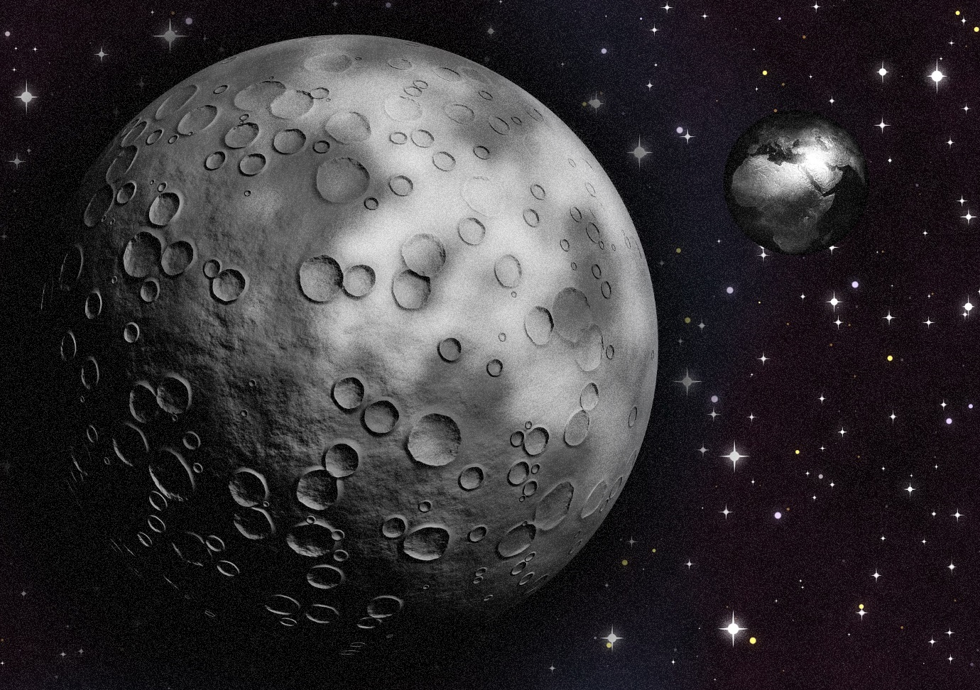

Knowledge Organisers
Year 5 Science

Newquay Junior Academy

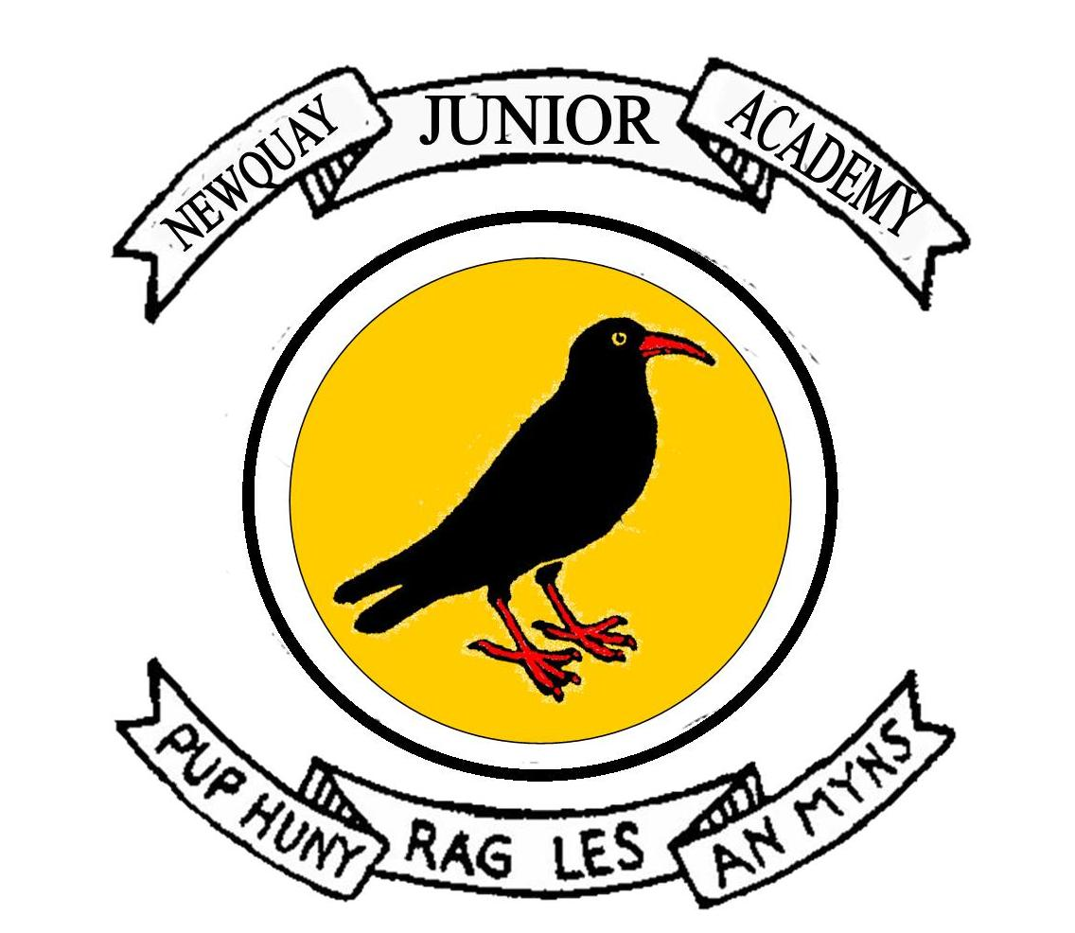

Contents

Life Cycles | p3
Human Growth | p4
Materials | p5
Earth and Space | p6
Forces | p7

Life Cycles
Amphibians
1.) Eggs – Female lays eggs which are fertilised by the male.
2.) Tadpole – After 2-25 days the tadpole hatches from the egg and swims.
3.) Jumps on Land – Grows front legs and uses nutrients in its tail as food.
4.) Grows fins and hind legs – Develops lungs and stringer tail.
5.) Adult Frog – Eats insects instead of plants and after 2-4 years it becomes an adult frog and can lay eggs.

Mammals
1.) Gestation – An embryo grows inside the mother, reliant on her for everything it needs.

2.) Young – Growth and development is independent from parents.

3.) Independent Adult – Seeks company in order to mate and now nurses their young.

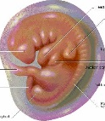
BIRDS
- Live in water and on land
- Lays eggs
- Moist, slimy skin
- Babies different from adults

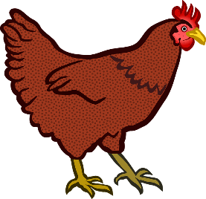
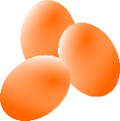

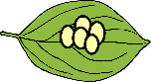
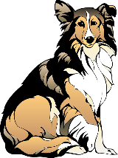
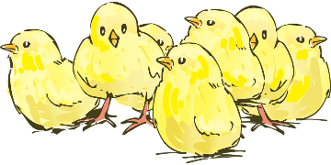
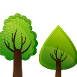
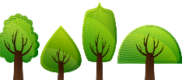
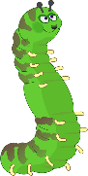
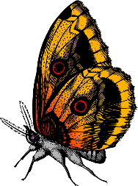
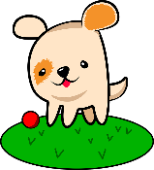
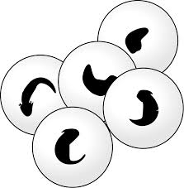
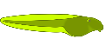
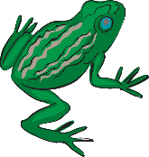
1.) Eggs – laid by the female insect.
2.) Larva – Eggs hatch and larva is born. It looks different to its adult self (e.g. caterpillar/maggots).
3.) Pupa – When the larva moults for the last time, a pupa is formed. It acts as a camouflaged, protective shell for the larva to transform.
- hatch from eggs
- some look like parents, shed skin and grow (the young are called nymphs)
- some go through metamorphosis where young and adult look different.

Plants
1.) GERMINATION – seeds grow
2.) ROOTS GROW - underground
3.) STEM and LEAVES - over ground
4.) POLLEN – used to make seeds
5.) SEEDS SPREAD – the cycle re-starts.

- have hair or fur
- are warm- blooded
- feed babies milk
- give live birth

Insects
4.) Adult – The adult breaks out of the pupa and matures.

Human Growth
PRENATAL DEVELOPMENT
Before birth, a human must develop from a series of cells to a baby inside its mother.

Germinal Phase – First two weeks where cells develop and divide.

Embryonic Phase – Between two and eight weeks when major organs and structure to the organism develops.

Foetal Phase – After eight weeks until birth when it takes on a recognisable human form and grows until it is ready to be born. This is called a foetus.

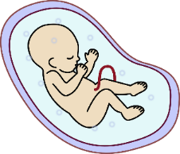
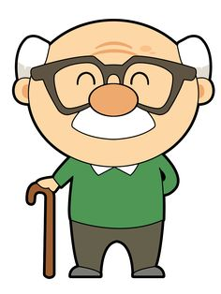
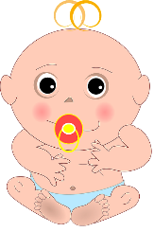
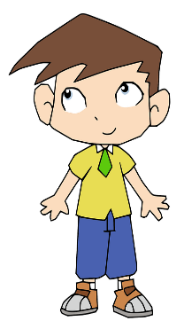
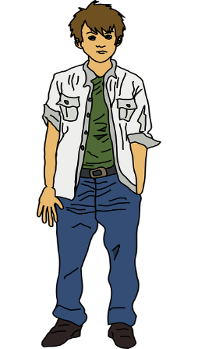
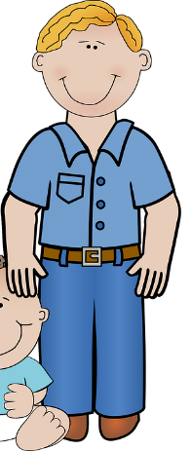
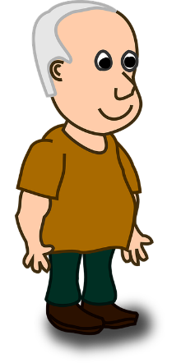
ADOLESCENT – During the ages of 9-19, humans become more independent, begin puberty ready for reproduction and become ready for adulthood.
ADULTHOOD – The human body is at its physical peak of fitness and strength and are able to be completely independent. This is when most humans reproduce.

LATE ADULTHOOD / OLD AGE – Body declines in fitness and health from 60 years onwards and there is an increased dependence on others to look after them as time goes on. The life cycle ends when a human dies.

Late
Adulthood / Old Age
Middle
Adulthood
Adulthood
Adolescent
Child
Baby
BABY – Babies drink milk after they are born. They usually start eating solids when their teeth start to appear at about 6 months. Many can crawl by 9 months and begin to walk after they are 1. All babies are different and develop at different times.
CHILD – Running, talking and learning to read, write and count are all developing in a child. They are developing skills in sports, art and music as well as developing socially, emotionally, physically and psychologically.
AMAZING HUMAN FACTS!
- The strongest muscle in the human body is the tongue.
- The lifespan of a human hair is 3-7 years.
- During your lifetime you will produce enough saliva to fill two swimming pools.
- Human shed and regrown their outer skin every 27 days.
- Humans are the only species that produce emotional tears.
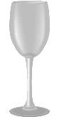
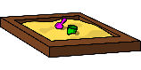
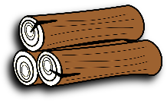
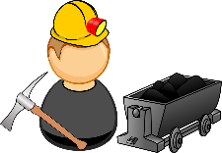
. Heat proud
MAN-MADE
NATURAL
Thermal Insulators – Do not let heat travel through easily such as fabrics, wood and plastics. Can keep heat in or out.

Thermal Conductors - Lets heat travel easily through such as metals.

When things get hot, atoms start to vibrate. Heat produces energy. This could cause them to change state!

KEEPING COOL
Materials
DISSOLVING
Dissolving is when the particles
of solids mix with particles of
liquids, often appearing like it
has disappeared but it has
dissolved in the liquid to make a transparent solution (e.g. mixing sugar into water). It does
not always need heat to occur. If a material does not dissolve it is insoluble. If it does, it is soluble.
MELT ING
Involves only solids which change into a
liquid due to heat. They stay
as the same material
(e.g. ice to water).
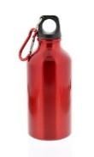
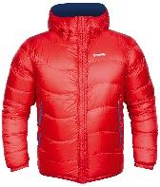
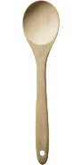
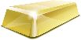
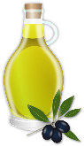
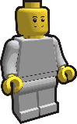
Three states of matter
GAS: particles far apart and randomly arranged / move around
LIQUID: particles close but randomly arranged / move around
SOLID: particles very close together / vibrate around a fixed position

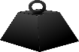
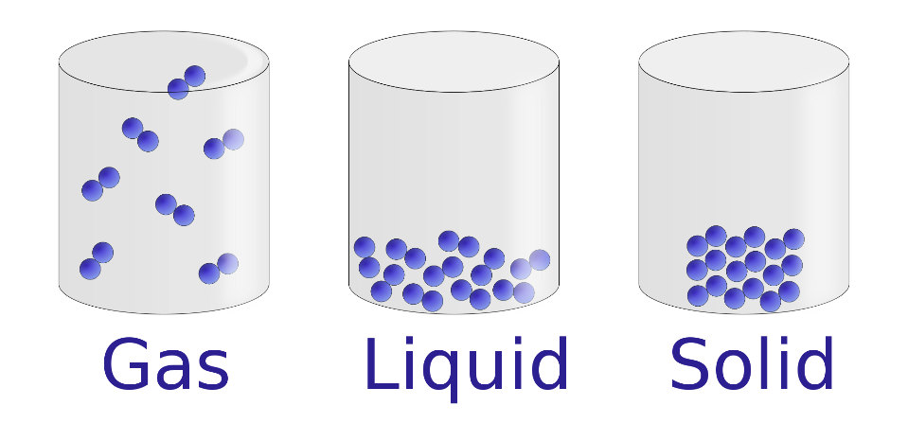
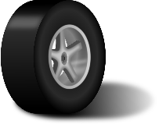

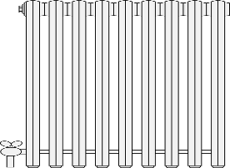
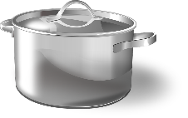

Three states of matter:
SOLID: particles close together / vibrate around a fixed position
LIQUID: particles close but randomly arranged / move around
GAS: particles far apart and randomly arranged / move around
Examples
Steam (water vapour)
Hydrogen
Carbon Dioxide
Oxygen

Examples
Ice
Wood
Glass
Diamond

Examples
Water
Milk
Washing up liquid
Juice

Separating Materials
SIEVING – A way to separate two solids of
different sizes (e.g. flour and raisins).
FILTRATION – A mixture of liquids and solids
which haven’t dissolved can be filtered using
paper with tiny holes (e.g. sand and water).
EVAPORATION – A solid dissolved in a
liquid (solution) can be heated. Liquid
evaporates and leaves behind the solid (e.g.
salt and water solution).
MAGNETISM – Metal attracts to the
magnet, leaving behind the other solid (e.g.
paper clips and matchsticks).
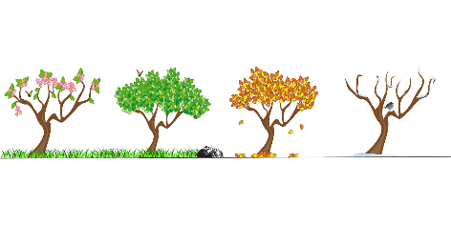
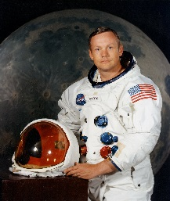


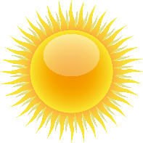
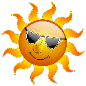
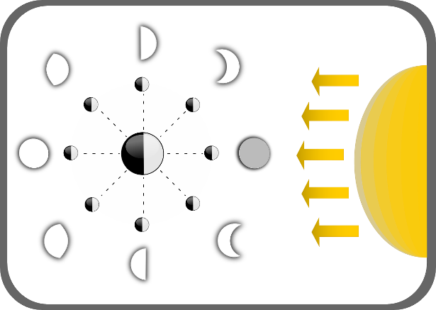
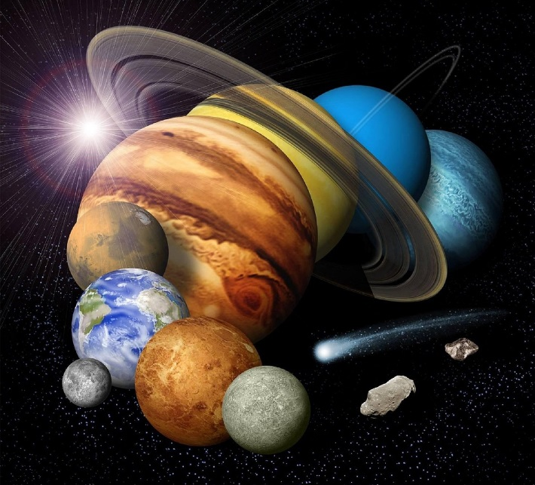
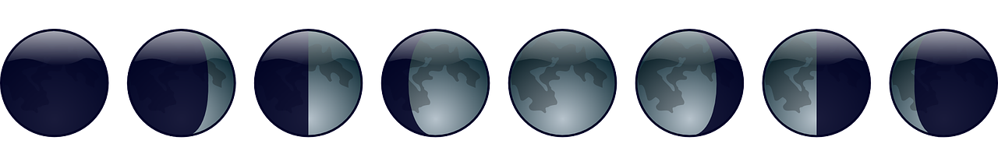
Waning means the moon looks like it is getting smaller. Waxing means the moon looks like it is getting larger. How much of the moon we see, depends on how much sunlight is hitting it. The moon reflects this sunlight.
GEOCENTRIC – People used to believe that the earth was the centre of the solar system and that the sun, and all the other planets, orbited it.
HELIOCENTRIC – Over hundreds of years, scientists began to understand that the sun was at the centre of the universe. They realised that all the planets actually orbited the sun not the earth.
The Sun
A star at the centre of our solar system.
15 million degrees hot at its centre. It is 1.3 million times bigger than earth.

The Sun is incredibly bright. It is not safe to look directly at the sun, even when wearing sunglasses!
Neil Armstrong
(The first man to step on the moon - 1969)

A solar eclipse is when the moon passes between the sun and the earth so the moon blocks the sunlight.
The Solar Eclipse
Time
The Earth to spin once on its axis.
(When the Earth faces the sun it is daylight and when it faces away from the sun it is night. It makes the sun appear to travel across the sky)
24hours

The moon to orbit the Earth
(A lunar month – see Phases of the Moon)
28 days

The Earth to orbit the sun
(Every 4 years there is a leap year due to the extra quarter – an extra day in February)
365 days ¼ days

The Earth’s tilt on its axis is what causes the 4 seasons. Sometimes it points towards the sun and other times it points away from the sun.

Mercury, Venus, Earth, Mars, Jupiter, Saturn, Uranus, Neptune
(Pluto was reclassified as a dwarf planet in 2006)
Waning
Crescent
Last
Quarter
Waning Gibbous
Full Moon
Waxing Gibbous
First
Quarter
Waxing Crescent
New Moon
Phases of the Moon
Earth and Space
LEVERS
A way to lift heavy weights using
the least amount of effort. The longer the lever, the easier it is to lift. The fulcrum is where the lever pivots in order to lift the heavy load.
Gravity
Gravity is a force that holds things to Earth’s surface and prevents things from floating off into the atmosphere. It ensures that unsupported objects to fall back down to Earth.

It is said that the famous scientist Isaac Newton was sitting under a tree when an apple fell on his head. He identified it was a force pulling the object down. We now measure gravity in Newtons (N) because of this.

There is gravity on the moon but it is much less than on Earth, so during the moon landings of 1969, astronauts could jump higher for longer due to the weaker pull of gravity.

Forces
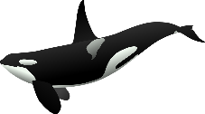
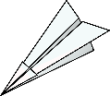
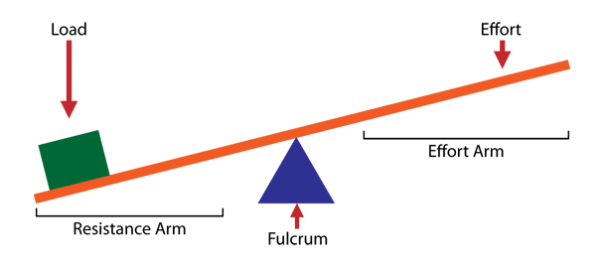
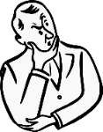
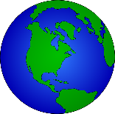
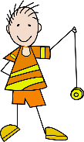
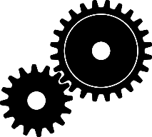
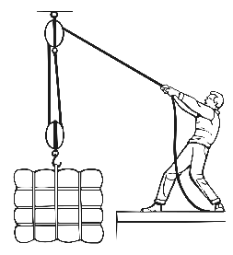
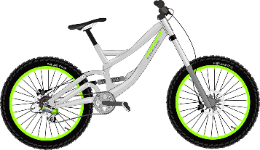
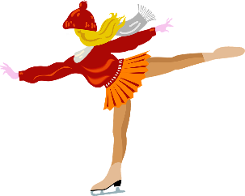
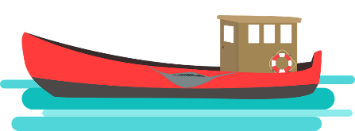
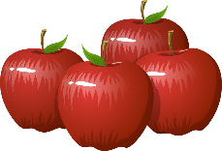

Friction
When objects are pushed or pulled, an opposing force can be felt. This opposite force is called ‘friction’. Friction causes things to slow down or stop. The grip on our shoes stops us slipping. Therefore, friction is great. An ice-skate on an ice-rink will move for a long time because there is very little friction. The rougher the surfaces, the greater the friction. This rubbing of two surfaces can release energy, causing heat. (Try rubbing your hands together!)
GEARS - Used to transmit power from one part of a machine to another. Connected gears can increase speed, increase force or cause a change in direction. When joined (in mesh) the direction of rotation of the driven gear is the opposite of the drive gear.
PULLEYS
Used like levers to lift loads with less effort but for longer distances. Rope is passed through a pulley which is attached to an anchor point and returned back to the ground to be pulled.

Air Resistance
Air resistance (sometimes referred to as drag) acts against gravity on falling or moving objects. It’s what you feel on your hair when riding fast on a bike or it’s what fills a parachute to help slow you down when falling from the sky. Object such as aeroplanes reduce air resistance because of their streamlined shape.
Water Resistance
Water resistance is a type of friction which can slow things down in the water. Water acts upon objects making them harder to pass through. A fish has a streamlined body shape to help it swim through water more easily. Upthrust is the name of the force which keeps things afloat in water. When gravity is greater than upthrust, the object sinks. When the two are the same, the object floats.

