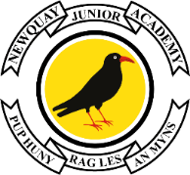
PTA Events at NJA
Friday 21 June – PTA Snack Shack
The PTA Snack Shack will be open each week at home time on Friday.
There will be ice lollies, cold drinks and sweets for sale.
Please bring cash at home time/collection if you wish to purchase a treat.
The snack shack will be open for the next few Fridays at home time in the playground.

Friday 28 June – Non-Uniform Day for Luxury Items for PTA Fayre
Pupils can wear suitable non-uniform and bring in luxury items for the PTA Fayre.
Chocolates, bath products, toys etc. can be taken straight to class in the morning.
If you are donating alcohol, please bring it to the office so we can keep it safe.

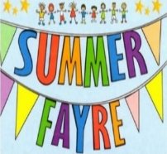
Thursday 11 July – PTA Summer Fayre
The PTA Summer Fayre will take place on Thursday 11th July from 3.30pm to 5.30pm.
All friends and family are welcome to attend and help to raise funds for NJA’s PTA.
We look forward to another fantastic fundraiser and thank you in advance for your support.

