Chartwells Information regarding pupils with allergies and academy meals at NJA.
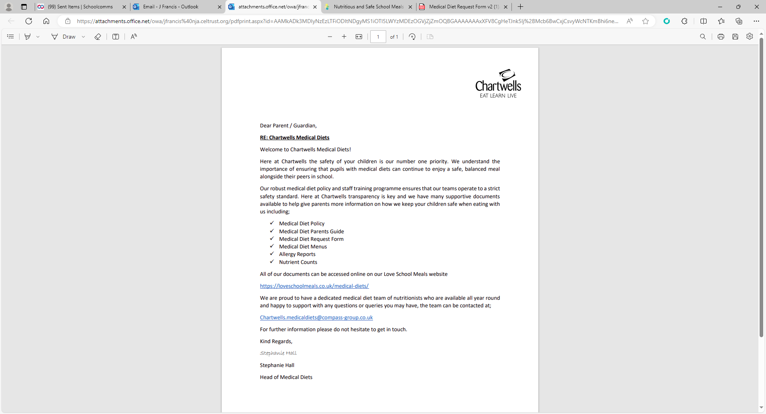
https://loveschoolmeals.co.uk/allergy-aware/

