
Christianity & Non-religious Knowledge Organiser – Autumn Term 2
Year 6 – Pupil Version

Unit U2.11 Why do some people believe in God and some people not? (Christians, non-religious)
Key Vocabulary  Christian Someone who follows the Christian religion.  Humanist A person who does not believe in a god. They believe it is possible to live a good and fulfilling life without following a traditional religion.  God The all-powerful and all-loving being that Christians believe created the world and everything in it.  Church Place where Christians worship.  Theist A person who believes in the existence of a god or gods.  Atheist Not believing in any gods or deities  Agnostic Some people who call themselves "agnostic" say that it is not possible for anyone ever to know if there are any Gods or deities.  Overview  1. To explore why some people believe in God and others don’t.  2. To compare the sources of authority of Christians with some non-religious sources.  3. To explore some reasons why people do or do not believe in God  4. To recall and build on learning to explore how and why Christians still believe in God in an age of science.  5. To explore what impact believing in God might make on the way someone lives his or her everyday life. Is faith in God restricting or liberating?  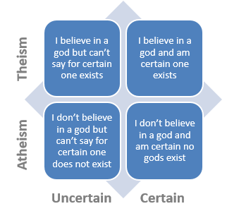  Belief or non-belief  in God. | Knowledge Building blocks • Christians believe that God created the Universe (in 7 days). A poem explaining how this happened can be found in the Old Testament of the bible (Genesis 1).  • Humanists do not believe in a God. They believe it is possible to live a good and fulfilling life without following a traditional religion.  • The holy book for Christians is called The Holy Bible and they worship in a church.  • Humanists do not have a holy book or a place of worship. They believe that all humans can live a good life and do lots of things to help people without having religious beliefs.  • Christians follow the 10 commandments and teachings from the bible to decide how to live their lives.  • Humanists believe that rules don’t need to come from a God, they evolve naturally based on reason and empathy.  Humanist logo ‘Happy Human’ A church (A Christian place of worship) Humanism refers to a non-theistic approach to life, looking to science instead of religion in order to understand the world. The term was made widely known by scientists in the mid-20th century. Many wanted to recognise human values, but without depending on religion as the main source of values.  Christians believe that God created the Universe (in 7 days). A poem explaining how this happened can be found in the Old Testament of the bible (Genesis 1). Scientists (Cosmologists) believe that the universe was created by the big bang – an explosion that occurred about 13.73 billion years ago.

