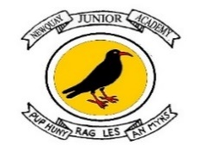
Hinduism Knowledge Organiser – Autumn Term 2
Year 3 – Pupil Version

Unit L2.8 What does it mean to be a Hindu in Britain today? (Dharma)
Key Vocabulary  Dharma One of the four main aims in a Hindu’s life. Dharma is the duties a Hindu should follow in their life.  ‘Sanatan Dharma’ An important dharma that means eternal truth. It is universal, which means it applies to all people at all times. Many Hindus would refer to their religion as sanatana dharma rather than Hinduism as they believe it sums up their beliefs better.  Murtis A statue of a god or goddess which has been made holy through a special ceremony; a term for any statue of a god or goddess.  Aum Known as the 'sacred syllable', this sound and symbol is used by many Hindus to convey how deep and complex the divine is.  Puja The word puja means ‘worship’ or ‘adoration’. It comes from the Hindu culture of the Buddha's childhood.  Bhajans A Sanskrit word meaning “singing to glorify God."  Overview  1. To discuss how Hindus show their faith within their families in Britain today (e.g., home puja)?  2. To investigate how Hindus show their faith within their families?  3. To explore what kinds of things Hindu families do during the week (e.g., daily puja, blessing food, arti ceremony, singing hymns, reading holy texts, visiting the temple, etc).  4. To investigate what Hindus do to show their tradition within their faith communities.  5. To explore how Hindus celebrate Diwali in Britain today.  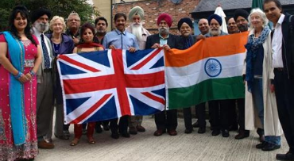  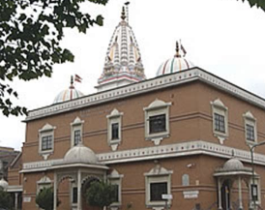 | Knowledge Building blocks PUPILS WILL KNOW THAT:  • There are today more than 800,000 Hindus in Britain, making them the country’s third largest religious group after Christians and Muslims (many came to Britain after the 2nd World war).  • Despite there being many Gods, Hindus recognise one, Brahman, the eternal origin who is the cause and foundation of all existence. Although he is the Creator, he is not worshipped in the same way as other gods because it is believed that his work - that of creation - has been done.  • Hindus are often classified into three groups according to which form of Brahman they worship:  Those who worship Vishnu (the preserver) and Vishnu's important incarnations Rama, Krishna and Narasimha;  Those who worship Shiva (the destroyer)  Those who worship the Mother Goddess, Shakti, also called Parvati, Mahalakshmi, Durga or Kali.  Dharma is the duties a Hindu should follow in their life. There are various types of dharma for a Hindu. Some are personal duties and some are eternal duties, meaning that they are for everyone. Dharma or duties are expected of all Hindus, and Hindus should live their lives with these in mind. Dharma is one of the four main aims in a Hindu’s life. The four aims are:  Dharma - The duty a Hindu should perform in their life.  Kama - Enjoying the pleasures of life.  Artha - Gaining wealth in a lawful way.  Moksha - Freedom from samsara so that the atman joins up with Brahman.  