Guide to applying for Year 7 Secondary School Online.
- Log onto Cornwall Council Admissions website
https://cornwall.cloud.servelec-synergy.com/SynergyWeb/School_Admissions/
- Click on the section “Click here to start your application”.
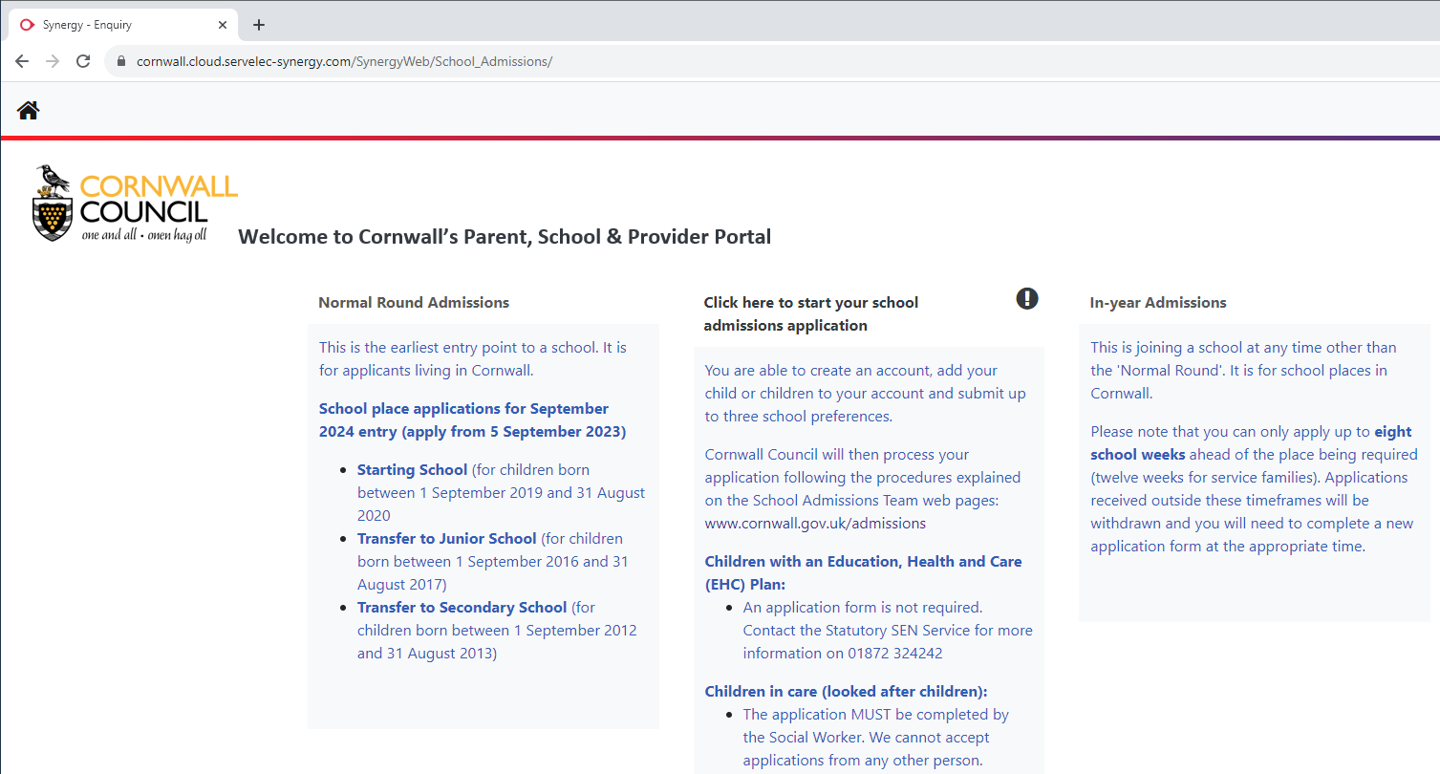

- Create your account with your details – you may already have one from applying to Junior School
(If you already did this for Year 3 - Try your email address to log in and select forgotten password)
- Add in your details (applicant)
- Add in your child’s details
- Select Secondary Transfer Sept 2024
- Select 2-3 secondary schools that you wish your child to attend, in order of preference

- Ensure you add in any reasons and proof of address (if needed)
- Keep clicking through until it says you have successfully applied
- The final page will show your Admissions account with your child’s application – submitted to LA.

The earlier you apply, the more chance you have of receiving your first-choice school.
We are aware that this is a large year group, so places will fill up very quickly.
Please apply as soon as possible from Tuesday 6th September.
Applications close by Tuesday 31st October.

