26th November 2024

Dear Parents and Carers,

**Year 3 Newquay Land Train Trips**

We are excited to announce that, as part of our Christmas Topic, Year 3 will be reading ‘The Polar Express’. To celebrate, we are going on an exciting, unique journey on the Newquay Land Train!

This will be a fantastic way to experience the story and to explore our local area on the Land Train. The adventure will take place in the afternoon, followed by party games and hot chocolate. Pupils will have their lunch as normal, take part in the private train ride and then be ready for usual 2.55pm home time collections.

**To help fund the cost of the Land Train and activities, we request a payment of £4.50 via ParentPay. Please make your payment as soon as possible so we can prepare for the trip.**

On ParentPay, please scroll down to “more items” and look for: Year 3 Xmas Land Train Trip.

The train trips will take place on the following days:

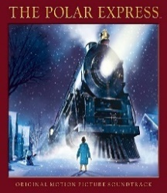**Wednesday 4th December**

3CS will go on the Land Train at 1pm from NJA.

3JJ will go on the Land Train at 1.45pm from NJA.

**Thursday 5th December**

3JR will go on the Land Train at 1pm from NJA.

3JKR will go on the Land Train at 1.45pm from NJA.

On their trip day, please can pupils bring in a warm, suitable onesie (or similar), to ride on the Newquay Land Train. Pupils will also need a warm winter coat, hat, scarf and gloves.

We will assume all pupils will be attending the trip. **If you do not want your child to take part, please contact the academy office on 01637 874543 to let us know.** Pupils who do not attend the trip will be expected to be in school and join another Year 3 class for the afternoon.

Thank you for your continued support and we look forward to an enjoyable “Polar Express” experience in December.

Yours sincerely,

Year 3 Team.

