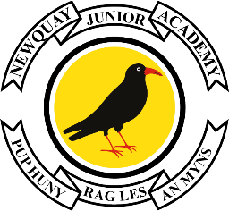

24th January 2024

Dear Parents and Carers of Year 3,

Year 3 World Book Day

Invitation to join our Reading Party on Thursday 7th March 2024

The Year 3 Team would like to invite you to join us on Thursday afternoon, for World Book Day. We will be holding a “reading party” in each classroom for families to share books with their children and discover more about the learning we have been doing so far this term.

On Thursday 7th March, please arrive at the side gate of the academy by the Edge Hall, at 1.40pm, where you will be welcomed by a member of staff and shown to your child’s class.

After sharing our work and stories, parents and carers will be escorted out and then pupils will be dismissed at 2:55pm from the MUGA at the back gate as normal.

We appreciate that not every family will be able to attend, due to work and previous commitments, however we hope to welcome as many parents and carers as possible.
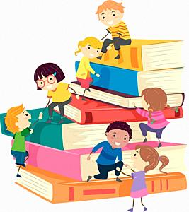
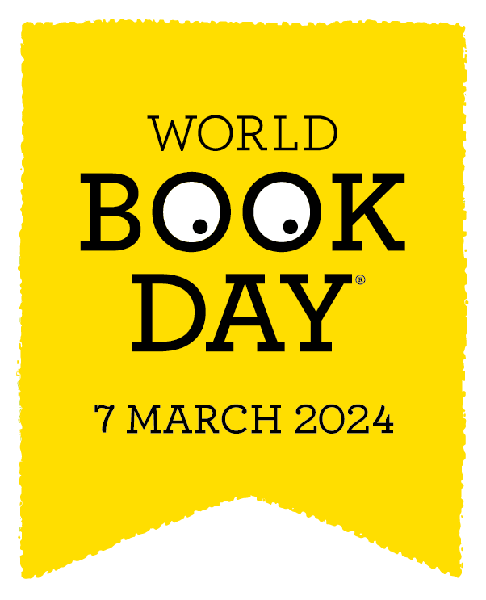
Thank you for your support.
Yours sincerely,

The Year 3 Team

