
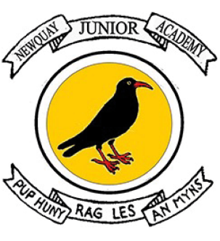

RELIGION AND WORLD VIEWS INTRODUCTORY STATEMENT

At Newquay Junior Academy, we believe that Religion and World Views should provoke challenging questions about the meaning and purpose of life, beliefs about God, issues of right and wrong and what it means to be human. Our Religion and World Views curriculum focuses on developing a deep interest in world views and a sound knowledge built through a coherent and tightly sequenced curriculum. It embraces a global and cultural breadth, and we are mindful to ensure that the uniqueness and background of every child is recognised and valued.
Newquay Junior’s diverse, culturally-rich and wide-scoping curriculum is underpinned by the teaching of basic skills, knowledge, concepts and values in a rigorous and coherent way. Explicit links to story-telling and creativity are made to enthuse learners. Many enhancement and enrichment activities are used throughout the curriculum to engage children and create purposeful, high-leverage outcomes that give children the opportunity to use and apply their developing knowledge and skills.
Our aim is to create an environment that prompts curiosity and critical thinking and allows learners to connect strands of learning across all aspects of the curriculum.
We aim to ensure that all pupils:
- Make sense of a range of religious and non-religious beliefs through well told stories
- Understand the impact and significance of religious and non-religious beliefs on believers, exploring practice and history
- Make connections between religious and non-religious beliefs, concepts, practices and ideas studied as well as making links with and developing their own personal view.
- Explore the different lenses through which Religion and World Views can be interpreted, encouraging pupils to be curious and debate ideas.

