**SMSC**

**Spiritual development**

We provide opportunities for all children to reflect on their beliefs and values, helping them to develop self-awareness and a sense of purpose. Through exploring subjects such as art, music, science and humanities, we aim to inspire a sense of awe and wonder about the world around them. We enrich their experiences through trips to places of worship, museums and spiritual landmarks, where they can deepen their understanding of human creativity and achievement.

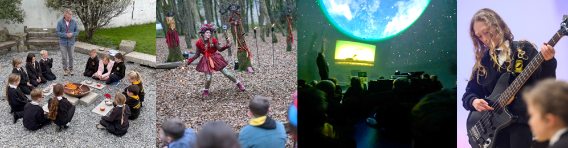

**Moral development**

We promote an understanding of right and wrong through encouraging all children to respect our school rules, follow the ‘NJA Way’, and consider the consequences of their actions. Through the national curriculum, we embed these values in subjects such as English, where the children explore moral dilemmas in literature, and history, where they learn about individuals and events that highlight ethical challenges. In PSHE, the children engage in discussions about real-life scenarios, such as respecting others’ rights, understanding equality, and tackling bullying and discrimination.

**Social development**

We provide opportunities for all children to work collaboratively, develop interpersonal skills, and take part in activities that foster connections with both local and wider communities. Throughout our curriculum, they learn about the importance of the British values, including democracy, the rule of law, individual liberty and mutual respect. Furthermore, our oracy programme enables children to engage positively and respectfully with others, even when challenging differing perspectives.

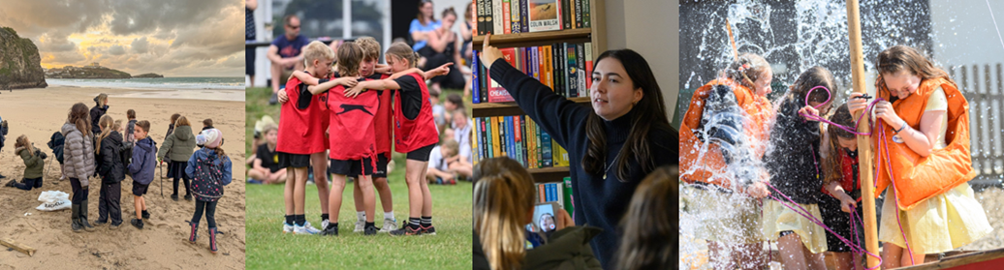

**Cultural development**

We promote an appreciation of cultural diversity through the national curriculum and wider school activities which helps all children to understand and celebrate the rich contributions different cultures have made to modern Britain. This is embedded across subjects such as RE, art and music, where the children explore global traditions, and geography, where they gain insight into how cultural identities are shaped by the environment and historical connections. In English, all our books are thoughtfully chosen to act as mirrors, reflecting the children’s own identities, as windows, offering insights into other cultures and perspectives, and as sliding doors, allowing them to step into new worlds and experiences.

