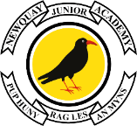

Edgcumbe Avenue, Newquay, Cornwall TR7 2NL
Tel: 01637 874543
secretary@newquayjunior.net
www.newquayjunior.net
Executive Headteacher:
Mr Craig Hayes B.ED (Hons)
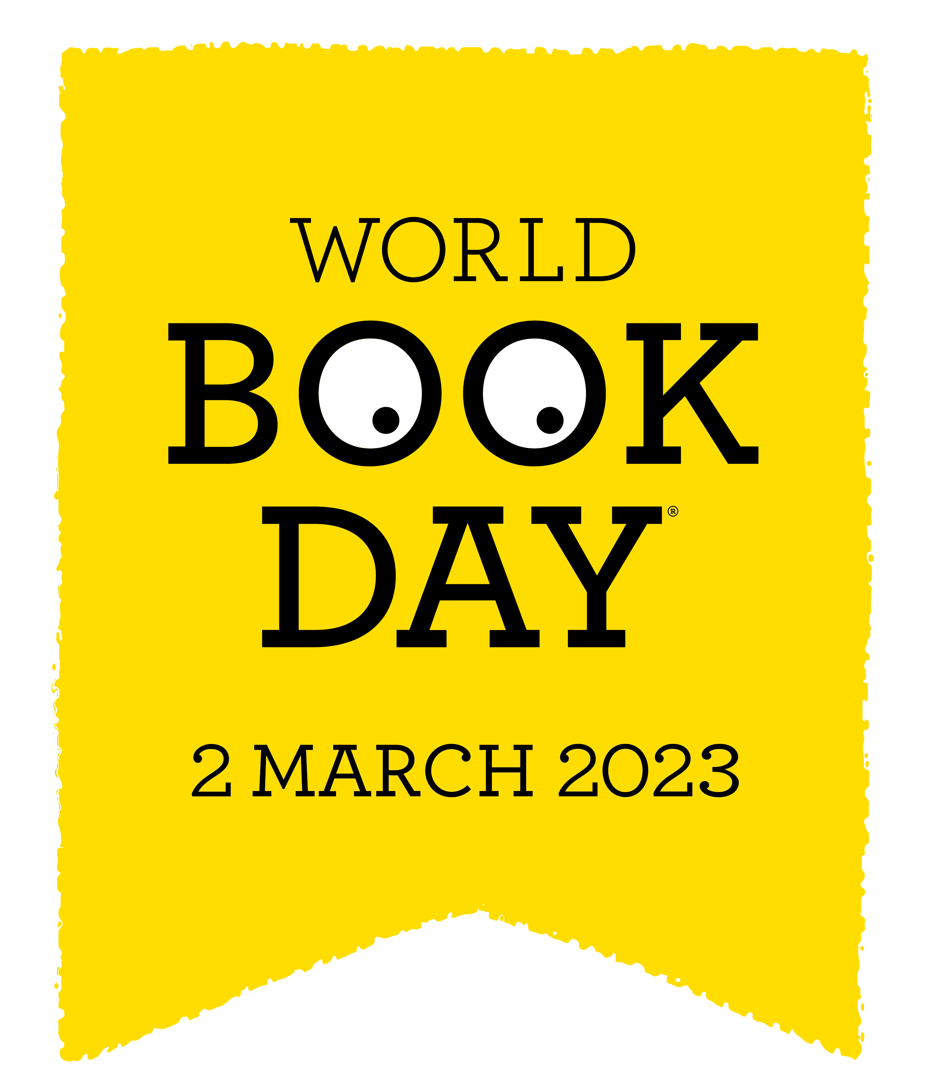
24th January 2023

Dear Parents and Carers,

World Book Day – Thursday 2nd March 2023

Reading for pleasure is the single biggest indicator of a child’s future success – more than their family circumstances, their parents’ educational background or their income. Therefore, we want to see more children develop a life-long habit of reading for pleasure and the improved life chances this brings them.
Although at Newquay Junior Academy, we value the power of books every day, World Book Day is a day where we celebrate with the rest of the world the importance of books and reading. This year, World Book Day is on Thursday 2nd March 2023.
We wanted to let you know, well in advance, that pupils should wear their normal academy uniform on this day as we will not be asking them to dress up as book characters. Instead, they will be asked to bring in their favourite book to share with their class as part of a wider range of activities across the academy.
Pupils will receive their World Book Day token on this day for them to spend in participating book shops and supermarkets.
We are really looking forward to celebrating on the day.
Yours sincerely,

Mr C Hayes
Executive Headteacher.

