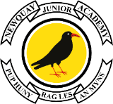

Edgcumbe Avenue, Newquay, Cornwall TR7 2NL
Tel: 01637 874543
njasecretary@nja.celtrust.org
www.newquayjunior.net
Headteacher: Mr Craig Hayes B.ED (Hons)
6th November 2023
Dear Parents and Carers,
We are delighted to announce that Newquay Junior Academy pupils and staff will be joining Newquay Primary Academy to record and film a song to raise money for Newquay Foodbank this Christmas.
On Friday 24th November, pupils are to arrive at the academy wearing their full uniform and a warm coat. We will be walking in groups to record the video at St Michael’s Church and will return for normal home-time arrangements. If your child has PE on this day, please bring their PE kit in a bag.
All pupils will go to the church, then only pupils with permission will be filmed and this will be shared on Facebook, YouTube and across the websites of Newquay Junior Academy, Newquay Primary Academy and Cornwall Education Learning Trust. Everyone who has permission will be involved in the singing and recording process. Then the final video will be edited to feature some of the singing that took place.

Please use this link to give permission for your child/children to appear in the video and for it to be shared across the various social media sites.

https://forms.office.com/e/mTLrsFpLTr

If you do not want your child to participate, please contact the academy office by 11am Friday 17th November on 01637 874543.

We will share the final version of the performance in the coming weeks, along with ways you can donate and support Newquay Food Bank.

This year, pupils will be performing Only You, this is the link to the video: The first one is Becky Hill's version so they can hear the melody and the other is the backing track we will use when we are recording at the church.
Becky Hill - Only You (Official Video) - YouTube – official melody video
Becky Hill - Only You (McDonald's Advert 2022) - Karaoke Version from Zoom Karaoke - YouTube

You can refer to the lyrics at the end of this letter if you wish to help your child practise during the week. Please note, we have slightly altered the lyrics from the original.
Please complete the online permission using the link in this letter to let us know if your child/children will be taking part by 11am on Friday 17 November. If you do not wish your child to take part, please contact the office and let us know.

Yours sincerely,
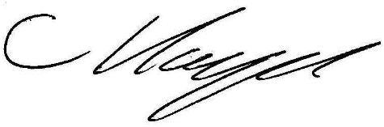
Mr Craig Hayes
Executive Headteacher

Only You

Looking from a window above
It's like a story of love
Can you hear me?
Came back only yesterday
I'm moving farther away
Want you near me
All I needed was the love you gave
All I needed for another day
And all I ever knew
Only you
Sometimes when I think of her name
When it's only a game
And I need you
Listen to the words that you say
It's getting harder to stay
When I see you
All I needed was the love you gave
All I needed for another day
And all I ever knew
Only you

Instrumental
All I needed was the love you gave
All I needed for another day
And all I ever knew
Only you
Looking from a window above
It's like a story of love
Can you hear me?
Came back only yesterday
I'm moving farther away
Want you near me
All I needed was the love you gave
All I needed for another day
And all I ever knew
Only you

