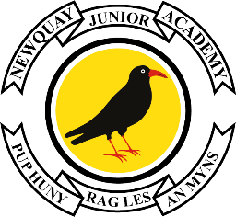

24th June 2024

Dear Parents/Carers,

We are writing to inform you that the children from 5AC and 6MA have been invited to attend the St Austell Festival of Children's Literature on Friday 28th June. This is a fantastic opportunity that allows the children to engage with Eve Wersocki-Morris, a well-known children’s author.
Eve Wersocki Morris grew up in North London and has been making up stories her whole life. As a child she wrote hundreds of poems and short stories, doodled characters, and made-up plays for her friends. Despite being diagnosed with dyslexia, and branded ‘the worst speller in the class,’ she wrote her first full novel aged thirteen and at fifteen she started submitted her writing to publishers – their polite refusals did not stop her ambition to become an author. She uses her Polish heritage to inspire her writing, where she creates adventure books full of mystery and suspense; her most popular book to date is The Bird Singers.
Your children will be leaving school at approximately 8:45am and will travel via coach to Carclaze. We kindly ask that pupils come to school on Friday with a drink and a snack that they can take with them. We will return in time for them to have lunch at the academy.

We will provide you with an update tomorrow on how copies of the book may be purchased.
Yours sincerely,
Mrs. Aubrey & Mrs. Clark
Class Teachers – 6MA and 5AC

