


Monday 2nd September 2024

Dear Parents and Carers,

We hope you had a good summer and are looking forward to starting the new term. Please find below a copy of the letter sent last term, to remind you of the details for the first day back.

The first day back is Thursday 5th September.
Please arrive from 8.30am, ready for 8.40am registration. Please ensure all pupils are on time, wearing full academy uniform and have a filled water bottle, waterproof coat, snack and packed lunch (or pay and book for an academy meal on ParentPay).

New starters in Year 3
We are delighted to be welcoming all our new Year 3 pupils on Thursday 5th September. If your child is joining us in Year 3, you can arrive and queue up at the door at the side of the Edge Hall with your child, between 8.30am and 8.40am. The Edge Hall is the building at the front of the academy, on the left-hand side. Staff will welcome the Year 3s where families can hand the children to their new teachers. We appreciate your patience and support during this process, as it can take some time to welcome the whole year group.

Booking academy meals and Ninjas paid for childcare
Please use ParentPay to book Ninjas or academy lunches for your child (including Free School Meals). ParentPay booking system will open for bookings in September. These must be booked and paid for by Sunday night for the week ahead. Please provide your child with a snack for break time and remember we are a nut free academy. If your ParentPay account is not activated yet, or you have not booked a dinner, please provide your child with a packed lunch for the first day. You will receive the details to activate your account during the first week back.

Medicines
If your child needs any medicines, inhalers, epi pens etc during the academy day, please bring these to the office on the first day, clearly named and labelled. All medicine must be brought to the office by an adult and please be patient, as there are a few forms you will need to complete before you leave. We can only administer prescribed medicine, inhalers, epi pens etc. We thank you for your patience and assistance with managing the medicines safely.

All pupils will need to bring a named coat, water bottle and snack on their first day.
Pupils need a packed lunch, or you can book an academy meal via ParentPay, ready for the week ahead.

End of the day
The academy day finishes at 2.55pm.
All Year 3 pupils need to be collected from the green playground at the back of the academy (called the MUGA) at 2.55pm. You can pre-book and pay for NINJAS wraparound childcare, but spaces are limited.

Year 4 – 6 pupils can be collected from the playground, given permission to walk, or booked into paid for Ninjas childcare. Please inform us of home time arrangements for the pupils in Year 4,5 and 6 using this form https://forms.office.com/e/WG2yqmjS2N. Thank you if you have already completed this form.

Any pupils collected late after 2.55pm, will be looked after by the Ninjas team to keep them safe and there will be a charge. Please do plan ahead and be mindful of the limited parking available, to ensure you can collect on time. We will let you know when the parking permits for the Heron Tennis Car Park are issued by the council. These will be available later in the term.

We look forward to welcoming everyone back on Thursday 5th September from 8.30am, ready for 8.40am registration on the first day.




Further useful information ready for our first week back

- We return for the first day of the Autumn Term on Thursday 5th September 2024.
Please arrive in good time from 8.30am, ready for 8.40am registration.

- Please use the link below to provide your child’s usual home time arrangements from September.
Pupils in Year 3 must be collected by an adult.
Pupils in Year 4 to 6 can be given permission to walk, or they can be collected at the end of the day.

Please complete this home time form for all pupils for September 24, thank you

https://forms.office.com/e/WG2yqmjS2N

- ParentPay Meal & Ninjas bookings system will open in September to take bookings for the Autumn Term.

- Please remember to book any meals required and Ninjas wraparound childcare using ParentPay. Your account will need to be in credit in order to secure any bookings for the week ahead. The system automatically cancels any future bookings made once your account reaches £0.00 https://app.parentpay.com/public/client/security/v2/#/login

- Please remember, all pupils need to bring a healthy snack each day for break time.

- There are no after school activity clubs in the first few weeks. Ninjas before and after hours paid for childcare will be available to pre-book and pay for, using ParentPay. Please note, spaces are limited. The information regarding booking our 3-4pm academy activity clubs will be sent out by email later in the term.

- Cornwall Service Music Trust lessons start week two, beginning on the Monday 9th September. CMST will contact parents and carers directly who are already signed up. These are paid for sessions during the academy day. If you would like your child to join, please contact CMST directly via https://www.cornwallmusicservicetrust.org/signup
Currently Guitars are on Tuesdays, Drums on Wednesday and Keyboards on Fridays.

- Pupils also have the opportunity to sign up directly for the weekly paid for Rocksteady Band Music School, where your child learns to play an instrument or sing as part of a band. Sign up for Rocksteady Music School - Fun that seriously builds confidence (Currently on Wednesdays). Rock Steady Band sessions start on Wednesday 11th September 24.

- The Autumn Term begins on Thursday 5th September and finishes on Friday 20th December 2024. Half Term and Inset Week starts Friday 18th October (inset day) then continues Monday 21st October to Friday 1st November. We have attached the calendar with all the term dates for the year ahead.

- You can now order the NJA PE Hoody directly from Macron, only to be worn on your child’s PE day. Pupils can also wear their academy jumper for PE, if they prefer. Once term starts, classes will be told which day of the week they have PE.

- We would like to remind you we are a nut free academy. We have several pupils with severe nut allergies. If anyone were to eat food containing nuts across the academy, such as peanut butter sandwiches or snack/cereal bars, this could cause another pupil to have a severe allergic reaction. Thank you for keeping everyone safe by checking packed lunches and snack bars are nut free: we really appreciate it.

Newquay Junior Academy Calendar – September 2024

Update to all parents and carers regarding attendance and taking holidays in term time.

August will see the changes to the National Penalty Notice Framework come into force.
Specifically, the changes are:

- A new national threshold of 10 unauthorised sessions for any reason (equivalent to 5 school days) within a rolling 10 school week period for which a penalty notice must be considered. A penalty fine can be issued for any combination of unauthorised absences over a 10- week rolling period. They can be consecutive or non-consecutive and can span over two terms.

- An increase in the penalty fine from £60 to £80 if paid in 21 days. If the fine is not paid by the first 21 days, it will rise to £160 if paid within 28 days of being issued.

- If a 2nd penalty fine is issued to the same parent for the same child within a 3-year rolling period, the fine will automatically rise to £160 with no option to pay the lower rate of £80.

- If a parent then commits a third offence in a 3-year rolling period, the local authority will need to consider options available to them to improve attendance. This will include a consideration to prosecute under section 444 of the Education Act 1996.

- The current penalty notice warning letter used for unauthorised absence (not holiday) will be changed to a Notice to Improve.

Please find the reminder of academic calendar below, first sent out in November 2023, to ensure you can plan your holidays out of term time. Thank you for your support with this.
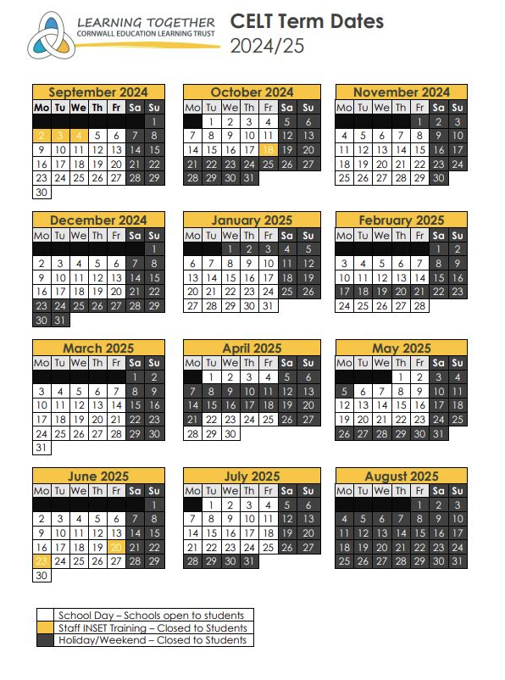

Yours sincerely,

Newquay Junior Academy

