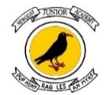
3rd February 2023
Dear Parents and Carers of Year 5 and 6
VIRTUAL AUTHOR AND ILLUSTRATOR VISIT - Friday 10th February
ALASDAIR BECKETT-KING AND ILLUSTRATOR CLAIRE POWELL!
We are very lucky to have comedian, film maker and author, Alasdair Beckett-King joining us for a live virtual visit on 10th February 2023 – and the event will also include award-winning illustrator and character designer, Claire Powell!
During our online visit, Alasdair and Claire will be talking to the pupils about their brilliant new detective mystery adventure, Montgomery Bonbon, Murder at the Museum. There will be interactive sessions and time for Q&As at this live event! All the pupils in Year 5 and 6 will join this session. Following the virtual visit, there is a wonderful opportunity for your child to own a signed book by the author and illustrator. We will be working with a local independent bookshop, and a signed copy of the book will be offered at the discounted price of £7.00, to be delivered after the event.

If you would like to order a signed copy of the book at £7.00, please make your payment on the ParentPay item “Murder at the Museum Book Order”. All orders must be placed by Friday 10th February and then the books will be distributed by staff when they arrive a few weeks later.
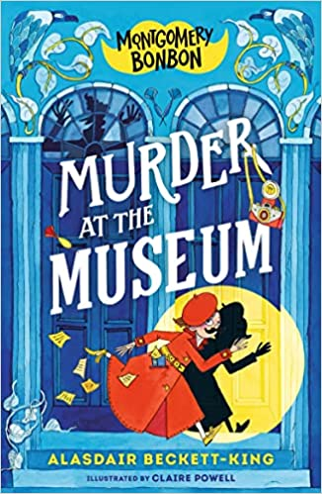 | About the book…  Many people go their whole lives without noticing anything that is afoot, amiss, or even untoward; without ever experiencing that toe-tingling, stomach-twisting sensation that a mystery is about to unfold. Not Bonnie Montgomery – the world’s best detective. Not that anyone (other than Grampa Banks) has heard of her…  But they might have heard of the great Montgomery Bonbon, the well-dressed gentleman detective who (apart from the hat and moustache) looks suspiciously like a 10-year-old girl.  Their newest case: solving the mystery surrounding a highly suspicious death at the Hornville Museum.  Together they will interview some dodgy witnesses, scour the scene for clues and – above all – hope no one notices that Bonnie and Montgomery are never in the same room at the same time...

Yours sincerely

Newquay Junior Academy

