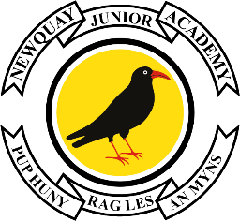

Edgcumbe Avenue, Newquay, Cornwall TR7 2NL
Tel: 01637 874543
secretary@newquayjunior.net
www.newquayjunior.net
Executive Headteacher: Mr Craig Hayes B.ED (Hons)
6th June 2023

Dear Parents and Carers

We have booked Al Scarlett Photography to come into the academy on Tuesday 13th June 2023 to take individual class photographs.
Please can you ensure your child wears the full correct uniform on these days, if it is a normal PE day for your child’s class please may they come to the academy in their correct uniform and bring their PE kit with them.
However, due to Data Protection, we do require your permission for your child to be in the photo and for other families to receive the class photograph. If you do not wish for your child to appear in the class photograph. please complete the e-form by clicking on the following link
https://tinyurl.com/3cppzcpk
Further information regarding how to order and pay for the photograph will be communicated to you in due course.

Yours sincerely
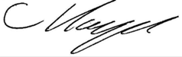
Mr C Hayes
Executive Headteacher

